Greensight: The prototype of a web-based auditing tool   
to evaluate the carbon footprint of the computing equipment of an organisation

Clément MOUCHET

Submitted in partial fulfilment of   
the requirements of Edinburgh Napier University   
for the Degree of

MSc Information Systems Development

School of Computing December 2011

**Authorship Declaration**

I, Clément MOUCHET, confirm that this dissertation and the work presented in it are my own achievement.

Where I have consulted the published work of others this is always clearly attributed;

Where I have quoted from the work of others the source is always given. With the exception of such quotations this dissertation is entirely my own work;

I have acknowledged all main sources of help;

If my research follows on from previous work or is part of a larger collaborative research project I have made clear exactly what was done by others and what I have contributed myself;

I have read and understand the penalties associated with Academic Misconduct.

I also confirm that I have obtained informed consent from all people I have involved in the work in this dissertation following the School's ethical guidelines

Signed:

Date:

Matriculation no: 10011053

**Data Protection Declaration**

Under the 1998 Data Protection Act, The University cannot disclose your grade to an unauthorised person. However, other students benefit from studying dissertations that have their grades attached.

Please sign your name below one of the options below to state your preference.

The University may make this dissertation, with indicative grade, available to others.

The University may make this dissertation available to others, but the grade may not be disclosed.

The University may not make this dissertation available to others.

**Abstract**

Recent years have seen an increase of concerns related to global warming, and an increase of efforts targeted to reduce emissions related to information technology and computing equipment. However, if major companies have solid plans and logistic to achieve that, smaller organisation lacks tools and help. This dissertation discusses how a fit-for-purpose auditing tool could address this.

Based on the findings of an in-depth literature review on sustainability and sustainable practices in IT, the requirements of a prototype auditing-tool to calculate the carbon footprint of the computing equipment of an organisation were developed. Research was also conducted to find a suitable development methodology. Upon completion of the implementation, the prototype was evaluated by conducting an audit on Edinburgh Napier University School of Computing and the Institute for Informatics and Digital Innovation, located in the same building at Merchiston campus.

The audit confirmed that energy policies are not often enforced efficiently enough and that considerable savings and reductions of emissions can be achieved with minimum investments. Further steps are also suggested, based on research findings and literature review.

The results of the project confirm the effectiveness of such auditing tools, despite the limitations of the prototype version used and suggest ways to improve it in order to carry on with the development of the proof of concept implemented.

Table of Contents

[1. Introduction 10](#_Toc311040752)

[1.1. Aims and Objectives 11](#_Toc311040753)

[1.2. Structure of this dissertation 12](#_Toc311040754)

[1.3. Project Plan 13](#_Toc311040755)

[2. Literature Review 14](#_Toc311040756)

[2.1. Sustainability 14](#_Toc311040757)

[2.1.1. General considerations & Sustainability strategies 14](#_Toc311040758)

[2.1.2. Sustainable practices & Green IT/S 19](#_Toc311040759)

[2.1.3. Conclusion 25](#_Toc311040760)

[2.2. The Life Cycle Approach 27](#_Toc311040761)

[2.2.1. Life Cycle Assessment 27](#_Toc311040762)

[2.2.2. Conclusion 29](#_Toc311040763)

[2.3. Carbon Footprinting 30](#_Toc311040764)

[2.3.1. General considerations 30](#_Toc311040765)

[2.3.2. Carbon calculation 32](#_Toc311040766)

[2.3.3. Conclusion 35](#_Toc311040767)

[2.4. Conclusion of the literature review 36](#_Toc311040768)

[3. Methodology 37](#_Toc311040769)

[3.1. Development Methodologies 37](#_Toc311040770)

[3.2. Evaluation & Testing Methodologies 40](#_Toc311040771)

[3.3. Data Collection 43](#_Toc311040772)

[3.4. Conclusion of the methodology chapter 44](#_Toc311040773)

[4. Analysis and Design 45](#_Toc311040774)

[4.1. System requirement Analysis 45](#_Toc311040775)

[4.1.1. Existing software review 45](#_Toc311040776)

[4.1.2. Mission statement 48](#_Toc311040777)

[4.2. Features Definition 49](#_Toc311040778)

[4.2.1. Functionality 49](#_Toc311040779)

[4.2.2. Usability and User Experience 52](#_Toc311040780)

[4.3. Platform Review 54](#_Toc311040781)

[4.3.1. Data source 54](#_Toc311040782)

[4.3.2. Server-side scripting language & host 56](#_Toc311040783)

[4.3.3. Client-side scripting language & standards 57](#_Toc311040784)

[4.4. Conclusion of the analysis and design chapter 60](#_Toc311040785)

[5. Results 61](#_Toc311040786)

[5.1. Prototype Development 61](#_Toc311040787)

[5.1.1. Development stages 61](#_Toc311040788)

[5.1.2. Development documentation 63](#_Toc311040789)

[5.2. User Documentation 69](#_Toc311040790)

[5.2.1. Introduction 69](#_Toc311040791)

[5.2.2. User manual 69](#_Toc311040792)

[5.3. Prototype Evaluation 70](#_Toc311040793)

[5.3.1. Auditing the School of Computing 70](#_Toc311040794)

[5.3.2. Evaluating with end users 85](#_Toc311040795)

[5.4. Conclusion of the results chapter 86](#_Toc311040796)

[6. Conclusions 88](#_Toc311040797)

[6.1. Limitations 88](#_Toc311040798)

[6.2. New aims and objectives 90](#_Toc311040799)

[6.3. Future research 93](#_Toc311040800)

[6.4. Critical evaluation 95](#_Toc311040801)

[6.5. Final conclusions 98](#_Toc311040802)

[7. References 99](#_Toc311040803)

[8. Appendix 106](#_Toc311040804)

[8.1. User Manual 106](#_Toc311040805)

[8.2. Outputs of the web-application 119](#_Toc311040806)

[8.2.1. Listing of the entire audit of the S.o.C. & I.I.D.I. 120](#_Toc311040807)

[8.2.2. Report of the entire audit of the S.o.C. & I.I.D.I. 130](#_Toc311040808)

[8.2.3. Report of the Desktop PCs in the S.o.C. & I.I.D.I. 139](#_Toc311040809)

[8.2.4. Report of the Shared PCs in the S.o.C. & I.I.D.I. 143](#_Toc311040810)

[8.2.5. Report of the Laptops in the S.o.C. & I.I.D.I. 145](#_Toc311040811)

[8.2.6. Report of the Servers in the S.o.C. & I.I.D.I. 147](#_Toc311040812)

[8.2.7. Report of the Printers in the S.o.C. & I.I.D.I. 149](#_Toc311040813)

[8.2.8. Report of the Shared printers in the S.o.C. & I.I.D.I. 152](#_Toc311040814)

[8.2.9. Report of the Other equipment in the S.o.C. & I.I.D.I. 154](#_Toc311040815)

[8.2.10. Report of the comparison function 158](#_Toc311040816)

[8.3. Project Management documentation 159](#_Toc311040817)

[8.4. Audit Report 163](#_Toc311040818)

List of Tables

[Table 1: High level view of the project plan 13](#_Toc311040819)

[Table 2: Green IT/S strategy types and Green IT/S examples. Adapted from (Jenkin, Webster, & McShane, 2011, p. 23) 17](#_Toc311040820)

[Table 3: High-level Use cases 51](#_Toc311040821)

[Table 4: Energy Star Categories 55](#_Toc311040822)

[Table 5: MTP Average scale of use 55](#_Toc311040823)

[Table 6: MTP on standby factors 55](#_Toc311040824)

[Table 7: jQuery Plugins used 59](#_Toc311040825)

[Table 8: High level view of the four development iterations 62](#_Toc311040826)

[Table 9: IT assets of the Labs 71](#_Toc311040827)

[Table 10: Issue log of the audit of the Labs 75](#_Toc311040828)

[Table 11: Power usage policy of PCs 76](#_Toc311040829)

[Table 12: Power usage policy of Networked Printers 76](#_Toc311040830)

[Table 13: Staff rooms audited 77](#_Toc311040831)

[Table 14: Issue log of the audit of the staff rooms 78](#_Toc311040832)

[Table 15: Browser compatibility list 107](#_Toc311040833)

Table of Figures

[Figure 1: The Triple Bottom Line of sustainability Adapted from (Dao, Langella, & Carbo, 2011) 15](file:///C:\Users\Clement\Dropbox\Napier%20Uni\SOC11101%20Dissertation\dissertation_g.docx#_Toc311040834)

[Figure 2: Process overview from (Wookjin, et al., 2005) 39](file:///C:\Users\Clement\Dropbox\Napier%20Uni\SOC11101%20Dissertation\dissertation_g.docx#_Toc311040835)

[Figure 3: AMEE Aggregate Content. From (AMEE UK Ltd., 2011) 54](file:///C:\Users\Clement\Dropbox\Napier%20Uni\SOC11101%20Dissertation\dissertation_g.docx#_Toc311040836)

[Figure 4: Database & storage structure 63](file:///C:\Users\Clement\Dropbox\Napier%20Uni\SOC11101%20Dissertation\dissertation_g.docx#_Toc311040837)

[Figure 5: Drill-down sequence 64](file:///C:\Users\Clement\Dropbox\Napier%20Uni\SOC11101%20Dissertation\dissertation_g.docx#_Toc311040838)

[Figure 6: Webpages activity diagram 66](file:///C:\Users\Clement\Dropbox\Napier%20Uni\SOC11101%20Dissertation\dissertation_g.docx#_Toc311040839)

[Figure 7: Website structure 67](file:///C:\Users\Clement\Dropbox\Napier%20Uni\SOC11101%20Dissertation\dissertation_g.docx#_Toc311040840)

[Figure 8: Carbon calculator webpage activity diagram 68](file:///C:\Users\Clement\Dropbox\Napier%20Uni\SOC11101%20Dissertation\dissertation_g.docx#_Toc311040841)

[Figure 9: Extract from the report 79](file:///C:\Users\Clement\Dropbox\Napier%20Uni\SOC11101%20Dissertation\dissertation_g.docx#_Toc311040842)

[Figure 10: Example of the comparison function 80](file:///C:\Users\Clement\Dropbox\Napier%20Uni\SOC11101%20Dissertation\dissertation_g.docx#_Toc311040843)

[Figure 11: Listing of the entire audit of the S.o.C. & I.I.D.I. 121](#_Toc311040844)

[Figure 12: Report of the entire audit of the S.o.C. & I.I.D.I. 131](#_Toc311040845)

[Figure 13: Report of the Desktop PCs in the S.o.C. & I.I.D.I. 140](#_Toc311040846)

[Figure 14: Report of the Shared PCs in the S.o.C. & I.I.D.I. 144](#_Toc311040847)

[Figure 15: Report of the Laptops in the S.o.C. & I.I.D.I. 146](#_Toc311040848)

[Figure 16: Report of the Servers in the S.o.C. & I.I.D.I. 148](#_Toc311040849)

[Figure 17: Report of the Printers in the S.o.C. & I.I.D.I. 150](#_Toc311040850)

[Figure 18: Report of the Shared printers in the S.o.C. & I.I.D.I. 153](#_Toc311040851)

[Figure 19: Report of the Other equipment in the S.o.C. & I.I.D.I. 155](#_Toc311040852)

[Figure 20: Report of the comparison function on the school office 158](file:///C:\Users\Clement\Dropbox\Napier%20Uni\SOC11101%20Dissertation\dissertation_g.docx#_Toc311040853)

[Figure 21: Project plan overview 160](file:///C:\Users\Clement\Dropbox\Napier%20Uni\SOC11101%20Dissertation\dissertation_g.docx#_Toc311040854)

[Figure 22: Detailed project plan page 1 161](file:///C:\Users\Clement\Dropbox\Napier%20Uni\SOC11101%20Dissertation\dissertation_g.docx#_Toc311040855)

[Figure 23: Detailed project plan page 2 161](file:///C:\Users\Clement\Dropbox\Napier%20Uni\SOC11101%20Dissertation\dissertation_g.docx#_Toc311040856)

[Figure 25: Detailed project plan page 3 162](file:///C:\Users\Clement\Dropbox\Napier%20Uni\SOC11101%20Dissertation\dissertation_g.docx#_Toc311040857)

[Figure 24: Detailed project plan page 4 162](file:///C:\Users\Clement\Dropbox\Napier%20Uni\SOC11101%20Dissertation\dissertation_g.docx#_Toc311040858)

Acknowledgements

I would like to dedicate this dissertation to my beloved grand mother, who have been a unique inspirational example of bravory and integrity all her live, and to whom I owe so much.

I would also like to thank my parents and my sister who have been supporting me constantly during this adventure, and my girlfirend, without whom none of this whould be possible.

And finally I would like to express my gratitude to my supervisor and second marker who have been motivating and inspirational all along the project.

It was a gripping project.

# Introduction

*“In Europe, a survey by IT services firm LogicaCMG stated that more than four in five of the UK, French, German, Dutch, and Swedish companies needed technology that would help them improve their energy efficiency. Some 74% of them said they also needed a way to measure their impact on the environment.”*

(Garg & Dornfeld, 2008, p. 4)

In the context of global warming the challenges the world is facing are essentials. Human activities and way of life endangered the planet. Therefore, there is a need to take step to limit this destructive development, and move toward a more sustainable society. As ICT is growing, changing and dynamic, enabling many breakthroughs in all domains it is in a unique position to act as an example and a media to initiate and motivate the behavioural change that is needed to achieve that aim.

The purpose of the project is to research sustainability initiatives in ICT, by reviewing current literature in this subject area, and build a framework to develop an information tool to perform audits, to calculate carbon emissions and power consumption of IT devices, in order to give users informative and motivational feedback on how to reduce them. Research, and recent history has proven that web-design application from Web 2.0 have a tremendous impact on the behaviour of their users, and that information tools such as carbon calculators can be of great use to motivate and help decision making toward more sustainable activities. This proof of concept will thus be a web-based auditing tool, taking advantage of new web technologies, usability and accessibility guidelines, in order to increase user satisfaction and maximize its positive impact among users.

## Aims and Objectives

Based on the findings of an in-depth literature review on sustainability and sustainable practices in IT, the requirements of a prototype auditing-tool to calculate the carbon footprint of an organisation were developed. Research was also conducted to find a suitable development methodology. Upon completion of the implementation, the prototype was evaluated by conducting an audit on Edinburgh Napier University School of Computing and the Institute for Informatics and Digital Innovation, located in the same building at Merchiston campus.

**Overall aim of the project:**

To develop an auditing tool to calculate the carbon footprint of the computing equipment of an organisation.

To achieve this overall aim the following specific aims were defined.

**Specific aims:**

* To conduct an in-depth research on sustainability, sustainable practices and recent research outcomes in this area.
* To determine and use critical success factors of carbon calculators platforms, and related auditing tools, with an existing software review.
* To guarantee usefulness ease of use and accessibility of the deliverable, as well as transparency of the results generated by evaluating it with users.
* To find and use adapted project management methodologies.
* Understand what are the main factors motivating sustainability transformations, and what are the main barriers.

To achieve these, the following objectives or deliverables were formulated.

**Objectives:**

* To implement a scalable web-based framework to perform audits.
* To evaluate the proof of concept by conducting an audit in the School of Computing, and assessing the results with staff in charge of the computing equipment.
* To process the results of the audit, and draw conclusions.
* To evaluate the usability and overall quality of the prototype with potential end users.
* To develop refined requirements for future development.

## Structure of this dissertation

This dissertation is structured into seven main chapters as follows: Introduction, Literature review, Methodology, Analysis and Design, Results, Evaluation, Conclusion.

The current chapter introduces the project, the structure of the dissertation and the project plan.

The Literature review is structured from a wide area of research discussing concepts such as sustainability, to more precise and specific aspects such as carbon footprinting and carbon calculators.

The Methodology chapter introduces the development methodology of choice, as well as the evaluation and testing methodology, and data collection choices.

The analysis and design chapter defines the system requirements and features definition of the prototype auditing-tool. The choice of platform is also discussed in this chapter.

The result chapter presents the outcomes of the development; the development and user documentation produced the evaluation process as well as its results.

The final chapter provides both evaluation and conclusion of the project. It casts a critical eye on the results of the project, and draws conclusion as well as discuss what could be done to take it further.

## Project Plan

This dissertation project was achieved in fourteen weeks. During the first week, a detailed project plan was design to prepare and plan the project cf. appendix 8.3, page 159.

Table 1 is a high level overview of this plan.

Five stages were defined, and tasks were allocated to each phase, in the detailed plan. Although the reality of the project is less linear than the table reflects it, but the phases provide a framework that contribute to structure and evaluate the project progress. Time was logged on a day basis, with a high level description of the objectives for each week in the detailed project plan.

Table 1: High level view of the project plan

|  |  |  |
| --- | --- | --- |
| Phase | Weeks | Content |
| 1: Planning | 1 | Clarification of the project and project proposal |
| 2: Research | 2 - 4 | Literature review and Initial report |
| 3: Implementation | 5 - 9 | Methodologies, Implementation and testing |
| 4: Evaluation | 10 - 11 | Implementation, Evaluation |
| 5: Dissertation | 12 - 14 | Evaluation and Final dissertation |

# Literature Review

In order to define, and understand the state of Sustainability, Sustainable development and Green IT/S, an in-depth literature review has been conducted. Related scholarly articles have been searched in online databases such as ScienceDirect, Emerald, SpringerLink, the Wiley Online Library, IEEE Xplore, ACM Digital Library, and Edinburgh Napier library. Findings of the literature search are that a fair amount of research had been conducted on LCA, and sustainability in general, but there were fewer publications on Green IT/S. The following literature review is organised as follows: the first chapter outline the concept of sustainability and some of the strategies of its application; sustainable practices are discussed as well as Green IT/S. Further literature related to Life Cycle Assessment and Carbon calculators is reviewed to support the definition of the requirements of this project.

## Sustainability

### General considerations & Sustainability strategies

*“There is unlikely to ever be a single answer to the question, ‘what is sustainability’. Instead, definitions should be crafted to serve well in different times and contexts. And, more importantly, the definitions should be practiced, by implementing metrics and indicators of progress along the road to sustainability. It is from practicing sustainability that definitions can best tested and refined.”* (Vos, 2007)

Sustainability was originally a concept from biology and ecology that moved into economics to explain “the relationship between natural capital and economy” (Vos, 2007, p. 335) (Fuchs, 2008, p. 306). Indeed, in the 1980s, concerns about sustainability and sustainable development have become increasingly important, and the concepts of sustainability really evolved during the 1990s (Vos, 2007) supported by web technologies such as Web 2.0 (Hasan & Kazlauskas, 2009, p. 145).

In 1987, the United Nations defined it as ‘‘[…] development that meets the needs of the present without compromising the ability of future generations to meet their needs’’ (World Commission on Environment and Development., 1987, p. 43); binding it to economic growth and development. In 1994, the triple-bottom line illustrated in Figure 1 appeared and was soon widely adopted for making key strategic (O'Neil, 2010, p. 5). It is still the most common representation of the concept. It emphasized the link between Economic and Environment, as well as the Social component of that definition.

**Sustainability**

**Environmental**  
Performance  
*(Planet)*

**Economic**   
Performance  
(*Profitability*)

**Social**  
Performance  
*(People)*

*Viable*

*Bearable*

*Equitable*

Figure 1: The Triple Bottom Line of sustainability Adapted from (Dao, Langella, & Carbo, 2011)

However, several articles discuss the ambiguity and lack of clarity of that definition of 1987 (Jenkin, Webster, & McShane, 2011) (Vos, 2007), some value this fuzziness and some criticize it (Vos, 2007). Robert O. Vos explains that two versions can be distinguished: a “thin” version, which is the most common and a “thick” version that “require deeper transformations from ideas dominant today” (Vos, 2007). For the purpose of this research we won’t use a “thick” version of sustainability, not only because it would imply though choices and drastic change, which is not adapted for this project, but mainly because the aim of the project is to provide motivational feedback, which tends to imply a less drastic approach but more straightforward and feasible initiatives.

Most of the research about sustainable development is focused on corporate and business sustainability, there is much less literature about Universities and higher education sustainability, despite “universities are key stakeholders in achieving a sustainable future” (Ferrer-Balas, et al., 2008) (Stafford, 2011).

Still Universities too are undertaking changes to more sustainable activities, through “campus greening”, courses on sustainability or collaborative research opportunities (Ferrer-Balas, et al., 2008). However, as for businesses it is hard to rank or grading in sustainability (Mascarelli, 2009) as each case is specific, since all of them are facing different challenges, and thus follow different path (Stafford, 2011, p. 317). Sustainability still seems to be a luxury in higher education (Stafford, 2011, p. 355) and is not often a priority because of financial resources. Among the common barriers IHEs face when trying to change for a more sustainable development, we can count “the lack of an incentive structure for promoting changes” (Ferrer-Balas, et al., 2008, p. 312), the size and wealth of the Universities (Stafford, 2011) (Jenkin, Webster, & McShane, 2011), the absence of common structure-level general will to transform the University or the absence of a “networks of expertise within the universities” (Ferrer-Balas, et al., 2008, p. 312). On the contrary every successful project was backed-up by a “combination of drivers more than based on personal leadership” (Ferrer-Balas, et al., 2008, p. 312) (Jenkin, Webster, & McShane, 2011, p. 22). Those factors are different from the factors that influence corporate sustainability efforts; due to the fact most IHEs are non-profit organizations and for-profit and IHEs have different goals, and motivations (Stafford, 2011). However, although IHEs tend to make long-term investments more likely than for-profits business, financial resources prove to be a major curb (Stafford, 2011).

On the other side, if regulatory pressures generally fail to encourage sustainability efforts, “alumni, faculty, and the community — appear to play a more dominant role in encouraging the adoption of sustainable practices than they do for corporations.” (Stafford, 2011, p. 355). Literature (Jenkin, Webster, & McShane, 2011) (Stafford, 2011, p. 356) also recognizes the influence of media, socio-cultural forces, values, beliefs and trends. Promoting an image of sustainability could be a major incentive just like for business or organizations that advertise their efforts in sustainability to attract customers and/or investors. Such strategies have given birth to “greenwashing” which is part of what (Jenkin, Webster, & McShane, 2011) classified as Image-oriented strategies. They identified “four types of environmental sustainability strategies” according to the impact and amount of change they demand. Table 2 from (Jenkin, Webster, & McShane, 2011, p. 23) shows the classification with examples. This is derived from well-established management literature. This classification will be helpful to decide what strategy to adopt for the case study.

Table 2: Green IT/S strategy types and Green IT/S examples.   
Adapted from (Jenkin, Webster, & McShane, 2011, p. 23)

|  |  |  |  |
| --- | --- | --- | --- |
| Strategy type | Description | Green IT/S strategy | Green IT/S |
| Type 0:  Image-oriented only | Involves portraying an image  of caring about the environment by publicly announcing environmental policies (espoused strategy). These policies and practices are not subsequently implemented. Intentions can  be “green” (authentic) or “greenwashing” (not authentic). | Announcing a strategy to reduce energy use in the organization's supply chain by using IT/S. | Although intentions are authentic, there are insufficient resources (for example, financial and human resources) to implement the IT/S application. |
| Type 1: Prevent, control, eco-efficiency | Involves making efficient use of natural and firm resources in order to reduce negative environmental impacts. Focuses on resource efficiency, waste prevention and control. | Introducing an objective to reduce IT/S power consumption across the company. | Implementing energy efficient servers and powering off PC's when not in use |
| Type 2:  Product stewardship, eco-equity | Subsumes type 1 strategy and also involves attempts to achieve eco-equity goals (balancing the firm's and society's short and long term needs for natural resources) by minimizing environmental impacts throughout a product's lifecycle (product stewardship). | Developing a strategy to use IT/S to help reduce the environmental impact of an organization's product(s). | Implementing an IS and associated technology to capture environmental data during product distribution, use and maintenance for product design improvements |
| Type 3: Sustainable development, eco-effectiveness | Subsumes type 1 and 2 strategies; involves infusing environmental sustainability considerations throughout all of the firm's activities and interactions with the goal of stopping environmental degradation altogether. | Introducing a goal to substantially reduce business travel using IT/S. | Implementing videoconferencing, telepresence and collaboration tools as substitutes for travel |

From this classification, Type 1 seems to be the most realistic and adapted strategy for this project. Type 2 and above would require a longer analysis and would likely imply redesigning the IT and IS systems, which is out of the scope of this study. Still there are some lifecycle aspects of the last 2 strategies that could be used in this case. Another problem that could come from the adoption of a strategy of type 2 or 3 is that the drastic changes it would imply could scare as discussed earlier, and that would be counterproductive; the aim being to initiate or consolidate a sustainable initiative, changes have to be done step by step, but must also be on-going.

Rewards have a positive influence on sustainable development, as they act on several factors previously mentioned; starting from the image of the organization, a champion organization attracts more investments and is present in the media (Ferrer-Balas, et al., 2008). The spin-off of such media coverage is often positive as far as finance and reputation are concerned. However until now research can’t establish whether students choose they campus for their sustainability programme (Stafford, 2011, p. 340) although it will probably change in time (Stafford, 2011, p. 345) but this can already enable a university to be part of a network of expertise, which is proven to boost research and progress in sustainable development (Ferrer-Balas, et al., 2008). It can also increase “an institution’s value function directly because sustainable practices are part of the institution’s contribution to the public”, or “attract higher quality students and faculty” thus boosting its research (Stafford, 2011, p. 340).

The effect of a known environmental violation would likely be worse for a University than for a business or a corporation, as the University is a symbol with high expectations from society in general.

Given that financial resources and size are key aspects in the adoption of sustainable practices (Stafford, 2011, p. 356) (Jenkin, Webster, & McShane, 2011, p. 22), developing programme and investing in sustainable development can be seen as a win-win relationship (Vos, 2007) as (Stafford, 2011, p. 345) points out that high levels of research activity are likely to receive more external funding than organizations that are not involved in sustainable development programme.

This conclusion is not so different from the argument that adopting TBL can benefit the growth of firms (Dao, Langella, & Carbo, 2011, p. 65).

In practice, the case of Edinburgh Napier University Carbon Management Plan 2008 – 2013 (Edinburgh Napier University, 2009) (Edinburgh Napier University, 2011) confirms the findings from the literature review so far, as credits and funding have been awarded “from internal ring-fenced capital budgets and Salix with consultancy support from the Carbon Trust.” (Edinburgh Napier University, 2011). This helps keeping a holistic approach with on-going efforts.

Following the choice of a strategy of type 1 as described in Table 2, the next chapter examines the links between IT and sustainability, and how IT relate to sustainability.

### Sustainable practices & Green IT/S

*“Green information technologies and systems refer to initiatives and programs that directly or indirectly address environmental sustainability in organizations.”* (Jenkin, Webster, & McShane, 2011, p. 17)

Why is IT so important when an organisation is developing a sustainable programme? IT have been adopted everywhere and is now part of everyone’s job. In organisation IS often making the difference between organisations because a well design, adapted system gives an organisation a competitive advantage over another (Dao, Langella, & Carbo, 2011, p. 65). We have discussed it earlier; few organizations are engaged in sustainability efforts (Dao, Langella, & Carbo, 2011, p. 65) mainly because of the investments that they imply, but also because of the fact people tend to think IT is not a major sector to put efforts in (Jenkin, Webster, & McShane, 2011, p. 34). However, legislation related to reduction of carbon emission is coming, and soon organizations will have no choice but to adhere and abide by the law (O'Neil, 2010, p. 2)

The ICT industry would be responsible for “approximately 2 per cent of worldwide carbon emissions” (O'Neil, 2010, p. 1) (Intel Corporation, 2009) (Fuchs, 2008), which seems little compared to other sectors such as transportation. But the growth of IT is a factor to be considered, and eventually, “IT is quickly surpassing air transportation in terms of its carbon footprint” (Jenkin, Webster, & McShane, 2011, p. 18) as the use of information technologies is exploding. In fact, IT could contribute way more than other sector to globally reduce carbon emissions (O'Neil, 2010, p. 1) it could have the potential to reduce global emissions by 15% (Jenkin, Webster, & McShane, 2011, p. 18). “IT contributions to the sustainability go beyond reducing IT’s energy consumption through green IT initiatives” (Dao, Langella, & Carbo, 2011, p. 76).

Indeed changing to a sustainable IT can contribute to changing people routines and affect their cognition and awareness about sustainability (Dao, Langella, & Carbo, 2011, p. 26). “The relationship of ICTs and sustainability is not only a question of ethical consumerism, but also one of corporate social and ecological responsibility.” (Fuchs, 2008, p. 298)

This is where Green IT/S comes from, and what it is aiming at. Not only “Green IT is a collection of strategic and tactical initiatives that directly reduces the carbon footprint of an organization’s computing operation” (O'Neil, 2010, p. 4); but it can also “enable the development of sustainability capabilities that address all three factors of the TBL” shown on Figure 1 [economic, social and environmental] (Dao, Langella, & Carbo, 2011, p. 76)

Green IT/S is made of two components that have different roles and impacts. (Hasan & Kazlauskas, 2009, p. 147) The most common and well know is *Green IT,* which *“addresses energy consumption and waste associated with the use of hardware and software tends to have a direct and positive impact.”* (Jenkin, Webster, & McShane, 2011, p. 18) (O'Neil, 2010, p. 4) (Hasan & Kazlauskas, 2009, p. 147).

But there is also *Green IS*, which is related to the *“development and use of information systems to support or enable environmental sustainability initiatives and, thus, tends to have an indirect and positive impact.”* (Jenkin, Webster, & McShane, 2011, p. 18) (Hasan & Kazlauskas, 2009, p. 147). Some see more potential in Green IS than Green IT because it “tackles a much larger problem by recognizing the context of an information system as an ecosystem” (Hasan & Kazlauskas, 2009, p. 147)

Still, the two are meant to help reducing “the organisation’s overall carbon footprint, regardless of the type, shape or size of the organisation.” (O'Neil, 2010, p. 4)

However, despite Green IT/S has been well defined, little research on information systems has focused on sustainability (Dao, Langella, & Carbo, 2011, p. 76) and “limited research has examined the contribution of IT resources to sustainability beyond reducing energy consumption of corporate IT infrastructure” (Dao, Langella, & Carbo, 2011, p. 76) an acknowledgement generally found in other documents; (Jenkin, Webster, & McShane, 2011, p. 27), (Hasan & Kazlauskas, 2009, p. 147). The next sections bring more light and details on them.

*“An appropriate mantra for any organisation committed to Green IT should be ‘Reduce, Reuse, Recycle’”* (O'Neil, 2010)

As far as reducing energy consumption is concerned, much experimentation has been conducted. The relative success of Green IT compared to Green IS is due to the fact it is less difficult to setup energy efficient products than it is to redesign a whole system, and there is a real urge for a drastic reduction of IT computers and super computers. For instance, western European electricity consumption of data centres has been estimated at 56 TWh/year in 2007 and is projected to increase to 104 TWh/year by 2020 (O'Neil, 2010) and this poses problem to the EU energy and environmental policies, as well as it represent a considerable cost of energy, that corporations and organizations would like to reduce.

Many recommendations are going in that direction. For instance CRT monitors must be replaced, as they use 60% more power than a LCD on average or using networked laser printers rather than inkjet printers that waste more ink. (O'Neil, 2010)

Replacing older PCs with Energy efficient (Gold EPEAT rating) PCs, since their actual use over their lifecycle is the most emitting proportion in terms of carbon emissions, along with the energy needed for their production (Intel Corporation, 2009). This replacement policy has its limits tough.

Indeed, Moore’s Law states that the computing power of computers doubles every 18 months and so far his law has proven true. It gives computers a short lifespan of 2 to 3 years. The problem is that people frequently buy new computers in order to participate in technological progress, because their computer gets depreciated (Fuchs, 2008, p. 299), which is obviously this is against sustainability goals.

However, sustainable development does not imply that technological progress should slow down, but “the ways hardware is manufactured and diffused surely have to change because the low life span of computers is detrimental to reaching ecological goals.” (Fuchs, 2008, p. 299)

“What is needed are reusable, recyclable, and upgradeable computer hardware and periphery” (Fuchs, 2008, p. 299) (O'Neil, 2010, p. 49) or a green information systems that can run on older machines and limit the need to renew infrastructure every 2-3 years, “but this would require some steps away from the logic of profitability towards the logic of ecological sustainability” (Fuchs, 2008, p. 299), or in other words, towards sustainable development as descripted in the TBL in Figure 1. “If corporate social responsibility shall not only be an ideology, corporations must be ready to go beyond and to question to a certain extent capitalist logic.” (Fuchs, 2008, p. 299)

Another very efficient initiative is to reduce the number of PCs on site to provide not more than one PC per user unless necessary (O'Neil, 2010) was effectively done in Napier and produced positive results (Edinburgh Napier University, 2011).

A further step could be to implement a PC sharing scheme to reduce the number of units to less than one par user. However this implies a tight secure management of users privacy, and require steps to be taken to ensure that personal data is not stored nor accessible once the user has logged off for instance (O'Neil, Green IT for Sustainable Business Practice - Sustainable Working Practices, 2010).

Still unused or unwanted infrastructure need to be recycled, or reused and must not end up in a landfill (O'Neil, 2010, p. 49). Best practice and CM (Configuration Management) help organization to identify, reuse or reassign assets. In many cases rather than sending a working infrastructure to recycle it can be given to a school, or a charitable organization to be reused. (O'Neil, 2010).

However, this implies security measures to ensure no data goes out of the organisation. Measures must also be taken when an infrastructure than cannot be reused. It must then be recycled. To ease this process, organisations should only buy flexible products that can be disassembled to be recycled, and contract licenced organisations that commit to recycle products properly, and make sure they don’t end up in a landfill (O'Neil, 2010) (Dao, Langella, & Carbo, 2011, p. 47) or worse.

Green IT is focussed on reducing consumption, but the contributions of IT to sustainability should go beyond that, “to the contribution of IT in a broader sustainability framework.” (Dao, Langella, & Carbo, 2011, p. 76).

“IT/S fits within and contributes to corporate environmental agendas” (Jenkin, Webster, & McShane, 2011, p. 35) but it can also contribute to changing people’s habits and raise awareness (Jenkin, Webster, & McShane, 2011) (Dao, Langella, & Carbo, 2011) (Fuchs, 2008) (Bottrill, 2007). But “achieving the organization's espoused Green IT/S strategy depends on the actual behaviours of the employees and the organization.” (Jenkin, Webster, & McShane, 2011, p. 26)

Sustainability initiatives must be accompanied with cultural change and vice versa. Easy initiatives must be implemented to drive through “a collective focus of sustainability across the whole organisation.” (O'Neil, 2010, p. 5) Such initiatives have a positive impact at employee-level, which is valuable for both the organisation carbon footprint, its personnel, as it affects the employee cognitions and “could result in organizational routines, […] an organizational culture that becomes more environmentally-focused” (Jenkin, Webster, & McShane, 2011, p. 26).

‘The overall ownership of sustainability initiatives” (Jenkin, Webster, & McShane, 2011, p. 34) is also a key stakeholder in the success of sustainability programmes such as Green IS. In most cases the IT department manages implementation of technologies and systems whereas the provision of power, cooling and overall management of energy costs is managed by the Facilities Management team. Although they are interdependent in such situation, the independence of departments may result in “misalignment with organizational goals” (Jenkin, Webster, & McShane, 2011, p. 35); hence there is a need to align the two on common policies and goals. Having a coordinating office is very helpful in that case. Edinburgh Napier University followed that path and planned an on-going and holistic initiative, coordinated by a Sustainability Office (Edinburgh Napier University, 2011)

As discussed earlier limiting the renewal of PC units and using infrastructure with remote, virtualized systems that can run on older computers is a cost effective and efficient solution. Cloud computing, Platform as a Service (PaaS) or Software as a Service (SaaS) are part of the virtualization initiatives meant to limit that need to change PC, and ensure a longer lifespan, while reducing “operational expenses by decreasing power consumption and hardware acquisition costs.” (Jain, Benbunan-Fich, & Mohan, 2011, p. 28) (O'Neil, 2010).

Cloud computing can be public or private, with different advantages depending on the context, but in both case research has extensively proved the financial benefits and gain of flexibility, but little research has focussed on the energy saving (Baliga, Ayre, Hinton, & Tucker, 2011, p. 150). Datacenters and cloud are often very well managed structures, but while this side has seen many improvements lately, it is important to consider the network traffc and the client side power consumtion. Baliga, Ayre, Hinton, & Tucker research revealved that the transport is a significant proportion of the consumtion, and that public online cloud storage is only more efficient than local storage when files are accessed occassionnaly. They also explain that SaaS platform can contribute significantly to reduce the power consumption when used with a low screen refresh (Baliga, Ayre, Hinton, & Tucker, 2011).

Such solution belongs to both Green IT and Green IS, and reflects the tight link between the two, and the room for optimization and progress. (Hasan & Kazlauskas, 2009, p. 147)

Other easier steps can be taken in corporations and universities, such as encouraging “more use of digital document readers, digital editing capability (eg use tracking and commenting facilities in word processors), and online data collection, store, manipulation and display (eg online surveys).” (Hasan & Kazlauskas, 2009, p. 147). Following the example of banks that have used information systems since the 1960s (Hasan & Kazlauskas, 2009, p. 144)*,* and are now switching to greener systems, that for instance use online transactions which “replace the need for paper documents and the energy needed to move people to the shop-front” (Hasan & Kazlauskas, 2009, p. 147), IHEs tend to use more and more similar systems, such as Web Course Tools, Turnitin, and other internal information systems that limit the use of paper documents, as well as they provide efficiency gains (Berkhout & Hertin, 2001, p. 10).

### Conclusion

This chapter has described sustainability from its first conceptual definitions to the Green IT/S strategies, and applications. The reasons why adopting sustainable initiatives in and with IT is important and efficient have been explored. Green IT/S has been defined and the distinction between the term Green IT, which sees ICT as a contributor of carbon emission throughout the lifespan of a IT hardware and Green IS which “looks positively to ICT as a provider of solutions” (Hasan & Kazlauskas, 2009, p. 147) has been explained. Green IT/S interest and coverage has increased recently because of the increase of energy cost and the growing interest in sustainability. Literature in this area is very sparse, but some research is and has been conducted providing interesting tools for further work, and improvement. Recently a conceptual framework has been designed and the “recent calls by MIS journals for special issues focusing on Green IT/S” (Jenkin, Webster, & McShane, 2011, p. 34). Initiatives such as SMART 2020 (The Climate Group, 2008) will also contribute to the coverage of this area. But Green IT/S face another challenge, which concerns “how to accurately measure environmental impacts” (Jenkin, Webster, & McShane, 2011, p. 35), and that introduces the next chapters of this review: life cycle assessment and carbon calculators.

## The Life Cycle Approach

*“Just like living organisms, products have a life cycle as well.”*

(UNEP/ SETAC Life Cycle Initiative, 2005)

### Life Cycle Assessment

This brief chapter focuses on Life cycle assessment (LCA) and explains the reasons why taking a life cycle approach to grasp sustainability issues is crucial. Some applications of LCA is similar context to this project are mentioned, and the reasons why it cannot be fully applied to it are explained.

LCA is a quantitative tool for chain analysis, contributing to rational decision-making; its aim is to quantify potential environmental impacts of products over their full life cycle (Heijungs & Udo de Haes, Life-cycle assessment for energy analysis and management, 2007). It appeared in the early 1970s at the same time in four countries, the UK, Switzerland, Sweden and the US (Heijungs & Udo de Haes, Life-cycle assessment for energy analysis and management, 2007). The first versions were rather simple, focussing on energy usage, mainly of the final product, from which it was calculating its “embodied energy” (Heijungs & Udo de Haes, Life-cycle assessment for energy analysis and management, 2007).

However its image was quite stained by the fact the methodological basis was not rationalised enough at the time, leading to conflicting results between studies. (Heijungs & Udo de Haes, Life-cycle assessment for energy analysis and management, 2007).

In 1989, SETAC, The Society of Environmental Toxicology and Chemistry created an LCA Advisory Group (SETAC). Few years after in 1994, ISO (ISO, 2011) undertook to standardize LCA, but did not imposed one standardized methodology. Different viewpoints emerged from this attempt to standardize LCA, on one hand LCA as support for decision-making, and on the other hand, LCA as a source of scientifically proven results (Heijungs & Udo de Haes, Life-cycle assessment for energy analysis and management, 2007) but despite those differences of viewpoints, interest in LCA has increased a lot since then. (UNEP/ SETAC Life Cycle Initiative, 2005) (UNEP/ SETAC Life Cycle Initiative, 2009)

From 2002 the United Nations’ Environment Programme became active in the field of LCA and launched the UNEP SETAC Life-Cycle Initiative, (in cooperation with SETAC) to promote LCA and bring it into practice through 3 programmes (LCI, LCIA and LCM) aiming at the development of more simple methods and publicly available databases (UNEP/ SETAC Life-Cycle Initiative, 2011).

While the main applications of LCA where related to product design this has changed. LCA is now applied to large products and services, such as the management of municipal solid-waste, waste-water treatment, electricity production, the use of building materials, the production of automobiles and of ICT (Heijungs & Udo de Haes, Life-cycle assessment for energy analysis and management, 2007) few carbon calculators make use of life cycle assessment, to produce more a comprehensive and accurate results (Garg & Dornfeld, 2008). The major advantage of this approach is that the carbon footprint results produced includes embodied footprint of each components. As a consequence, some products that have a “green” image but have a large embodied footprint can be identified. Such precise results enable organizations to take steps to reduce their footprint and plan their sustainability programme more efficiently.

However they are some drawback to LCA. Although it can easily include impacts with an input-output character (extraction from, and emission to the environment), it cannot include impacts related to land use for instance (Heijungs & Udo de Haes, Life-cycle assessment for energy analysis and management, 2007). They are also problem of special and temporal resolutions. LCA performs at global level, without distinction, and omit potential catastrophes, meaning it is not usable for a precautionary approach (Heijungs & Udo de Haes, Life-cycle assessment for energy analysis and management, 2007). But more importantly in the context of this project, LCA implies a long rigorous process of analysis, which is not compatible with the time constraints of this project. However, examples of carbon calculators such as the one developed to calculate the carbon footprint of The University of Berkley library systems (Garg & Dornfeld, 2008) point out that this method is relevant in the context of sustainability and carbon calculation, and thus, should be used in a further evolution of the project.

### Conclusion

This chapter has described LCA history and progress from its first conceptual definitions. They are two major approaches to LCA, the decision-making, or the source of results. In the case of this project, both would be applicable. Some of its applications have been discussed, as well as its drawbacks. The reasons why it cannot be fully adopted for this project are discussed although the values of this method in the context of carbon calculation, the next chapter, are recognized. LCA would be of great benefit for such project on a longer time frame. In the context of this project with limited time to perform an in depth analysis suitable to perform comprehensive life cycle assessments, the use of another approach is more suitable. The next chapter explains alternative approach, and balance it with LCA.

## Carbon Footprinting

### General considerations

*“The carbon footprint is a measure of the exclusive global amount of carbon dioxide (CO2) and other greenhouse gases emitted by a human activity or accumulated over the full life cycle of a product or service”.*

(Wiedmann, Minx, Barrett, & Wackernagel, 2006)

As seen is the previous chapters, since the end of the 90s, with the Kyoto Protocol of 1998, there has been a growing demand for solutions to limit carbon emissions, and a real need to provide tools to accurately measure environmental impacts, in order to provide efficient recommendations to reduce them. Among the existing specific software, carbon calculators have become popular as they can be used to “forecast and monitor the carbon emission from all we do” (Hasan & Kazlauskas, 2009, p. 147). Their success is also partly due to their commercial application. This chapter examines them from every angle.

Reducing carbon footprints has become a necessary step in combating climate change on the global and on the individual level. Research from UK’s Economic and Social Research Council has identified that since the Stern Review on the Economics of Climate Change was published (The Office of Climate Change, 2006) ‘Carbon footprint’ has become a buzz phrase in the medias (Nerlich & Koteyko, 2009) (Padgett, Steinemann, Clarke, & Vandenbergh, 2008) (Finkbeiner, Carbon footprinting—opportunities and threats, 2009).

However, carbon footprint is not something new, “it has been around for decades—just being called differently, i.e. the result of the life cycle impact category indicator global warming potential (GWP)” (Finkbeiner, Carbon footprinting—opportunities and threats, 2009, p. 91). Many researchers in LCA and sustainability tend to look down on Carbon footprinting (CFP), they are concerned that some applications of CFP would be oversimplified, and thus lead to counterproductive results. (Finkbeiner, Carbon footprinting—opportunities and threats, 2009) (UNEP/ SETAC Life Cycle Initiative, 2009) (Heijungs, Huppes, & Guinée, Life cycle assessment and sustainability analysis of products, materials and technologies. Toward a scientific framework for sustainability life cycle analysis, 2010) (Garg & Dornfeld, 2008, p. 5).

Finkbeiner stresses that if everything were to be blindly assessed on their carbon footprint, many valuable steps towards sustainability, such as renewable energy would have to be abandoned, and we would also stop recycling things such as paper. This is obviously not the way to go, but this must be kept in mind.

This brings back LCA, and the need for a global understanding and approach to sustainability. And just like for LCA, the ISO working group is working on the standardisation of CFP. The list of methodological issues they raise, including the scope of emissions, the life cycle stages, the system boundaries etc. (Finkbeiner, Inaba, Tan, Christiansen, & Klüppel, 2006) assert the value of CFP and the need for further discussion and standardisation (Finkbeiner, Carbon footprinting—opportunities and threats, 2009) and just like LCA is an interactive technique (Finkbeiner, Inaba, Tan, Christiansen, & Klüppel, 2006) that, as seen earlier, took years to evolve (Finnveden, et al., 2009), CFP will need several iteration of research and development to reach maturity.

LCA specialists tend to consider CFP as a way to “get life cycle approaches into organisations and decision making contexts which pure LCA did not reach yet.” (Finkbeiner, Carbon footprinting—opportunities and threats, 2009). In other words, just like “sustainability must be viewed as a journey, not a fixed destination” (Vos, 2007, p. 336) (UNEP/ SETAC Life Cycle Initiative, 2007, p. 5) CFP must not be considered as a destination, but a mean or a first step to promote sustainability. The call for publication on the relation between LCA and carbon footprinting (Finkbeiner, Carbon footprinting—opportunities and threats, 2009, p. 93) is a sign that it might become a valuable asset to LCA as soon as it has been fully standardized. Examples of successful methodological use of LCA in a CFP context (Garg & Dornfeld, 2008) validate the importance, and great potential of both.

In this section the dangers caused by carbon footprinting popularity have been discussed. Literature in this area stresses the link discussed in the previous chapter between LCA and CFP, and points out the risk of oversimplified use of CFP, as well as the positive opportunities it provides for sustainability. Bearing that in mind the next section gives more details into the carbon calculation tools.

### Carbon calculation

*“Carbon calculators hope to raise awareness about climate change and to give people an insight into how their behaviour contributes to the problem by enabling them to calculate the carbon emissions they are directly responsible for.”*

(Bottrill, 2007, p. 11)

The success of carbon footprinting discussed earlier brought plenty of carbon calculators that have been developed by all sorts of organizations, such as “non-government organisations, commercial companies, government agencies, universities and media groups.” (Bottrill, 2007, p. 1) (Nerlich & Koteyko, 2009)

(Padgett, Steinemann, Clarke, & Vandenbergh, 2008, p. 106) This section explains their purpose, target, and how they work. Their limitations are discussed and at the end, recommendations from the literature review are summarised.

Among the literature reviewed, the unanimous opinion is that carbon calculators are meant to be information tools to increase awareness about CO2 emissions, and promote carbon emission reductions (Padgett, Steinemann, Clarke, & Vandenbergh, 2008, p. 107) (Padgett, Steinemann, Clarke, & Vandenbergh, 2008, p. 114) (Bottrill, 2007, p. 1) (Mascarelli, 2009) (Garg & Dornfeld, 2008).

To achieve that, not only they should be able to “identify, quantify and monitor greenhouse gas emissions as well as to access meaningful feedback on opportunities to reduce those emissions” (Bottrill, 2007, p. 1). But they also have to be fit for purpose, “to meet the specific needs of energy end-users, be they government, organisations, companies, or citizens” (Bottrill, 2007, p. 1). And they must be consistent and clear to provide better benefit (Padgett, Steinemann, Clarke, & Vandenbergh, 2008, p. 114). This last aspect is often discussed in the literature, as it is poses problem, even more since carbon calculation has become a business with the creation of carbon offsetting companies.

Selling offset or enabling people to people to “invest in carbon saving projects to offset their emissions” (Bottrill, 2007, p. 2) is the arguable second function of carbon calculators. Carbon offsets are used to compensate emissions by funding a carbon dioxide saving elsewhere (Garg & Dornfeld, 2008, p. 3). This practice was introduced after the Kyoto Protocol, for large organizations to “buy carbon offsets in order to comply with caps on the total amount of carbon dioxide they are allowed to emit” but it could also be used to voluntarily contribute to carbon saving projects (Garg & Dornfeld, 2008, p. 3). However “buying offsets is still a fairly new and unregulated practice” (Mascarelli, 2009, p. 155) (Finkbeiner, Carbon footprinting—opportunities and threats, 2009, p. 91) and many are concerned that it could replace real efforts and initiatives toward emissions reductions (Mascarelli, 2009) and lead to an “overdependence on these several new carbon offsetting business” (Garg & Dornfeld, 2008, p. 5). Part of the concerns from LCA specialists discussed above come from that, and also from the general acknowledgment that many calculators lack transparency regarding the calculation methods (Padgett, Steinemann, Clarke, & Vandenbergh, 2008) (Finkbeiner, Carbon footprinting—opportunities and threats, 2009) (Bottrill, 2007) (Garg & Dornfeld, 2008). Many reviews comparing carbon calculators reported discrepancy between results from the same input (Padgett, Steinemann, Clarke, & Vandenbergh, 2008) (Bottrill, 2007).

The inconsistency of performance and results is due to the lack of efficient regulation and standardized methods for calculation, as discussed earlier. They are many different practices as of today. Among them two approaches can be distinguished: the first and potentially most accurate is based on a life cycle approach, discussed in the previous chapter, and the other one is restricted to “immediately attributable emissions from energy use of fossil fuels.” (Garg & Dornfeld, 2008, p. 3) Although “a general understanding is that CFP should relate to the life cycle using process-based data, the inclusion of the use phase might be controversial between business-to-business and business-to-consumer perspectives” (Finkbeiner, Carbon footprinting—opportunities and threats, 2009, p. 92).

Another reason of inconsistencies is the type of data input. “There are three types of data that calculators will commonly use to calculate the carbon emissions of an individual or household – 1) building fabric- and technology-based, 2) expenditure-based and 3) quantity-based.” (Bottrill, 2007, p. 2) The first is used to calculate building energy use, which is out of scope. The second is quite commonly used, although it is unlikely to produce accurate results, since it coverts a cost into a quantity and is not always aware of the tariff rate charged to the end-user of the calculator (Bottrill, 2007, p. 16) (Padgett, Steinemann, Clarke, & Vandenbergh, 2008). The third type, - quantity based - inputs is acknowledged to be the most accurate (Bottrill, 2007) (Padgett, Steinemann, Clarke, & Vandenbergh, 2008) (Garg & Dornfeld, 2008).

In the context of this project, the choice of the AMEE platform, (see Figure 3 in the Platform Review) (AMEE UK Ltd., 2011) limits the risks of miscalculation, and discrepancy, and will allow spending time on other key aspects of carbon calculators such as their content, guidance, and usability; the latter being a known key factor of success of an information tool (Bottrill, 2007, p. 7) (O'Reilly, 2005) (Davis, 1989).

Another limitation comes from the fact that most existing carbon calculators only focus on the emissions from home energy and travel use. (Bottrill, 2007) (Padgett, Steinemann, Clarke, & Vandenbergh, 2008) Not to mention that only few calculators try to estimate the embodied emissions, as “this is limited because of the difficulty in calculating these sources of emissions with any accuracy” (Bottrill, 2007, p. 2). Embodied emissions require LCA, which is time consuming and difficult for many reasons discussed earlier, but as a consequence can produce results that are not accurate. This lack of accuracy can also results in the discrepancy between conversions factors. Most calculators use the same conversion factors, than the national government, (Digest of United Kingdom Energy Statistics in the case of the UK) but some use different ones, providing different results. The delta can be very important some time. See (Padgett, Steinemann, Clarke, & Vandenbergh, 2008) & (Bottrill, 2007) for details.

This poses problem since “the accuracy with which carbon emissions are measured is important if people are to be able to benchmark and monitor the changes in their carbon emission profiles over time.” (Bottrill, 2007, p. 2) And this brings another problem: the fact that carbon calculators give results per annum while taking input from a shorter period such as week, month, and quarter. This limitation prevents them from taking into consideration seasonal fluctuations and variations in lifestyle (Bottrill, 2007, p. 2) (Padgett, Steinemann, Clarke, & Vandenbergh, 2008, p. 114) (Finkbeiner, Carbon footprinting—opportunities and threats, 2009).

### Conclusion

Having reviewed the role, target, principles and limitations of carbon calculators, the last part of this review provides some recommendations based on reviews of existing carbon calculators. The Paper presented at European Council for Energy Efficient Economies (ECEEE) Summer Study 2007 by Catherine Bottrill (Bottrill, 2007) introduces some acknowledged useful guidelines that should be used for this project. Another evaluation of a Carbon Credit Information System (Smart, Armstrong, & Vanclay, 2007) confirmed the importance of providing meaningful feedback to satisfy the user, and all articles reviewed stressed the need to provide clear and transparent information regarding the calculation methods, which could prove to be a problem with the AMEE platform. However, the review of both CFP and LCA literature stressed the importance of accuracy of the results to allow monitoring carbon emission over time, and thus evaluating efforts. This is just as important as the quality of usability and accessibility. Further discussion on AMEE will be provided in the platform review, to see if it acts as a workaround or as a proper alternative.

## Conclusion of the literature review

With the exponential increase of use of information technologies, taking actions to reduce their carbon emission has become crucial and critical to mitigating the global warming. The literature review conducted revealed that Green Information Technologies and Green Information Systems are getting attention and there are very promising initiatives and research conducted in sustainability. Green IT/S should contribute to reducing the carbon footprint of the ICT sector, but could and should also contribute to greater change, through behavioural change. IT has great potential to help and the increase of coverage, call for articles and multidisciplinary research projects in this domain are very positive indicators of increased concerned and interest. The sustainable practices and strategies reviewed will prove useful when producing feedback from the carbon calculator’s results, and will help focussing on how to provide motivational feedback and recommendations.

The review of LCA and carbon calculation related articles introduced some very useful recommendations, and emphasized the potential tremendous impact of such tools with regard to behavioural change if designed the right way. It also drew the intrinsic link between IT and sustainability. The review provided some insights regarding the mistakes to avoid, which will contribute to the design phase of the prototype. Evaluation methodologies such as the Technology Acceptance Model and the User Information Satisfaction Model have also been found, and they will underpin the design and evaluation of the prototype. Incidentally, this review helped drawing boundaries to the project and contributed to define its scoped. Choices had to be made in order to maintain the feasibility of this project within its time constrains, and that explains why the research project won’t be focused on or analyse very interesting aspects such as LCA and Green IS are would deserve more attention and research in further research. The societal impact of ICT and relationship between this and sustainability should also be part of further work, as it is also crucial to understand it to propose and provide efficient solution.

# Methodology

The third chapter of this paper, structures the development and evaluation methodology of the prototype and tries to include the strengths of the existing solutions as found by the software review and other reviews and research. In order to deliver both deliverables of this project in time within the time constraints, the development started as early as week four, when the initial report was submitted, and an initial MoSCoW was defined. Both development and research were then conducted in parallel. The development approach is discussed first, followed by the evaluation methodology and the data collection.

## Development Methodologies

*“The Internet changed software development’s top priority from what to when. Reduced time-to-market has become the competitive edge that leading companies strive for. Thus, reducing the development cycle is now one of software engineering’s most important missions. The market demands that we deliver software ever more quickly, but also with richer functionality and higher quality.”* (Aoyama, 1998)

Agile development life cycle is different from traditional waterfall life cycle, as it not following a sequential approach, and therefore has much more flexibility. (Zhang & Dorn, 2011). There is a myriad of methods based on Agile, but they share a common philosophy, explained in the Manifesto for Agile Software Development (Beedle, et al., 2001)

The concept of Agile Development involves a rapid succession of iterations, materialised by software releases. “Working versions” are provided on a regular basis with short intervals corresponding to the development iterations. In Agile philosophy customer and/or end users are part of the development team. They provide rapid feedback based on the evaluation of each iteration prototype. (Zhang & Dorn, 2011) (Wookjin, et al., 2005) (Ran, Zhuo, Jun, Jianfeng, & Jun, 2008) Coding begins as early as possible, that is to say when there is enough documentation necessary to move the project forward. (Wusteman, 2009) (Wookjin, et al., 2005) (Ran, Zhuo, Jun, Jianfeng, & Jun, 2008). In that respect Agile is perfect to meet the market demand expressed in the quotation from Aoyama that opened this chapter. But a literature review in that area showed that Agile, and the methodologies such as Scrum, Extreme Programming (XP), UML-based Web Engineering (UWE), or Object-Oriented Hypermedia Design model (OOHDM) and others derived from Agile are often criticized for not being adapted to Web development because they either require too many activities and artefacts, or do not provide proper tools and design methodology. (Wookjin, et al., 2005).

Some adapted methodologies have been developed to solve those problem, among which Agile Web Development with Web Framework (AWDWF) (Ran, Zhuo, Jun, Jianfeng, & Jun, 2008) and Agile Web Engineering (AWE) (McDonald & Welland, 2001). All consist in lightweight process designed to tackle issues related to short development lifecycle time, small development teams and delivery of bespoke solutions (McDonald & Welland, 2001). They all encourage requirement analysis, testing and evaluation. Some processes have developed to solve specific issues of take advantage of Frameworks, like AWDWF, mentioned earlier. Although they come from a very similar concept and have the same aim, Wookjin, et al. criticise AWE is for it focuses on agile process (Wookjin, et al., 2005). They insist on the importance of providing proper tools and design methodology to developers to apply AWE to Web development projects in practice” (Wookjin, et al., 2005), but the Agile core in all the process mentioned previously is very similar. It is shaped for Web-based applications, and “endeavours to deliver solutions that satisfy End-Users, who are ultimately the litmus test for success.” (McDonald & Welland, 2001)

Wookjin, et al. identified that web application development methodologies must include models, tools, and an agile process for systematic and fast development, and they explain that models should extend from UML to focus on the behaviour of web application. They propose tools to support process execution and modelling activity to guide developers in applying the process. (Wookjin, et al., 2005). This is how they introduce it: “The process is agile so as to accept requirement changes rapidly, covering an overall development process. We focus on a behavioural aspect of models such as navigation and communication. Tools including a storyboarding tool, Web Modeller, an HTML editor, and Integrated Development Environment (IDE) are required for agile and rapid development.” (Wookjin, et al., 2005)

The use of this process seems very appropriate for this project, it supports the quick-to-market property mentioned since the very beginning, and is only composed of a small number of activities (Wookjin, et al., 2005) making it suitable to fit within the time constraints of the project.

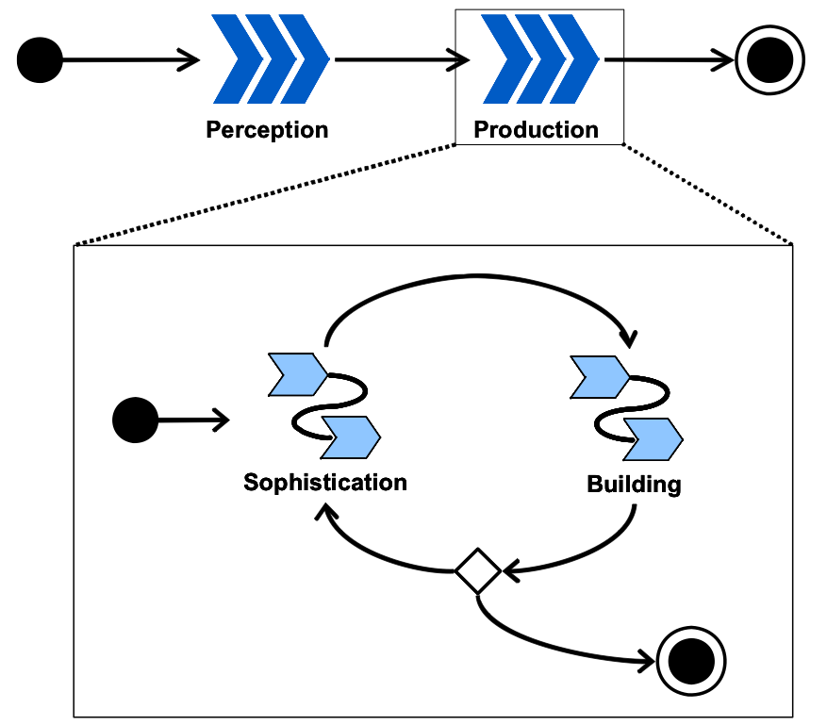

Figure 2: Process overview from (Wookjin, et al., 2005)

The process has two phases: Perception phase and Production phase as shown on Figure 2: Process overview (Wookjin, et al., 2005). The Perception phase is basically the initial phase of analysis activities. The Production phase is composed of both design and implementation activities in an Agile-style, making the basic unit of development cycle. (Wookjin, et al., 2005).

Following the outline of the process introduced in (Wookjin, et al., 2005), its adaptation to this project will be the following: the Perception Phase of this development involved defining the problem statements as there is no actual “client” to explain it. The initial requirements will be derived from this early problem definition, based on the literature review and aims of this project. A conceptual model will be drawn from the initial requirements. From that, an initial architecture will be designed using UML tools, to provide easy understanding of the software, and quality documentation. A visual vocabulary will also be used to produce website specific documentation such as site maps. Such vocabulary is increasingly common in web development documentation as it is very simple and easily understood by both clients and developers or designers. The other advantage of its simplicity is the fact it does not require any software and can be used on a whiteboard to discuss and specify the requirements with the client. (Garrett, 2011)

As stated above, Green-sight will be built using Agile methods through several iterations of development cycle. The “Perception phase” discussed earlier will be carried out first, and each module of Green-sight has been added incrementally. The entire development will be split into small development cycles, ended by testing sessions, making it adaptable to requirement evolution, coming from testing feedback. Consequently development process shall take the advantages of a model-driven approach and a test-driven approach simultaneously, following (Wookjin, et al., 2005) recommendations.

## Evaluation & Testing Methodologies

*“Usability: the extent to which a product can be used by specified users to achieve specified goals with effectiveness, efficiency and satisfaction in a specified context of use.”* (Bevan, 2006)

As discussed above, working in interaction with the users is one of Agile’s core principles. To make sure the application is well designed and fit for purpose; User-Centered Design (UCD) methods have been developed. Questionnaires, interviews and usability testing are some of them, and will be applied to this project. The most important and successful UCD method in the design of software is usability testing. It is now a common component of Software Design (Wusteman, 2009, p. 215), and not just for the importance of error finding (Ian Sommerville, 2004) and will be used in the development of this project. The literature review revealed that several approaches have been recognised, the most popular consist in asking the user to think out loud while he is performing specific tasks, or asking him his impression when he is finished (Britton & Doake, 2005).

*“A simple test early – while you still have time to use what you learn from it is almost always more valuable than a sophisticated test later”* (Krug, 2005)

The importance of including testing in the development lifecycle from the beginning is well recognised by literature; however, there doesn’t seem to be any best practice defined (Ambler, 2010). One school of thoughts tend to say that three to four testers is enough to reveal most of the major problems of a system (Krug, 2005). This acknowledgment suits the project’s needs, and constraints. Testing is not restricted to usability testing and troubleshooting. As explained above it holds a crucial part in development as it enables the developers to make sure the software they are building is fit for purpose.

User satisfaction is a main objective, otherwise there is no point providing a system. Several Models have been designed to do so. Among them the Technology Acceptance Model (TAM & TAM2) (Davis, 1989) (Venkatesh & Davis, 2000) and the DeLone and McLean Model of Information Systems Success also known as UIS (DeLone & McLean, 2003). In a context similar to this project, (Smart, Armstrong, & Vanclay) explain that TAM might not be adapted to the evaluation of Carbon calculators. They argument is based on the ability of the end users. TAM promotes the design of systems that can appeal to all users, even those that might not be attracted to IT, or those that believe IT is not adapted to their needs, or requirements. In their evaluation, (Smart, Armstrong, & Vanclay) explain that a carbon calculator user does not fit in this case. They are able and willing to use the system and therefore, there is no point applying it to a carbon calculator to evaluate it. This analysis and statement on the attitude of the end-user is arguable. The Perceived Usefulness (PU), and Perceived Ease of Use (PEU) have been proved to be key factors in the adoption of ICT, in almost any context (Yousafzai, Foxall, & Pallister, 2007), (Greenfield & Rohde, 2009, p. 9), (Hanson, 2010, p. 8), (Venkatesh & Davis, 2000). Keeping that in mind, the choice made by (Smart, Armstrong, & Vanclay) is sound, and for this project, their approach of measurement of User Satisfaction will provide an interesting basis. However, one of the objectives being to design a motivational system, it is important to make sure the system is easily adopted by its end users, and also attractive. The PU introduced by TAM can still be of use as a guideline, and measurement unit, to judge the “extent to which a person believes that using the system will enhance his or her job performance” (Venkatesh & Davis, 2000) as well as the PEU can be to indicate the “extent to which a person believes that using the system will be free of effort” (Venkatesh & Davis, 2000).

Unlike for many other carbon calculator projects (Padgett, Steinemann, Clarke, & Vandenbergh, 2008) (Bottrill, 2007) (Garg & Dornfeld, 2008), testing the accuracy of the results is out of scope in this case. The data coming from AMEE won’t be evaluated for this project. The reputation of AMEE has been firmly established, and this platform is used by governmental agencies, which also feed the data that is used in this project. Among the various sources available, two were selected for this project. The prototype will make use of the Energy Star Qualified products (ENERGY STAR, 2011) data, for product comparison, and the Market Transformation Programme (MTP) from Defra (Defra, 2011). Both are governmental bodies and some of their data is available in the AMEE database. This is why the accuracy of their results will not be questioned, as the task would be too big within the time constraints of the project.

The testing and evaluation of the prototype should be conducted on a regular basis, and should start with potential end-users as soon as the prototype is sophisticated enough, and when users are available. Industry standard would be every 3 or 4 weeks, which is the approximate length of the entire development life cycle, meaning this schedule is going to be shortened. Software testing should involve no more than 4 testers for each session. In the absence of testers, the developer and supervisor of the dissertation could provide an alternative by quickly assessing the prototype on a regular basis.

## Data Collection

Due to the absence of “real” client in the context of this project, the developer will conduct the evaluation of the software by conducting an audit in Edinburgh Napier University School of Computing, and the Institute for Informatics and Digital Innovation (Edinburgh Napier University, 2011). Computer Labs and Staff offices will be used as test cases for the audit. When the audit is finished and the results processed, they will be presented to potential users from the target audience, working in the school of computing. Their evaluation of the results will partly assess the usefulness of the reports and results produced prototype. This should point out issues and requirements that will constitute the next phases of development in accordance with Aglie’s principles.

## Conclusion of the methodology chapter

As discussed in the literature review, ICT use has increased exponentially. Information Systems are everywhere, and many of them are web-based applications. The recent turn toward cloud computing will surely increase the number of these systems, and will likely push toward rapid development, as discussed earlier. Making sure that they are well designed and fit for purpose is crucial in such context. The methodology chapter introduced development, testing, and evaluation methodologies that bring the clients need into the project to ensure that the system delivered is fit for purpose. The advantages of iterative methodologies derived from Agile have been discussed, and the importance of producing solid documentation and modelling of the software, to communicate efficiently with the all the parties involved in the development of a project.

Ways to test and evaluate the prototype have also been discussed, again the central role of the client have been stressed as a key factor of success as his constant contribution from the start is recognised to make a difference. As discussed earlier, in the context of this project no client will be available; however, regular evaluation and testing of the prototype will be conducted by both the author and the supervisor of the dissertation. Finally this chapter introduces the way the prototype will be evaluated at the end of the implementation phase, by conducting an audit in a real organisation, and evaluating its success with “real” users.

# Analysis and Design

The literature, and software review has introduced some recommendation and guidelines derived from previous studies, reviews and analysis of carbon calculators. The recommendations provided were be used as a basis, with an existing software review to determine the features and “MoSCoW” of the prototype. As said earlier, the development started as early as week 4 with a basic MoSCoW, following an Agile methodology. The requirements were refined with every development cycles as the findings, of testing and research revealed needs and issues, enabling the sophistication of the software. This fourth section of the present paper structures the requirement analysis, features definition, as well as the platform review.

## System requirement Analysis

### Existing software review

To be able to determine the needs and functionality of the software, existing solution were researched and reviewed. The literature review introduced some interesting insights and recommendations but also revealed that they were very few products addressing the needs of an organisation willing to measure the carbon footprints of their computing equipment.

The review was limited by the time constraints of the project; a proper comprehensive analysis would have taken too long to allow time to develop. As a consequence, a high level comparison of a selection of various solutions was conducted, in order to observe trends, such as usability, generic features and quality of the output. This contributed to clarify the needs and to have a baseline for evaluation.

The literature review, introduced existing solution review and evaluation methodologies (Bottrill, 2007), (Smart, Armstrong, & Vanclay, 2007), and (Padgett, Steinemann, Clarke, & Vandenbergh, 2008). But only one article mentioned an existing solution for schools and universities, “the Campus Carbon Calculator provided by Clean Air-Cool Planet, a non-profit group based in Portsmouth, New Hampshire.” (Mascarelli, 2009). However, this solution is hardly comparable to the other as it consists in an Excel spread sheet, designed for US IHEs. (Clean Air - Cool Planet, 2011). Although it is really powerful, it is also highly complex and requires a lot of data to be gathered prior to the use of the calculator. Furthermore, this solution aims at calculating the global footprint; and does not provide any ways of getting the footprint of computing equipment. Compatibility issues were also observed during the testing between versions of Excel.

Catherine Bottrill’s review of 23 carbon calculators (Bottrill, 2007) is the only one that includes calculators from the UK. Her review is focused on personal calculators rather than organisation auditing tools, but it provides useful recommendations that can be applied to various aspects of the project. Indeed, she identifies factors that contribute to the success of carbon calculators such as:

* Support user through the process of learning, understanding and taking actions
* Give the ability to quantify and monitor carbon emissions
* Connect with others to share data, information and ideas
* Must be interactive, effective tools
* Should have different level of sophistication
* Interface and architecture of the calculator to provide both easy navigation and access to in depth information on demand.
* Presentation and usability should be of high quality as it affects the user experience
* Communicate information more visually and graphically rather than relying heavily on text and numeric presentations
* Designed to have flexibility
* Give users accurate and effective carbon results and feedback
* Information input into calculators should incorporate behavioural aspects of energy use.
* Calculators need to be designed to enable users to regularly input data, to develop a much more accurate sense of their carbon emissions.
* Interprets the users’ carbon results and gives guidance.
* Calculators need to get the balance between communicating to users their full carbon emission impact and still motivating them to change their emissions.
* Carbon impact figures should be presented in the context of other carbon profile results.
* Take advantage of social networking tools for engaging people in personal carbon.

Some of her findings were confirmed in other studies, such as (Smart, Armstrong, & Vanclay, 2007) evaluation of a carbon calculator. Their findings point out that the “user satisfaction with a web-based system is not dependent on its usefulness”. In the context of their study the perceived ease-of-use (Davis, 1989) (DeLone & McLean, 2003) and overall presentation was a more important factor for the end user.

In their review (Padgett, Steinemann, Clarke, & Vandenbergh, 2008) stress the lack of transparency of most carbon calculators. This conclusion is closely akin to Bottrill’s. They all concerned about the lack of information that could explain the variations between the results provided by the various products tested. They all recommend that at least the conversion factor and calculation methods must be available for the user. Information must be made transparent to help the user to understand the figures and act upon the results.

Following the summary of the existing software review found in the literature review a brief high-level analysis of current successful carbon calculator platform was conducted.

The British website [www.thecarbonaccount.com](http://www.thecarbonaccount.com) (Torchbox Ltd, 2011) brings powerful tools to monitor personal carbon emissions. It makes use of web 2.0, social networks, and displays information graphically and helps the users at all time, with unobtrusive help and tips. Generally the interactivity with the user is very interesting, and useful. However, this is not suitable for anything else than personal carbon footprinting and monitoring, and it provides little information on the basis of the results, the conversion factors used, or the source of their generic values.

This high level analysis of existing solution pointed out more issues and recommendations that could possibly be address by a prototype within the time constraints. This is why a MoSCoW had to be derived from the results of the review.

### Mission statement

Part of the requirement analysis consisted in defining a mission statement to guide the development and contributing to provide a definition of the scope of the project, helping decision-making.

*“Greensight is a web based auditing tool that helps quickly calculating the carbon footprint of all the computing equipment of your organisation, and help you take steps to reduce it”.*

The mission statement was intentionally very simple and clear. It informs on the global aims and objectives of the project, rather than goes into details.

## Features Definition

To start the development early while keeping the project in scope, a MoSCoW was produced as suggested in PRINCE 2 (Office of Government Commerce, 2009, p. 43) as a “prioritisation technique” and was refined as the project was progressing.

### Functionality

The MoSCoW was mainly derived from the findings of the literature review and the review of existing solutions, the development being features driven, the main focus was to develop the maximum functionality with the time constraints, to provide a solid proof of concept.

**MUST HAVE**

*The prototype must:*

* Ability to use data from the AMEE database, at least generic values from computers
* Give the ability to quantify carbon emissions using reliable average values
* Have several profiles in an Audit
* Display footprint for each profile, and for the overall audit
* Register and login users
* Be able to save the audit online for the logged in user
* Be able to show a custom report for each audit
* Display the information both graphically and numerically
* Sort by product type categories
* Be able to print the content of an audit
* Be able to export the content of an audit to XML

SHOULD HAVE

*The prototype should:*

* Make use of eco-friendly design and development practices (using HTML 5, limit exchanges, light webpages, optimized transfers etc.)
* Be attractive to influence the perceived ease-of-use and usefulness.
* Have contextual help
* Be able to compare audits
* Should be flexible, with a basic, simple view and a detailed one
* Use filters to show only parts of the results
* Sort by role categories
* Cross-browsers compatibility (at least back to IE8)
* Give the ability to quantify carbon emissions incorporating behavioural aspects of energy use (time use)

COULD HAVE

*The prototype could:*

* Be able to export the content of an audit to XLS
* Be able to monitor changes and trends
* Give the ability to quantify carbon emissions incorporating behavioural aspects of energy use (load)
* Interprets the users’ carbon results and gives guidance.
* Display the results in context of other results or average values.

**WOULD HAVE**

*A next version of the prototype would:*

* High security login and exchanges
* Take advantage of social networking tools
* Monitoring changes over time, other than the comparison function.
* Several data source input (measurement hardware, desktop clients or any other source)
* Import data, from past audits, or other source such as spreadsheets etc.
* Mobile version of the interface (for tablets, and post PC devices)
* Make use of more up to date data from Energy Star (AMEE database is not up to date with the latest products)
* Be a hub of information, to facilitate learning and sharing of information on Green Computing initiatives and progress

Although this list is not exhaustive, is constituted a basis for the rest of the initial requirement to be conducted. Modelling using UML tools was used to support the development and provide documentation, as discussed earlier.

In addition to the MoSCoW, a couple of high-level use cases were written to specify the functional requirements and refine the development guidelines.

Table 3: High-level Use cases

|  |  |
| --- | --- |
| Use Case: | VISIT WEBSITE |
| Goal in Context: | Visitor visits the website, looking for information |
| Actors: | Visitor |
| Description: | When a visitor visits the website they are looking for information, and they want to find quickly, if they don’t they might leave the website very quickly. |

|  |  |
| --- | --- |
| Use Case: | CALCULATE A CARBON FOOTPRINT |
| Goal in Context: | VISITOR TRIES THE CALCULATOR |
| Actors: | Visitor |
| Description: | User is offered to load an audit saved in cache if it exist or to create a new one.  Visitor discovers the drill down process, assisted by tooltips. Selections are appended to a table.  The visitor can create a full audit, generate and print a report with no more requirements. |

|  |  |
| --- | --- |
| Use Case: | SHOW REPORT |
| Goal in Context: | Visitor request a report of his audit |
| Actors: | Visitor |
| Description: | Visitor wants more than the numerical view of this audit, and click on the show report button. The audit is saved in cache, and a report is displayed. The report is made of charts and table, and can be printed or exported. |

|  |  |
| --- | --- |
| Use Case: | REGISTER |
| Goal in Context: | Visitor decides to create an account to have more features |
| Actors: | Visitor |
| Description: | Visitor completes the signup form and agrees to the informed consent form. On success the system automatically logs in the user. |

|  |  |
| --- | --- |
| Use Case: | LOG IN |
| Goal in Context: | User wants to log in to access extra features and saved audits |
| Actors: | User |
| Description: | User logs in using his email and password. |

|  |  |
| --- | --- |
| Use Case: | SAVE AUDIT |
| Goal in Context: | User wants to save an audit for later use |
| Actors: | User |
| Description: | User is requested to enter a description. The audit is saved with a unique ID, the description and a time stamp.  The newly saved audit is appended to a table listing all the saved audits. |

|  |  |
| --- | --- |
| Use Case: | DELETE AUDIT |
| Goal in Context: | User (or Visitor) wants to delete an audit |
| Actors: | User, Visitor |
| Description: | User clicks the “DEL” button corresponding to the desired audit. On conformation, the audit is deleted |

|  |  |
| --- | --- |
| Use Case: | EXPORT AUDIT TO XML |
| Goal in Context: | User wants to export an audit to XML |
| Actors: | User |
| Description: | User clicks the “Export to XML” button, a dialog offers the possibility to download or open the document in the browser. |

|  |  |
| --- | --- |
| Use Case: | COMPARE AUDITS |
| Goal in Context: | User wants to compare two audits |
| Actors: | User |
| Description: | User loads two saved audits. The audits are displayed in tables and a chart with two series renders the content of the tables for easier reading. |

Activity Diagrams were designed to model the website structure and functions. Refined versions can be found in the result chapters, in Figure 6 & Figure 8, page 66. The structure of the website in Figure 7, page 67, was also modelled at the beginning of the development.

### Usability and User Experience

“Usability: the extent to which a product can be used by specified users to achieve specified goals with effectiveness, efficiency and satisfaction in a specified context of use.” (Bevan, 2006)

Recent research has shown the benefits from user-centered design (UCD) (Wusteman, 2009, p. 215). This approach identifies end users as a central actor in the design process. Many user-centered design methods exist such as questionnaires, interviews, participatory design and usability testing. The arguably the most important and successful UCD method in the design of software is usability testing. It is now a common component of software design. However, in the context of this project, conducting usability testing on a regular basis is not possible, because of the time constraints, and absence of a “real” client. As a consequence, a theoretical evaluation will be conducted, and if possible, tests with potential end users.

The target audience of this software does not fit in a single category; indeed, there is a wide range of possibilities. To start with, and keep the project in scope, an end users corresponding to an academic that can be in the 40s or older was chosen as a potential user. The reason of this choice is that it implies some special requirements of usability and accessibility that should be part of the development from the start. These requirements, such as font-size, contrast etc. do not negatively affect a younger user, but not taking them into account could hamper the use of the website by older users.

The readability, and clarity of the website should be considered of great importance, as they influence the end-user perception and will to use the software (Davis, 1989), (Venkatesh & Davis, 2000), (DeLone & McLean, 2003) and (Bottrill, 2007) (Shneiderman, Plaisant, Cohen, & Jacobs, 2009, p. 49). However, in the case of this project the need to over-simplify the software is not a requirement as the end-users are not new to computing environment, but on the contrary is looking for advanced, specific features and clear and valuable information. Many formal and informal frameworks exists to help designing fit-for –purpose user interfaces. From the extremelly detailed specification documents produced by major software corporations such as (Microsoft Corportation, 2010), to smaller, high level guidelines such as the NCIB (Smith & Mosier, 2004) or Nielsen’s “10 Usability Heuristics” (Nielson, 2005). To be able to focus on the main goal of this project, only guidelines where used to influence the decisions reguarding the usability of the interface.

## Platform Review

### Data source

As discussed earlier, choice of AMEE was done to be able to get reliable values from Governmental organisations in a short time. The accuracy and transparency of the values is often criticised in the various software review that were found. Using AMEE enabled to focus on the development of the platform rather than the validation of the results. This platform is used by governmental organisations all around the world and a team of professional scientists validates the data made available. AMEE provides various services, most of them are not free of charge, but the database access is free.

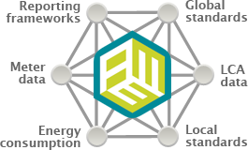

Figure 3: AMEE Aggregate Content. From (AMEE UK Ltd., 2011)

In the context of this project this is enough to get reliable data (kWh) to perform calculations. The data is gathered by performing a “drill down” to find the required product or a generic value for a product type. Among the available data category two sources were used: the Energy Star dataset (ENERGY STAR, 2011) and the Market Transformation Programme dataset from Defra (Defra, 2011). Energy Star data provides data of products that have achieved the Energy Star qualification. Today’s computer are almost always designed to get this label, which is recognised everywhere in the world. MTP is a similar organisation from the UK government. The data they provide consists in generic values for computing equipment, unlike Energy Star; they give some information concerning the basis of their average. When Energy Star uses Categories from A to D, corresponding to kWh, MTP provides stock average kWh for a specified number of hours (see Table 4 & Table 5).

Table 4: Energy Star Categories

|  |  |  |  |
| --- | --- | --- | --- |
| Desktops & similar | kWh/Year | Laptops & similar | kWh/Year |
| Category A | <= 148.0 kWh | **Category A** | <= 40.0 kWh |
| Category B | <= 175.0 kWh | **Category B** | <= 53.0 kWh |
| Category C | <= 209.0 kWh | **Category C** | <= 88.5 kWh |
| Category D | <= 234.0 kWh |  | |

Table 5: MTP Average scale of use

|  |  |
| --- | --- |
| Type | Hours/day |
| **Desktops & similar** | 6.257 hours/day |
| **Laptops & similar** | 2 hours/day |
| **Other** | 5.5 hours/day or stated if different |

The availability of the time factor to obtain kWh means that figures from the MTP dataset could be reverse engineered, to get kWh for any amount of time. This allowed the prompt the user to enter a specific use of their equipment, based on the number of weeks, days per week, and hours on, off and on standby to produce a dynamic estimation of their energy use, and thus of the corresponding carbon footprint. The MTP dataset provided a set of factors to evaluate the contribution due to standby. The factor is applied to the annual stock averaged value. This option was made available to all the equipment that could not use the custom time use (see Table 6).

Table 6: MTP on standby factors

|  |  |
| --- | --- |
| On Standby | Factor |
| Never | -0.05 |
| Sometimes | 0 |
| Mostly | 0.05 |
| Always | 0.08 |

However, as no official factors were available to calculate the impact of switching, off or putting the computer on standby when calculating the power usage for a specific time use; indicative factor were used to show the impact of behavioural use, and the positive impact of shutting down and putting on standby a computer that is not used. In a future version of the system, they should be validated from a testing protocol, or generated from a client running on a computer. Such investigation was out of the scope of this project; this is why it was not conducted.

The Energy Star dataset was kept for the static estimation, as they might interest some users who want a quick estimation of their computing equipment based on a standard use. This enabled the prototype to fulfil the recommendation to have “different level of sophistication” stated in Bottrill’s report (Bottrill, 2007).

### Server-side scripting language & host

The platform will be composed of Apache (The Apache Software Foundation, 2011), MySQL (Oracle, 2011) & PHP (The PHP Group, 2011). When running on Linux, they form a standard package well known as LAMP Server, which is also available under Windows as WAMP, or Mac OS as MAMP. The great advantage of such web server is that it is very easy to setup and can run on any hardware. It can also be very secure, and has become the most powerful web-hosting platform because it is open source and well documented.

The web server could run inside a virtual machine. The benefits of virtualization have already been discussed earlier in this paper, regarding the energy efficiency, but it also has a great advantage of flexibility when the system must be setup. The virtual machine can be copied to a server and run almost instantly with is no further configuration, since it has been done previously. It also eases recovery process in case of crash.

During the development the website was hosted locally on the main computer of the developer running Mac OS X. As it comes with a pre-installed Apache and PHP server, only MySQL standard package had to be installed. However, during the testing and evaluation of the software, another computer running a LAMP server was setup to host the website, since a Wi-Fi connection was not available in all the rooms and labs where the audits had to be conducted. The website was also tested on a WAMP server running in a VMware virtual machine.

The choice of PHP was done quite quickly early in the project. AMEE offers three official APIs, written in Java, Ruby and PHP, plus another not yet supported written in Python. Since the prototype was to be web based the most flexible solution was to use the PHP API. It allowed easy web hosting, and yet is powerful enough to quickly perform all the required computations. Furthermore, most of the processes are not done on the server-side, the server scripts are only used to call the API, retrieve data from AMEE and send it back to the client, which performs most of the computations.

### Client-side scripting language & standards

The client-side language is very important part and the choice of a Framework or language can make a big difference. Many options are available nowadays and all have pros and cons. A couple of Frameworks were considered such as Flex, and ASP .NET, but eventually JavaScript was chosen, for it is compatible with every browsers and ensure compatibility with more browsers than the Frameworks mentioned above, and was more suitable for the rapid, feature driven development required for this project. ASP .NET for instance would have implied learning the Razor syntax are based on C#, and the benefits for the prototype would not have been obvious. Flex would have been suitable for it has powerful graphics tools and built-in plotting functionalities, required for the report, however, it requires Flash to be installed on the browser, and that reduces considerably compatibility. Flash is not installed by default with web-browsers apart from Chrome, which means that the user may have to install it. It is not always possible on some office computers, and is not possible on many mobile platforms, such as iOS mobile tablets. This is why JavaScript and HTML5 were chosen. One of their big advantage is that they are both free, and built-in all recent browsers.

JavaScript, the client-side scripting language is the one that performs most of the computations. This choice was done to relieve the server from heavy load, indeed, if the server treats most of the process, it could get loaded quite fast when many users are connected and requesting pages and calculations, which can lead to crashes. When the role of the PHP server is only limited to serving pages and returning minimal objects to the client, the server can perform faster, and is less likely to crash. On the client side, the JavaScript can perform most of the process without loading heavily the computer. All it requires is a good JavaScript engine, and today’s browsers are focussed on the JavaScript optimisation, enabling unobtrusive and efficient use of it. The other advantage of using JavaScript is that it can perform manipulations on the DOM, without requesting a page load. This was used extensively along with Asynchronous JavaScript and XML (AJAX) and JavaScript Object Notation (JSON) to minimise the exchange with the server. This enables a high interactivity between the user and the webpage, without delays and wait, as well as it contributes to reduce the impact of browsing the web page, and using the website functions. This approach has become a standard in the last years and contributes to reduce the carbon footprint of web services (Wusteman, 2009).

In addition to AJAX, JSON was chosen over XML to transfer and store data as it lighter and faster than XML, since it has fewer tags. Also most browsers have native management of JSON, meaning they are processed quicker than XML. HMTL5 was also used to minimize the exchanges between client and server. However, the ability to export to XML was offered to the end user.

Audits are temporarily saved in a cache file using a function called “localStorage” that was introduced in HTML5. Thanks to this, there is no need to load audits from the database every time a page is loaded, or to save it back before showing the report. This is very efficient and a convenient, but implies that the browser must be able to handle HTML5. Internet Explorer does since version 8, Firefox since version 3.5, Safari since version 4, and Chrome since version 4, cf. Table 15: Browser compatibility list page 107. Today all browsers support this function and HTML5 is increasingly becoming a standard for all websites.

To be able to take a feature driven development approach and provide a sophisticated prototype within the time constraints, a JavaScript library (jQuery) was used. jQuery is an open source project that allows faster development by simplifying the “HTML document traversing, event handling, animating, and Ajax interactions” (The jQuery Project, 2010). The jQuery project also opens the door to thousands of open source plugins that facilitate rapid development. The entire client code was written in jQuery, and a couple of plugins where used to animate, validate, plot and improve the user experience, see Table 7 for details. The time saved from using the jQuery library and plugins gave more time to focus on other issues, and develop a richer, more interactive an functional web-application.

Table 7: jQuery Plugins used

|  |  |  |
| --- | --- | --- |
| jQuery Plugin | URL | Use |
| jQuery UI | www.jqueryui.com | Interface effects and interactivity |
| jQuery Validate | www.bassistance.de | Validate forms and inputs |
| jQuery Tooltip | www.bassistance.de | Provide unobtrusive tooltips |
| jqPlot | www.jqplot.com | Create dynamic charts |
| jQuery MSG | www.dreamerslab.com | Create dynamic, unobtrusive dialog boxes |
| jQuery Center | www.dreamerslab.com | Center an element of the DOM |
| jQuery Cookie | github.com/carhartl | Manage Cookies |
| jQuery Select box | www.texotela.co.uk | Populate & manage select boxes |
| jQuery Numeric | www.texotela.co.uk | Input validation |
| jQuery JSON2XML | www.michalkorecki.com | Parse and convert JSON object to XML |
| jQuery dateFormat | github.com/phstc/ | Format date |
| jQuery replaceText | www.benalman.com | Find a replace text |

One of the biggest advantages of jQuery is that it is designed to be cross browser compatible. This ensures the well behaviour and usability of the web-app on a very large number of platforms, while taking advantage of the various optimisation and specific features they provide, without any effort from the user, unlike some other Frameworks, as discussed previously.

## Conclusion of the analysis and design chapter

In this chapter, system requirements have been discussed and specified based on quality literature review and evaluation of current products, a MoSCoW has been produced, and initial features requirements have been defined. Usability concerns have been stressed, notably the importance of perceived ease of use and perceived usefulness. The choice of platform for the development has also been discussed and information regarding the scripting languages, libraries and plugin used have been provided and explained in details.

The desire to develop this web-app in an environmentally friendly manner has been expressed and ways to tend to it have been discussed. More on this will be revealed in the next chapter, where the results are presented.

# Results

Based on findings of the literature review and on the requirements produced in the analysis and design chapter, a prototype was developed and tested in Edinburgh Napier School of Computing. This fifth section of this dissertation presents the results of the development and evaluation of the prototype auditing tool produced.

## Prototype Development

This chapter presents the different stages of the development, in relation with the requirements developed and discussed previously in chapter 4. The documentation produced during the development is also presented and explained in details. Eventually, the documentation created for the end user is also introduced and presented.

### Development stages

The prototype was developed in four weeks, equivalent to about 180 hours. As stated in the development methodology chapter, each week corresponded to development iteration, concluded by a version of the prototype. Each version of the prototype was evaluated before being presented to the supervisor of this project and his remarks and comments were used as feedback from a potential user. The development of the next iteration always started by fixing the software in accordance with the negative feedback received, or by developing based on the positive feedback (suggestions, or requests).

Unfortunately no proper testing was conducted during the development with external users or potential testers. Usability testing was considered but the impossibility to get a reasonable number of valuable users would have limited the quality of the feedback provided.

Table 8 introduces a high level view of the iterations content. For more details please refer to the detailed project plan in the appendix, page 159.

Table 8: High level view of the four development iterations

|  |  |  |  |
| --- | --- | --- | --- |
| Iteration | Iteration Content | MoSCoW status | Hours |
| 1 | Setting up the server  Understanding AMEE API  Performing the Drilldown  Obtaining Carbon figures  Initial design of the interface  Initial Database design | MUST | > 35 hours |
| 2 | Improvements  UI Design  Numeric and Graphic presentation of the figures  Compare audits  Initial export and print options | MUST | > 45 hours |
| 3 | Improvements,  Contextual help and information  Custom Defra conversion factor  MTP on standby factor | SHOULD | > 50 hours |
| 4 | Improvements  Custom time use  Optimization, bug fixes | SHOULD | > 50 hours |

This high level view shows that all the “must have” and most of the “should have” of the software were implemented in time for the evaluation. The development stopped before all the desired features were implemented, to give priority to the evaluation, this is why the “could have” and “would have” were not started. The lasts hours of development were mainly spent consolidating and increasing the stability of the software, as well as the compatibility with different web-browsers.

### Development documentation

During and after the development documentation was produced to clarify and model the software functions. This documentation was done using UML standards and Garrett Visual Vocabulary (Garrett, 2011).

The class diagram in Figure 4 shows the two tables of the database, and the JSON objects stored in the table. This approach was designed to minimise the calls from the client to the database. When a user wants to load an audit, the audit is saved in the cache of the web-browser using an HTML5 function called “localStorage” (W3C, 2011), thanks to this all the reporting, and modifications performed are performed at the client side, in the cache, with no exchange between the server and the client. When finished, the user can save a new, or an updated audit back to the database, or just leave it in cache. HTML5 localStorage will not expire unless requested by the user.



Figure 4: Database & storage structure

Using a class diagram to represent a database schema is not new. Oracle’s JDeveloper works by creating a logical model using a UML class diagram and transforming it to a physical model. (Oracle, 2011)

Figure 4 is a class diagram representing both database structure and storage structure, to provide a comprehensive view of what is stored in the system and how.



Figure 5: Drill-down sequence

The sequence diagram in Figure 5 designed using Garrett Visual Vocabulary (Garrett, 2011) documents the drill down process to get a Device profile object, containing the data described in Figure 4. It is also refered to in Figure 8.

The use of AMEE API is visually displayed with a red frame, to explain the how it was used an extended to provide more detailled information, when possible.

Three types of devices in the computing equipment from the MTP (Defra, 2011) dataset were documented enough (see Table 5, page 55) to allow reverse engineering the kWh per year figure returned by AMEE databse. Based on the input of weeks used per year, days used per weeks and hours on, off and on standby, a new, custom kWh per year figure is calculated.

Since AMEE API only returns CO2 figures with a minium information on the profile itself, the script was extended to perform another request based on the profile UID returned from the API. This request gets all the details of the device profile. The object returned by this request has much more information than the default object returned from the API, it includes the source, date of creation and modification, and kWh per Year as part of other informations.

Based on the new data, a new custom object is created, this enabled the customisation shown in Figure 5. The benefits are noteworthy:

* Overal gain of flexibility
* Ability to use the latest conversion factors from Defra (Defra, 2011), and possibility to add new factors such as factors provided by the supplier.
* Ability to use the standby factors from the MTB dataset (Table 6 p. 55) on all equipment.
* Ability to input a location
* Ability to input a role
* Ability to calculate time use of an equipment (when kWh per year can be reverse engineered)
* Ability to use another source that AMEE

Indeed since the object is now specific to the system, it can be customised and a future version of the system could make use of different sources of data. This opens the system to a wide number of possibilities.

Using this visual vocabulary enables to simply model the process in a way that is understandable by all auidences, from clients or end-users, to developpers.

Several Diagrams such as the ones in Figure 5, Figure 6 & Figure 8 were split into different diagrams to ease their reading and understanding.



Figure 6: Webpages activity diagram

Figure 6 shows the behaviour of the web page when a user accesses them. The activity diagram is not the most appropriate to document a web site structure, that’s why a proper structure was designed using Garrett Visual Vocabulary (Garrett, 2011) (See Figure 7, page 67). However, this activity diagram shows the actions relative to the status of a user. The behaviour depends on it. If a user is not logged in, he won’t be able to access certain pages, or will have to login on the page. The opposite also exist the page to register will not be accessible to a user who is logged in.

Figure 7 shows all the web pages and the relations between them. Note the dotted line represents a conditional connector; in this case, they are accompanied with a legend. Depending on the login, some pages are available and some are not.



Figure 7: Website structure

Figure 8is the continuation of Figure 6. It shows the behaviour of the calculator and its functions. The “Get Device profile” process is the one described in Figure 5, now in context.

Figure 8: Carbon calculator webpage activity diagram



## User Documentation

### Introduction

In order to give assistance to people using the system, a user guide, or manual was written. Note that the following user manual is not presented in a final production form. This is a prototype version that should be evaluated just like the prototype before going into production.

A screencast should also be shot in present the web service in less than 2 minutes. Such introductory video has become a standard on the web and is very valuable to the user and contributes to the success of the website.

### User manual

See appendix 8.1 User Manual, page 106.

|  |  |
| --- | --- |
| **Abstract** | This guide describes how to use the Greensight Web Application, an auditing tool which allows calculating carbon footprint of computing equipment in an organization, and producing reports to help reducing their impact. |
| **Document Date** | 13 November 2011 |
| **Document Version** | 0.1 |

1. **Overview of the web application**
   1. Introduction
   2. System requirements
2. **Creating an account**
3. **Creating Audits**
   1. Adding a device profile
   2. Editing or Removing a device profile
   3. Saving an audit
   4. Exporting an Audit
4. **Creating reports**
   1. Using charts
   2. Printing reports
   3. Exporting reports
5. **Comparing reports**
   1. Creating comparison reports
   2. Printing reports
   3. Exporting reports
6. **Requesting assistance**

## Prototype Evaluation

In the context of this project, comparing the final version of the prototype to existing production tools such as personal carbon calculators was not considered a priority. In order to evaluate the prototype, an audit was conducted on the school of computing, and the research institute, as explained in the data collection chapter page 43.

### Auditing the School of Computing

The audit was conducted in Edinburgh Napier University School of Computing. The faculty is among the largest computing departments in the UK with more than 50 academics and 1000 students (Edinburgh Napier University, 2011). The audit also included the Institute for Informatics and Digital Innovation; which is located in the same building, at Merchiston Campus, 10 Colinton Road, Edinburgh. Together, they represent about 40 offices and over 70 staff members.

The audit was split in three phases. The computer labs where audited first to get feedback and be able to prepare the next two phases: the staff offices and server rooms. 36 staff offices were considered for this audit, this included both the School of Computing and the Institute for Informatics and Digital Innovation (Edinburgh Napier University, 2011). An issue log was made to track errors in the project, organize issues by type and severity in order to prioritise issues, to define the MoSCoW of the next iterations. This section describes the protocol used for the audit, and relates its development, before the outcomes are discussed.

##### Audit Context and Protocol

As explained earlier, the author of this dissertation conducted the audit, over a week. This section has been split in three to reflect the three groups of audit.

###### Labs

There are six “labs” in the Edinburgh Napier University School of Computing at Merchiston Campus: B56: a game lab, with both PCs and consoles; C6: a network and computer systems lab; C27: a large computer lab; C28: a networking lab; and two Mac labs in D35 and D36 multimedia and creative studies.

The labs have restricted access, students must request an authorization from the school office to be allowed to access them, or be part of a program that grant them access to the labs. It was a quick and easy process and did not cause any problems.

The IT assets of the rooms were input room by room in the web-app as separated audits. Table 9 lists the content of the rooms, their role and the estimate use of PCs, based on the timetable of the room. As certain labs such as C27 and C28 do not have Wi-Fi access, the website had to be put online. The opposite situation occurred in C6, where the computers are not connected online, but Wi-Fi is available.

Table 9: IT assets of the Labs

|  |  |  |  |
| --- | --- | --- | --- |
| Room | Role | Used equipment inside | Time use of PCs |
| B56 | Game Lab | 24 PCs HP Compaq dc7900 (USDT)  1 PC connected to  1 Plasma TV | Based on timetable  5 days/week, On 7h/day, Off 17h/day |
| C6 | Network Lab | 26 PCs RM Intel P4  25 testing microcomputers  5 Wi-Fi routers  1 server PC with switches | Based on timetable  5 days/week, On 4h/day, Off 19h/day, Standby 1h/day |
| C27 | Computer Lab | 51 PCs HP Compaq 8000 (USDT)  1 HP Laser Printer  Network Switches | Based on timetable  5 days/week, On 6h/day, Off 18h/day |
| C28 | Network Lab | 24 PCs Viglen Genie Intel i7  24 PCs RM Intel P4 without monitor  1 PC RM Intel P4  Network Switches | Based on timetable  4 days/week, On 4h/day, Off 20h/day |
| D35 | Multimedia Lab | 25 iMac 24” Core 2 Duo  25 Wacom pen tablets  25 USB sound cards | Based on timetable  5 days/week, On 4h/day, Off 18h/day,  Standby 2h/day |
| D36 | Multimedia Lab | 25 iMac 27” Core i5  3 Scanners | Based on timetable  5 days/week, On 5h/day, Off 16h/day,  Standby 3h/day |

Generic values were used for the power usage of the computers and other equipment. They were taken from the MTP (Defra, 2011) dataset, as this is the only data source available in the AMEE database that could be reverse engineered to be able to input the time use of the equipment, based on the timetable of each room, an average was calculated to estimate the use of the PCs, printers and monitors. No data was available to reverse engineer the kWh per year of other equipment than the three mentioned above, so the stock-average values provided by the MTP (Defra, 2011) were used instead.

Equipment that was not in available either in the MTP database or the Energy Star database was ignored, but their omission was stated in the description of the audit stored in the database.

###### Staff Offices

As explained earlier, 36 staff offices were considered for this audit, this included both the School of Computing and the Institute for Informatics and Digital Innovation (Edinburgh Napier University, 2011).

Auditing the staff rooms took about three days. The difficulty was to get in touch with the member of staff when they are available to ask them a couple of quick and simple questions in order to gather enough information to evaluate the use of their computing equipment.

The following questions were asked to all the staff members interviewed:

* What and how many computing equipment are used?
* How many weeks per year is the computing equipment used?
* How many days per week?
* How many hours it is on?
* How many hours is it on standby?
* How many hours is it off?

The questions were intentionally kept short in order to manage the audit of each room in a few minutes. No names or personal information were taken, or linked to the profiles in the audit. The only information kept in each profile is the location of the equipment. Brand, models and other details about the equipment were not kept in the audit of the staff rooms, since generic values are used, but mainly to reduce the time of the interview. More details were kept in the audit of the labs and server rooms, as more time was available to do them.

###### Server Rooms

Audits of the two server rooms were separated from the Labs where they are located. Indeed, although they are physically in the same rooms, they have a different role and their location has no other reason than space management reasons. Accessing the server rooms proved to be more difficult than the labs. These rooms are locked and are not supposed to be accessed by students at least unattended, for obvious reasons. A first visit was made with the supervisor of this project to get an idea of their content. Members of staff responsible for the equipment were contacted to gather details on their assets. Three people were contacted, to obtain as much information as possible.

Another visit was therefore scheduled with the supervisor to perform the audit in the server rooms, based on the information available.

##### Audit Results

The following section introduces the results of the audits. 6 Labs, 36 staff rooms, nearly 60 staff members (out of 72), and two server rooms were audited. Just as the section above, it has been split in three to reflect the three groups of audit. The reports produced by the prototype have been added to the appendix, chapter 8.2, from page 119. The report of the entire audit can be found page 119.

###### Labs

The audit of the Labs was done first, and revealed some issues in the software. But the main challenge was to determine the time use of the computing equipment, as discussed in the previous chapter. The audit suffered from the limitation of the data source. None of the dataset available in the AMEE database has any professional networking equipment. As a consequence, a large amount of the actual carbon footprint of the labs is absent of the audit. Switches and routers for instance could not be added in the audit. Cisco Wi-Fi routers were replaced by the equivalent domestic equipment when available.

Table 10 is a stripped down issue log produced during the audit of the computer labs. Among the issues listed, a couple of issues were solved to allow the audit to progress in the best conditions, some other were “bypassed”.

The absence of accurate information for instance about the time use of the computers, wasn’t really solved as it is not dependant on the auditor. To bypass the issue, assumptions had to be made, based on observation and common sense. This brought a crucial question though, as this solution is not a proper solution. Measuring time use is a crucial aspect of auditing an organisation. In order to get accurate data, other tools should be used to track time use. This aspect will be discussed later, and a simple framework should be proposed.

Table 10: Issue log of the audit of the Labs

|  |  |  |  |  |
| --- | --- | --- | --- | --- |
| Issue # | Issue Description & *Impact to Project* | Priority  (M/H/L) | Status | Resolution &  *Comments* |
| 1 | No Wi-Fi in some of the labs  *Delayed audit: the website was only hosted locally.* | High | Solved | The website was pout online.  *A CSS file should be created for mobile devices, which could use 3G when no Internet is available on site*. |
| 2 | Timetables are not always available / reliable. | Medium | Bypassed | Assumptions were made when no data could be found. *Further investigation should be conducted to validate the average.* |
| 3 | Input validation prevents inputting a computer that is never used.  *Development required* | Medium | Solved | Validation rules were changed, and algorithm refined to take into account computers that are not used. *A role “not used” should be added* |
| 4 | Equipment type is not in the database (neither generic or other) | High | Not solved | Absence is stated in the audit description  *No data was available for networking equipment, or games console for instance.* |
| 5 | Some roles are not in the list.  *Development advised* | Low | Not solved | *User should be able to set custom roles.* |
| 6 | Two bodies are responsible for the computers (C&IT / SoC)  *Development advised* | Low | Not solved | *User should be able to set the person / organisation responsible of the assets for later use.* |
| 7 | No way to keep comments /remarks other than in the audit description  *Development advised* | Medium | Not solved | *User should be able to add some comments to an audit. Such extra information can be valuable.* |
| 8 | Extension of issue #2. | Medium | Not solved | *Not all computers are used during classes, but some are left on after classes. Further investigation should be conducted to validate the average.* |
| 9 | No way to merge audits  *Development advised* | High | Solved | *A function to merge audits should be implemented for the final report.* |

An unexpected finding of the audit was that different parties manage the computer equipment in the School of Computing. The School of Computing technicians support some of the Labs, and others are supported by C&IT. The same is also true for networked printers. This complicated contacts with peoples responsible for their management. It also revealed that different policies were applied regarding the standby and shutdown of computers. These are listed in Table 11 & Table 12 they were taken in consideration when calculating the average use of computing equipment cf. Table 9.

Table 11: Power usage policy of PCs

|  |  |  |  |
| --- | --- | --- | --- |
| PCs in room | Standby after | Shutdown after | Supported by |
| C27, C28 & B56 Labs | Never | 40mn idle | SoC |
| C6 Lab | Never | 2h idle or at 9PM | SoC |
| D35, D36 Mac labs | 1h idle | 9PM | C&IT |

Table 12: Power usage policy of Networked Printers

|  |  |  |
| --- | --- | --- |
| Printers in room | Switched off | Supported by |
| C27 Lab | Never | SoC |
| All other rooms | Never | C&IT |

Apart from the networked printers that are never switched off the energy policies applied to the computers in the Labs are quite efficient. Some delays to standby or shutdown could be reduced, but overall, not much more could be done to reduce the energy consumption.

###### Staff Offices

Table 13: Staff rooms audited

|  |  |  |
| --- | --- | --- |
| Room | Staff members | Status |
| School Office | 7 | Done |
| C35 | 4+ | Done  *(4 assumptions)* |
| C36 | 2 | Done |
| C37 | 2 | Done |
| C38 | 2 | Done |
| C39 | 2 | 1 missing |
| C40 | 3 | Done |
| C41 | 2 | Done |
| C42 | 3 | Done |
| C43 | 3 | Done |
| C44 | 4 | Done  *(3 assumptions)* |
| C45 | 3 | Done |
| C46 | 4 | Done  *(3 assumptions)* |
| C47 | 1 | Done |
| C48 | 2 | Done |
| C49 | 2 | Done |
| C50 | 0 | Done |
| C51 | 5 | Done  *(3 assumptions)* |
| C53 | 1 | Done |
| C54 | 1 | Done |
| C55 | 2 | Done |
| C56 | 2 | Done |
| C58 | 1 | Done |
| C59 | 1 | Done |
| C60 | 2 | Done |
| C61 | 1 | Done |
| C62 | 2 | 1 missing |
| C63 | 1 | Done |
| C64 | 1 | Done |
| C65 | 2 | Done |
| C66 | 1 | Done |
| C67 | 1 | Done |
| C68 | 1 | Done |
| D58 | 1 | Done |
| D30 | 2 | Done |
| D31 | 2 | Done |

Auditing the staff rooms took about three days. The difficulty was to get in touch with the member of staff when they were available to ask them a couple of quick and simple questions in order to gather enough information to evaluate the use of their computing equipment.

Table 13 lists all the rooms that were audited, their status, and number of staff member using each room.

Although the audit could not take into account absolutely all the equipment used in the School of Computing, it revealed the weaknesses of the platform, allowing the draw new specifications for the next phases of development. It also revealed that the current prototype was able to handle almost two hundred profiles corresponding to more than two hundred different equipment. The port produced also pointed out that the energy policy regarding the computing equipment could be improved.

An issue log was also kept and has been included in Table 14.

Table 14: Issue log of the audit of the staff rooms

|  |  |  |  |  |
| --- | --- | --- | --- | --- |
| Issue # | Issue Description & *Impact to Project* | Priority  (M/H/L) | Status | Resolution &  *Comments* |
| 1 | Only one role can be selected. | Medium | Not solved | *Several roles should be selectable* |
| 2 | Description can only be edited when the profile has been returned from the server  *Usability issue* | Medium | Not solved | *Comments should be added during the input process. Extra field to store comments should be implemented* |
| 3 | Time use input format is restricted to weeks/year,  Days/week, hours on/off/standby  *Usability issue* | Medium | Not solved | *Some user consider the number of hours per week, rather than per day, several options should be available* |
| 4 | Standby time is treated separately from time on  *Usability issue* | Medium | Not solved | *Many users consider time on standby as part of the time on. This option should be considered* |
| 5 | Lack of peripherals and devices available in the dataset  *Absence of some equipment* | High | Not solved | *A small number of peripherals such as speakers, phone, card readers etc. had to be ignored. Other data source should be available* |
| 6 | No way to reorganise the rows in the audit  *Usability issue* | Low | Not solved | *User should be able to reorganise the list as desired* |
| 7 | No way to group profiles  *Usability issue*  *Development advised* | High | Not solved | *User should be able to group profiles that correspond to a set. E.g.: A Desktop & Monitor(s).* |
| 8 | No way to compare the average number of equipment / user / room  *Development advised* | Medium | Bypassed | *The number of people / room was kept in the description of the audit. The list produced when the audits are merged shows it, allowing manual calculation.* |
| 9 | Wi-Fi not available during the audit  *Delays* | Low | Not solved | *In two situations access to the website was not available. A mobile device version could solve the problem.* |
| 10 | System cannot take decimals when inputting time use | Medium | Not solved | *Input validation should be changed to take decimals* |
| 11 | System can only show results grouped by Location | Medium | Not solved | *Sorting functions and other grouping functions should be designed* |

This audit of the staff suffered the same limitations that the two other audits of the labs and the server rooms: the accuracy and coverage of the data used.

The absence of some peripherals and networking equipment for instance is an unfortunate limitation. The use of generic values to estimate the energy use is a severe limitation as well. However, no other alternative was available to perform such an audit in a short time. The advantage of the current platform, using the MTP dataset is that it provides an indication of the trends of time use and a rough estimate of the power usage and carbon footprint in a very short time, as explained earlier.

Based on the results, policies can be developed or changed to focus efforts toward reducing the carbon footprint where them can be the most efficient. A much longer time period should be considered in order to accurately measure the power use of all the computing equipment in the School of Computing, and this would imply measuring the actual power consumption of the equipment separately. A possible framework will be proposed to do so, in the conclusion of this section, chapter 0.

Many users reported that they use their Desktop computer as a server, or at least need to access it from home using a VPN. For this reason they never switch off their computer, sometime even during holidays. However, most of the same users do switch off their monitor(s) when they leave the university. Because of that, Desktop and monitors were separated from each other, as shown in Figure 9, an extract from the report produced by the prototype.



Figure 9: Extract from the report

The need to separate a set in two different profiles brought the need to group them, a feature absent from the prototype, as stated in the issue log in Table 14. It also prevents sorting the profiles in a meaningful manner. A next version of the prototype should allow grouping profiles together to clarify the report. A way to do achieve that could be to use Asset tags when available. Grouping using asset tags would also provide easier understanding and would allow sorting the products by amount of pollution for instance, or perform quick search to find the biggest polluter, or find the estimate for a set of device that belong to the same group.

The finding that a large number of PCs are left on is not specific to the organisation audited. This is a well-known, common fact, and for instance the University Of Leeds published a report describing the same use (University of Leeds, 2011). Aware of the fact that relying on staff member to responsibly switch off or put their computer to standby, they enforced new software-supported policies. Similar solution should be applied to Edinburgh Napier University.

The following figure is an extract from a comparison report generated by the prototype. It reveals that the footprint of the school office could be divided by two, simply by switching off computers and printers at night, and putting them to standby when they are not used. Cf. appendix Figure 20: Report of the comparison function on the school office, page 157.



Figure 10: Example of the comparison function

Since many users mentioned the need to access their computer remotely, but only from time to time, a solution should be deployed to allow the machine to standby: for instance using the S3 Sleeping State. As stated in the ACPI specifications, “the S3 sleeping state is a low wake latency sleeping state where all system context is lost except system memory. CPU, cache, and chip set context are lost in this state. Hardware maintains memory context and restores some CPU and L2 configuration context. Control starts from the processor’s reset vector after the wake event.” (Hewlett-Packard Corporation, Intel Corporation, Microsoft Corporation, Phoenix Technologies Ltd., Toshiba Corporation, 2010, p. 42)

There are numerous advantages to use the S3 sleeping state; first as explain above, it reduces drastically the power use from the machine to 1 to 3 W (O'Neil, 2010, p. 74), but its main advantage is the low wake latency, mentioned in its definition. This means that unlike S4 and S5 sleeping state, the users can have access to the computer with very little delays.

This is why it is a recommended alternative to leaving the machine on, as it would provide an unobtrusive solution to save power. Furthermore, in this configuration context it is still possible to wake the computer on demand, (Hewlett-Packard Corporation, Intel Corporation, Microsoft Corporation, Phoenix Technologies Ltd., Toshiba Corporation, 2010, p. 55) allowing the user to wake and access their computer from anywhere.

If the staff member’s computers were set to go to sleep when not used for 30mn, this could provide a major reduction of the School Of Computing carbon footprint at no cost, since all the computers currently used in the faculty support the ACPI standards.

Setting the monitors to standby after a period of time could also make considerable energy savings. Most staff members audited reported that their monitor did not go to sleep automatically, and that they had to switch it off manually. However, the current hardware and operating system used in the staff offices do support such policy. Setting the monitor to standby after 15mn of inactivity is recommended at it could save several hours of consumption every week.

Printers, whether shared to not, are often reported to be left on all the time. Even during weekends and holidays. Users should be encouraged to switch them off over the weekends, and during long breaks, and if possible even overnight. The last option might not suit all users as some users reported that they use them remotely, for instance, to print large number of pages in advance. In this case, ensuring that all printers are compliant with energy efficiency labels such as Energy Star is important. Printers that are not capable to go to standby should be replaced. Very few of them were found on site. And users using them said that they were conscious of the impact of switching them off, and that they do switch them off as often as possible.

One of the issues related to printer that is not obvious in the report is the absence of consumable. Cartridges and toners are not counted in the carbon footprint of the printers. This should be part of the requirements of a future version. Currently an Inkjet printer will have a lower footprint than a Laser printer because if uses less power, but if the cartridges where included, that would be the opposite.

###### Server Rooms

In order to be able to audit the server rooms Desktop values had to be used, as no data was available for servers. This is a serious limitation but no other alternatives were available with the dataset used. The values used from the MTP dataset were the one of a Desktop without monitor. Based on the information made available by the different members of staff responsible for the servers. Servers were counted in terms of number of CPU: a single CPU server = 1 Desktop without monitor, a dual CPU server = 2 Desktop without monitor, and so on. The other limitation came from the lack of information about the server being used by the School of Computing. Different parties are concerned, and not all of them provided accurate information enabling to audit the rooms in the best conditions.

##### General conclusions of the audit

As explained earlier, several devices such as some peripherals or custom build testing tools in the labs where difficult to evaluate. Most of these devices are based on low power micro controllers, and thus comparing them to Generic Desktops was not appropriate. Ultra low power netbooks where used as equivalent source to include them in the audit, although the figures provided are likely to be higher than the actual value.

Networking equipment proved to be a serious problem. As no data was available in any dataset, most switches and routers had to be excluded from the audit. The absence of data on those devices is a real problem, as they should be part of the audit. Such equipment is often always on and is therefore responsible for a large carbon footprint, and research have already been published to reduce the emissions related to the activity of such equipment (Baliga, Ayre, Hinton, & Tucker, 2011).

The choice of using average generic values to estimate the energy use of computers and printers have been discussed earlier, this is questionable but no other solution was available at the time, to manage the project in scope within the time constraints. The current prototype could, and should make use of different sources in future version. An efficient evolution of the platform would be to working in partnership with AMEE to enrich the database with new measures, from additional figures. The advantage of such database is an obvious gain of time and productivity.

No Internet access was available twice during the audit. This meant that note had to be taken and processed later, when the network connection was re-established. Although web-based platform are flexible and compatible, the obvious requirement of an Internet connection complicates the process. However, even a client version would not solve the problem, as the platform would have to connect to the AMEE database. A queuing system should be designed to allow auditing offline.

Most of the computers in the Labs and staff offices are from HP, Dell and Apple. These three manufacturers are in the top 5 of the Greenpeace Guide to Greener Electronics (Greenpeace, 2011), a recognised guide ranking leaders in the IT industry since 2006. It is based on the following criterion:

* Reduce emissions of greenhouse gases (GHGs) with energy efficiency and renewable energy
* Clean up their products by eliminating hazardous substances;
* Take-back and recycle their products responsibly once they become obsolete, and;
* Stop the use of unsustainable materials in their products and packaging.

In the latest edition of this guide, HP is the top scoring company, followed by Dell and Apple. The first two score on their sustainable operations and energy criteria but could improve on green products criteria whereas Apple scores high on green products and on sustainable operations, but scores poorly on energy. (Greenpeace, 2011). Overall, this tend to be positive, if the whole lifecycle of the products is considered, the School of Computing is on the right way to a greener IT, as it follows recommendations discussed in the literature review, section 2.1.2.

However, many other assets were from brands that are not evaluated in this guide or any other. Equipment such as PCs from Viglen (Viglen Ltd, 2011) for instance are neither available in the Energy Star database, and their “spec sheet” does not provide any information regarding the consumption or the compliance with Labels such as the Energy Star, the EPEAT Gold label (EPEAT, Inc., 2011) or the RoHS (RoHS Enforcement Authority, 2006) label for instance. This doesn’t impact the audit in itself, as generic values were used for computers, but it doesn’t help evaluating the sustainability of the product over its entire lifecycle. The Greenpeace guide does not provide detailed figures for each model of each brand but gives an indication that can, and should influence purchasing decision, so does the efficiency labels such as the Energy Star label (ENERGY STAR, 2011) or the RoHS (RoHS Enforcement Authority, 2006). A recent documentary from Frank Poulsen revealed that no manufacturer has to communicate on the source of raw materials they use, and that large majority of them come from mines in Africa, notably in Congo, exploiting local population, and financing wars (Poulsen, 2011). Although an organisation such as a University have little power on that, demanding labels of traceability and energy efficiency when buying new machines would contribute to improving the sustainability of both the products and the market itself, due to its size, role and status.

A broad conclusion on the audit would be that the current computing equipment is compliant with most energy efficiency standards, but that available energy-saving technologies are not exploited enough. Therefore there is no need to renew the computing equipment but new policies should be enforced to reduce the power usage when the computers are not used. This would increase their lifespan and reduce their carbon footprint without affecting the comfort of the users.

To take that further, software as a service should be considered. Recent research has shown that “significant energy savings can be achieved by using low-end laptops for routine tasks and cloud processing services for computationally intensive tasks, instead of a midrange or high-end PC, provided the number of computationally intensive tasks is small” and that the impact of “transport with a private cloud processing service is negligibly small.” (Baliga, Ayre, Hinton, & Tucker, 2011, p. 165). As a consequence, the replacement of the current machines could be planned from now by preparing services in the actual servers, and in time, replacing the current Desktops with laptops. The flexibility gained would also reduce the frequency of remote access required by the staff, as the laptops can store data, and can be used outside of the campus.

### Evaluating with end users

Upon completion of the audit, a short report was written to present the results to Sally Smith, the head of School of Edinburgh Napier University. The report, included in appendix 8.4, page 163, was emailed to her along with the outputs of the prototype. She declared that the study was useful, and that the recommendations should be implemented. As her feedback arrived a week and a half before the deadline, a request was made to Dr Gordon Russell, to contribute to the implementation of the proposed changed in the energy policy.

## Conclusion of the results chapter

The self-evaluation of the prototype not only provided much information about the prototype itself but the results of the audit conducted with it provided valuable information potentially enabling improvements in the energy policy of the computing equipment in Edinburgh Napier School of Computing and the Institute for Informatics and Digital Innovation, as discussed earlier in the conclusions of the audit.

As far as the prototype is concerned, the conclusion of the audit revealed that although there is a very large number of equipment in such an organisation, the number of different equipment is limited. Indeed, the same type / model of computer are often found in many places, as they are bought in bulk. This means that precise specific values could be obtained in a reasonable amount of time. This would greatly improve the quality and accuracy of an audit, and could enable to provide a very representative figure of the power consumption and carbon emissions not only of the IT assets, but also of any electrical equipment desired.

The following simple framework was proposed to achieve that goal.

Framework to evaluate time use:

* Log computer activity over a representative time period (a week, a month, a trimester, a year) using a simple client or use another source of information such as timetables, calendars etc.
* Measure the power usage when the equipment is used, over a representative time period
* Measure the power usage when the equipment is on standby.
* Measure the power usage when the equipment is off.

The above measures would provide a much more accurate picture of the power usage and carbon footprint of the equipment used, and could take all of them into account. The main issue would be the time needed to do perform such audit. Another potential problem could be the accessibility to the devices. The audit of the staff offices, and server rooms revealed that their rooms are not accessible and this could be difficult to access the equipment to perform the measures. Such an audit would have to be part of a holistic, global effort, were every member of staff should feel involved in, as explained in the literature review, this idea is often repeated in literature (Jenkin, Webster, & McShane, 2011, p. 34), (O'Neil, 2010, p. 5).

The large number of profiles revealed limitations with the current display of the charts. To fit in an A4 for export they are fixed-sized, and the chart for become hard to read when more than 80 products are displayed in it.

This should be fixed in the final version, and other charts should be implemented, for instance, to monitor products based on their footprint, or grouped by set, or by room, and of course, monitor over time using trends.

This aspect is absent from the prototype but is considered as crucial for a final product. A few platforms such as thecarbonaccount.com (Torchbox Ltd, 2011) offer such plotting features, and they provide valuable information that supports efforts conducted to reduce carbon footprints.

To conclude, the evaluation of the prototype revealed several issues, which contributes to enrich the requirement specification of a potential final product. It also showed that the current prototype is already fairly mature as it is capable to handle more than two hundred profiles and provide detailed report in seconds, with interactive charts, and that the overall cross-browser compatibility goal has been achieved. The prototype was developed in time to be evaluated with a real large-scale organisation, within a few days.

# Conclusions

This final chapter discusses the entire project, it presents in order; the limitations of the project, the new aims that derived from both achievements and limitations, some suggestions of future research, based on the findings of the research conducted during this project, but also suggestion found in the literature review. The latter is followed by a critical evaluation of the project and eventually the final conclusions of this dissertation.

## Limitations

Many limitations have been introduced from the literature review, in the analysis and design, and results chapter. Some of them were expected, and some other not. Overall, the conclusion is that the prototype is merely a basis for a much more sophisticated application, which should be adapted to make use of LCA, and social networks and should suit any type infrastructure, and organisation.

One of the most obvious limitations of the project is the time constraint. This implied that although the project had to be comprehensive in scope, it also had to be limited at the same time. This is not easy to achieve but very realistic; all projects must have a deadline.

In order to develop a fairly sophisticated prototype, its development started early. As a consequence the time spent to work on the initial requirements was quite short. Although it was sufficient to develop with goals and guidelines, the prototype would have benefited from a longer analysis and research on usability and report making. The main issue with that is that very few solutions exist to perform auditing tool of carbon footprint in organisations, and the one that exists are all based on Excel spread sheets (Clean Air - Cool Planet, 2011) (Carbolibrium Ltd., 2011). Web-based carbon calculators on the other side are mostly personal carbon calculators, or for organisations, but focussed on household and transport, and very few of them provide accurate information. If problem of transparency discussed in the literature review was partly addressed by the prototype, through extensive communication of the source and factors used, the problem of accuracy remains for now on the current platform, with the datasets used. Solutions have been proposed earlier to solve that.

The lack of testing with external users during the development proved to be a cruel limitation. Many issues and missing features could have been spotted and addressed if testing sessions had been conducted. Sadly the absence of end-users of client and the limited time to develop prevented testing sessions from happening, apart from short testing from the supervisor.

The data available is a severe limitation that has been repeated many times during this dissertation. The initial source has been enhanced as much as possible to perform an audit with evaluation of the time use, but no verified factors could be found to accurately measure the effect of standby and shutdown on the power consumption and carbon footprint. The results provided were useful to understand the impact of managing the power usage of computing equipment, but seriously diminish the credibility of the results in term of accuracy.

Although much attention has been paid to user experience and usability, the current prototype could be largely improved. The input process was designed to be sequential in the first place to simplify it, but the evaluation revealed that this is not always the best approach when performing an audit. An alternative approach is discussed in the next chapter. Other aspects of usability such as colour schemes, font size etc. could be improved from testing and evaluation with users.

The very choice of a web-based platform has been questioned during the evaluation, because no Internet connection was available twice during the audit. However, this limitation would still be present with a client application, as the data source is online, and additional compatibility limitations would be present in that case. A version for mobile devices such as tablets should be considered for that, as it work without Wi-Fi access, using cellular network.

## New aims and objectives

As discussed in the previous chapter, the current prototype could benefit from many improvements. This section presents some new aims that came from the ending of this project.

One of the conclusions that came out of the results was the need and desire to improve the platform. This carries both meaning of a confession of failure, and the encouragement coming from the success of the unfinished prototype.

Among the new aims the need to multiply and improve the data sources is crucial. The evaluation revealed the lack of equipment available but also the asset of being able to get a reliable data in seconds without having to measure power usage of all the equipment used, as the task would be massive and take long.

The platform has been designed to be flexible and should be able to do both. In some situation, an average value or a value from a dataset will be enough, but in other, being able to input or get data from a measurement device will be required. This is not out of scope; many devices are already on the market, and some of them are affordable. Although complexity and accuracy varies from basic energy meters to devices capable to calculate footprints independently (Belkin International, Inc., 2011) or even to communicate real time power usage on a network to information systems such as Pachube (Pachube, a LogMeIn company, 2011).

The estimation of time use could be much more accurate if performed from a client software running on computers, measuring time use and power consumption when possible. And such software could even use software development kits to monitor system components for instance such as the one provided by CPUID (CPUID, 2011) to provide very accurate time use and load figures of computers.

The ability to monitor over time has not been addressed thoroughly due to the complexity of such system. The current prototype only gives the opportunity to compare and contrast changes between two audits. This is just a first step; a real function to enable monitoring over time should be designed, as it would provide an invaluable help to understand the behavioural aspect of the use of computers and would help tracking and finding where changes can be made to reduce carbon footprints.

A first aspect to it would be to calculate or set an average or acceptable use of equipment and instantly compare the input processed to it. Such function could be expanded to all steps of the audit, from the individual input of equipment to the creation and navigation in the reports and charts. This would help reading and understanding them by providing a way of comparing the entire audit, group, set or individual equipment.

History and research have proven that usability is a key factor in the success of a system. But although much time has been spent on this aspect, much is left to do, as said earlier. Much more testing should be done to improve and optimise the usability the interface and processes of the web-app. The input process especially could benefit from a complete re-design, as revealed the audit.

Among the possibilities that were considered to improve it, an iterative process could be implemented. In this case the user would be asked to: enter a high level description of all the computing equipment used and their quantity before they enter details about each of them. As said earlier, many sources would be available, then, the platform should ask the user what kind of report he would like to generate. The current prototype lack the ability to split and group computing equipment and this should be part of a final product.

Efforts to guarantee compatibility should also be continued, and compatibility toward older browsers such as IE 6 and 7 should be optimised, but mainly toward mobile devices, such as tablets and smartphones. Because of its design, the current platform is already capable to work on such devices and has been successfully tested on an iPhone 4. But some features are missing and the interface is not optimised at all for such devices. However, they could be very useful in the context of an audit, because of their mobility and simplicity of use.

Social networking is a low priority but still part of the new aims. Indeed, it was part of Bottrill’s recommendations (Bottrill, 2007) and recent platforms have started using it (Torchbox Ltd, 2011) enabling friendly sustainable competitions and exchange of ideas and knowledge. Such features could help supporting carbon reduction campaigns, contribute to motivate staff members and students, and would provide a platform to exchange ideas and raise awareness.

The importance of communication in the context of a carbon reduction effort is just as important as the policies themselves. In fact it should be considered part of it. As repeated many time in this paper, research as proven the importance of involving everybody in such campaign. To reach a maximum of people, public awareness campaign should be conducted. Pedagogic communication should be supported visually with striking images. This would increase the number of people influenced by such campaign, and could contribute to trigger personal reflection, potentially motivating efforts to reduce carbon footprints in other places or generally more toward greener operations.

A possibility to do that could be to take part in the INSIDE OUT (JRSA, 2011) project or make a similar approach to paste in the middle of the university, on the building, an image or a figure representing the carbon footprint of the University. Such action would make people react, talk about it, think about it and discuss it, contributing to public awareness, involving everyone in. As discussed in the literature review this is the best way to succeed (Jenkin, Webster, & McShane, 2011) (Dao, Langella, & Carbo, 2011) (Fuchs, 2008) (Bottrill, 2007) as it acts on all aspects of the TBL (Dao, Langella, & Carbo, 2011, p. 76) (O'Neil, 2010, p. 4).

## Future research

An immediate need for the software would be to use verified standby factors when estimating time use and calculating. Research and experiments should be conducted to provide valid standby factors. A first step would be to establish generic factors for equipment in the categories available. This should then be extended to more categories and refined in time. Using the data provided by Energy Star (ENERGY STAR, 2011) the factors could even be calculated without measurements simply using the data available in their spreadsheets. This would provide detailed, accurate and specific figures to each model. For other devices and equipment, measurements have to be made.

In order to make them, research should be conducted to establish a protocol for measurements, and also to find the right tool to measure accurately. Several options could be possible, depending on time and liberty available on site.

LCA has been introduced since the very beginning of the project as one of the best approach to estimate carbon footprints. As said earlier, the issue is that it requires much more time than a simple estimation of the power usage related footprint. However, when trading with big manufacturers such as Apple, Dell and HP, the University could ask for figures about the embodied footprint of the products they are buying. This information could be added to the estimated footprint of the activity of the product and if possible, the footprint of recycling it, to estimate the life cycle footprint of the product. When divided in sub tasks as above, a life cycle approach doesn’t seem impossible. The difficulty would be to get the information from manufacturers and recycling organisation, but if the request is made repeatedly, they will have to satisfy the demand eventually.

Another interesting area to research in is the recyclability of products and parts. The energy efficiency of laptops compared to most desktops has been proven for long, and can be verified in seconds using the prototype. However, the recyclability of certain computers is better than other, and research should be conducted to find out if laptops are actually better for the environment over their entire life cycle. O'Neil explains that although laptops are more difficult to upgrade and repair, their sales are increasing exponentially and that 22 million laptops are expected in the UK by 2020, just one million less than the desktop estimation (O'Neil, 2010, p. 74).

Finally, research should be conducted to evaluate if and how cloud computing could benefit to the reduction of the carbon footprint of an organisation. Indeed, although this would generate an increase in the network traffic, this could allow more machines to be switched off more often because files and data could be centralised in the cloud, and could increase their lifespan, as less resources would be required. This should be considered seriously, a lot of research is conducted in this domain at the moment and many publications are stressing the positive impact on productivity and flexibility, but recent research has also shown that it can contribute to reducing carbon footprints in some context (Baliga, Ayre, Hinton, & Tucker, 2011). To evaluate the benefits, research should include networking and virtualisation. The latter has been used during the project at its simplest level, to run virtual machines in order to test the prototype with different systems, but much more can be done with it at an infrastructure level.

## Critical evaluation

Part of the final stage of a project is to evaluate the achievements and appraise the work and research conducted during the project. This chapter casts a critical eye on the project, and summarizes the high and low points.

In order to achieve the initial aims of the project, a large number of publications of all sorts have been consulted and reviewed. This proved very helpful to scope the project, understand it in its entirety, and define what would be addressed by this project. This helped re-evaluating the initial objectives and directed the project toward the direction of an auditing tool. However, very little has been found on carbon footprint auditing. The only few solutions on the market are based on Excel spreadsheets, that are not attractive and not very dynamic. The limited number of existing solutions and previous studies regarding carbon footprint auditing forced to expand the review to other products, mainly personal carbon calculators. Two sources (Bottrill, 2007) & (Padgett, Steinemann, Clarke, & Vandenbergh, 2008), were extensively used for their reviews were comprehensive and very useful. To verify their analysis, products reviewed and new products were consulted and reviewed. Findings were then synthetized to create the requirements of the development. Since very few of the web services they reviewed had changed, and as the findings from the review of a few other platforms corroborated with their findings, it was decided not to review more in more details, which could have put back deadlines.

The research oriented the project toward a web-based application. Decision was made no to use any framework for development. Given the size and scope of the project, this approach actually saved development time, but this should be reconsidered if the solution was to be produced. The justification here was to ensure the delivery of a sophisticated enough proof of concept, in time. However, a framework should be used if the prototype was to be taken into production, in order to facilitate development, and maintenance. This would also ensure scalability, which was one of the initial objectives. This objectives has still been achieved in many ways, since the prototype is based on open source standards, and that the data structure is object oriented. Many other limitations of the prototype have been pointed out in the results chapter and the limitation section of this chapter. However, it proved quite successful overall, and the audit performed with it brought valuable results, enabling the faculty to save money and reduce its carbon footprint. Nonetheless many concessions had to be made to manage the audit without harassing staff members. Descriptions of the computers for instance are missing in the staff room audits, because of the limited time spent in staff rooms. Asset tags as well are not present, but this time, it is because their importance was not realised in time. As explained earlier they could have provided a very efficient way to sort and group items. More research should have been conducted on auditing approaches as well.

The evaluation phase proved to be fairly difficult, auditing in staff rooms and server rooms especially, because they have restricted access and people are not always available, or willing to give a few minutes to contribute to the audit. It was also difficult to get feedback from persons in charge of computing equipment and from the head of school because they are very busy. However, most stakeholders contacted replied in a week or so. This was anticipated from the start of the project and five weeks were allocated to perform the entire evaluation, including the audit and the evaluation of the audit. This enabled to receive some feedback before the deadline, but could have been shortened to introduce another development cycle, or rather, an early evaluation of the platform with end users, as planned initially. This would also have been difficult but might have pointed out some issues that could have been fixed before the start of the audit. The difficulties encountered during this phase of the project were not all expected, and it is likely that more experience and more preparation would have facilitated the audit. The absence of formal feedback and proper evaluation of the prototype by end users is an unfortunate limitation, but much effort were put to give stakeholders time to reply, and decision was made not to harass them, as advise by the supervisor of this project.

Time management has always been a priority during the project, as it was part of the primary objectives. The project management documentation designed at the beginning of the project was maybe a bit too detailed, but provided, very valuable information all along the project, especially for time tracking, and prioritisation. It was refined during the first couple of weeks, and then followed all the rest of the project, thanks to this detailed plan, all deadlines were respected and the project was completed before the final deadline. The choice to use a self-made custom solution, instead of Gantt chart, is personal, and justified by the fact that management was limited to one person. Traditional project management documentation should be preferable for a software development project with several developers, but this provided a centralised and easy to maintain solution to manage the project. For the same reasons no real version control was used, as it wasn’t needed. Hourly backups were automatically scheduled, and each version of the prototype was saved separately. Major changes were also saved separately as sub-versions, and all of them have been included in the CDROM attached to this dissertation, along with electronic versions of all documentation produced, and evidences of research.

It is hard to evaluate the prototype against other similar auditing tools, since no web-based auditing tool exists, as explained earlier, spreadsheet based auditing tools exists, but lacks flexibility and interactivity. On this aspect, the prototype is better, but the requirements defined also limited the prototype to certain functions, in order to develop it, and evaluate it within time constraints. This is why it lacks crucial functions, many of them discussed above. Compared to other personal carbon footprints, it is closer to comply with the recommendation stated in the various software reviews from (Bottrill, 2007) (Padgett, Steinemann, Clarke, & Vandenbergh, 2008). Sources, factors and calculations are explained and efforts have been put to provide more transparency and up-to-date official factors. The interactivity and usability is also inspired from the best examples reviewed, but would need to be evaluated with end users, as said earlier.

Overall the project went well, and all aims and objectives were achieved to a certain extent, in time. Improvements could be made, and some of the decisions taken are arguable, many have been recognised and discussed, in the results and conclusion chapter.

## Final conclusions

All recent research related to green computing recognise the need for ICT to pay more attention to energy consumption. Although most major manufacturers and datacentre providers are aware of it and are acting to various extents to reduce their emissions, research has also revealed that few solutions are available to smaller organisations. And yet both research and the findings of this project confirmed there is much room for improvements in this sector, and that there is a demand for services that would help companies to reduce their spending and emissions related to energy consumption. The audit performed in Edinburgh Napier University has contributed to point out issues, and develop new policies to drastically reduce the energy consumption and carbon footprint of the computing equipment, at a negligible cost, without replacing any equipment.

Further efforts have also been discussed to reduce even more the emissions related to computing equipment, by optimising network infrastructures and making the right choices of equipment and information system model. This is where lies the role of advanced auditing tools, the proof of concept developed during this project is merely a prototype of such platform, which might be very successful in the coming years, as concerns about global warming are likely to spread. Despite the limited evaluation of the prototype developed for this project, its warm reception and fair success is encouraging; it confirms that such platform could be of use, and that such auditing tool must be much more flexible than the one currently available. However, although this revealed a potential niche, it mainly brings new aims and objectives. Many of them have been discussed in this dissertation, and other could derive from demand of end-users.

The challenge now is be to successfully implement all the requirements discussed in this dissertation and even more, while keeping the flexibility required, not to forget the pedagogical and motivational aspect, as well as the ease of use, and accessibility needed. Both research review and the findings of this dissertation bring some insights and guidelines to achieve this.

# References

Ambler, S. W. (2010). *Agile Testing and Quality Strategies: Discipline Over Rhetoric*. Retrieved 02 17, 2011, from http://www.ambysoft.com/essays/agileTesting.html

AMEE UK Ltd. (2011). *Environmental Intelligence, Everywhere.* Retrieved 2011, from www.amee.com: http://www.amee.com/

Aoyama, M. (1998, Nov/Dec). Web-Based Agile Software Development. *IEEE Software, 15*(6), 56-65.

Baliga, J., Ayre, R. W., Hinton, K., & Tucker, R. S. (2011). Green Cloud Computing: Balancing Energy in Processing, Storage, and Transport. *Proceedings of the IEEE.* *99*, pp. 149-167. Melbourne, VIC, Australia: IEEE.

Beedle, M., Van Bennekum, A., Cockburn, A., Cunningham, W., Fowler, M., Highsmith, J., . . . Thomas, D. (2001, 11 13). *Manifesto for Agile Software Development*. Retrieved 09 26, 2011, from Agile Manifesto: http://agilemanifesto.org/

Belkin International, Inc. (2011). *Belkin : Conserve : Insight : Get clearer insight into your electric bill with Conserve Insight.* Retrieved 11 26, 2011, from www.belkin.com/uk: http://www.belkin.com/uk/conserve/insight/

Berkhout, F., & Hertin, J. (2001). *Impacts of Information and Communication Technologies on Environmental Sustainability: speculations and evidence .* Report to the OECD. Brighton: University of Sussex.

Bevan, N. (2006, 06). *International standards for HCI and usability.* Retrieved 09 29, 2011, from UsabilityNet: Interantional Standards: http://nigelbevan.com/papers/International\_standards\_HCI.pdf

Bottrill, C. (2007). Internet-based tools for behaviour change. *European Council for Energy Efficient Economies (ECEEE) Summer Study 2007 Dynamics of Consumption Session 9, paper 211* (p. 15). Oxford,: Environmental Change Institute.

Britton, C., & Doake, J. (2005). *A Student Guide to Object-Oriented Development.* Oxford: Elsevier Ltd.

Cadle, J., & Yeates, D. (2008). *Project Management for Information Systems* (5 ed.). Essex: Pearson Education Limited.

Carbolibrium Ltd. (2011). *Clear - Calculate the carbon footprint of a business, company or organisation*. Retrieved 10 12, 2011, from www.clear-offset.com: https://www.clear-offset.com/carbon-offset-my-business.php

Clean Air - Cool Planet. (2011). *Clean Air - Cool Planet | Climate Change Solutions for the Northeast*. Retrieved 10 6, 2011, from Clean Air - Cool Planet: http://www.cleanair-coolplanet.org/toolkit/inv-calculator.php

CPUID. (2011). *CPUID DEVELOPERS CORNER*. Retrieved 11 23, 2011, from www.cpuid-pro.com: http://www.cpuid-pro.com/

Dao, V., Langella, I., & Carbo, J. (2011). From green to sustainability: Information Technology and an integrated sustainability framework . *Journal of Strategic Information Systems*(20), 63-79.

Davis, F. D. (1989). Perceived usefulness, perceived ease of use, and user acceptance of information technology. *MIS Quarterly, 13*(3), 32-40.

Defra. (2011). *Market Transformation Programme - Defra, UK*. Retrieved 10 02, 2011, from www.defra.gov.uk: http://efficient-products.defra.gov.uk/

DeLone, W. H., & McLean, E. R. (2003). The DeLone and McLean Model of Information Systems Success: A Ten-Year Update . *Journal of Management Information Systems, 19*(4), 9-30.

DTI, D. o. (2003). *Our energy future - creating a low carbon economy.* London: The Stationery Office.

Edinburgh Napier University. (2009). *Carbon Management Plan 2008 - 2013.* Retrieved 09 11, 2011, from www.napier.ac.uk: http://www.napier.ac.uk/aboutus/sustainability/Pages/Carbon.aspx

Edinburgh Napier University. (2011, 08 11). *Carbon Reduction - Edinburgh Napier University.* Retrieved 09 11, 2011, from www.napier.ac.uk: http://www.napier.ac.uk/aboutus/sustainability/Documents/Carbon%20Reduction%20-%20Edinburgh%20Napier%20University.docx

Edinburgh Napier University. (2011). *IIDI*. Retrieved 11 18, 2011, from www.iidi.napier.ac.uk: http://www.iidi.napier.ac.uk/

Edinburgh Napier University. (2011). *School of Computing*. Retrieved 11 15, 2011, from www.napier.ac.uk: http://www.napier.ac.uk/soc/Pages/Home.aspx

Elkington, J. (2004). Enter the Triple Bottom Line. In A. Henriques, & J. Richardson, *The Triple Bottom Line: Does It All Add up?* (pp. 1-17). London: Earthscan.

ENERGY STAR. (2011). *ENERGY STAR Qualified Products*. Retrieved 10 02, 2011, from ENERGY STAR: http://www.energystar.gov/index.cfm?fuseaction=find\_a\_product.

EPEAT, Inc. (2011). *EPEAT*. Retrieved 11 23, 2011, from www.epeat.net: http://www.epeat.net/

European Commission - Join Research Centre - Institute for Environment and Sustainability. (2010). *Our Thinking - Life Cycle Thinking*. Retrieved 2011, from lct.jrc.ec.europa.eu: http://lct.jrc.ec.europa.eu/

Ferrer-Balas, D., Adachi, J., Banas, S., Davidson, C., Hoshikoshi, A., Mishra, A., . . . Ostwald, M. (2008). An international comparative analysis of sustainability transformation across seven universities. *International Journal of Sustainability in Higher Education , 9*(3), 295-316.

Finkbeiner, M. (2009). Carbon footprinting—opportunities and threats. *THE INTERNATIONAL JOURNAL OF LIFE CYCLE ASSESSMENT, 14*(2), 91-94.

Finkbeiner, M., Inaba, A., Tan, R. B., Christiansen, K., & Klüppel, H.-J. (2006). The New International Standards for Life Cycle Assessment: ISO 14040 and ISO 14044. (e. publishers, Ed.) *THE INTERNATIONAL JOURNAL OF LIFE CYCLE ASSESSMENT, 11*(2), 80-85.

Finnveden, G., Hauschild, Z. M., Ekvall, T., Guinée, J., Heijungs, R., Hellweg, S., . . . Suh, S. (2009, 08 29). Recent developments in Life Cycle Assessment. *Journal of Environmental Management*(91), 21.

Fuchs, C. (2008). The implications of new information and communication technologies for sustainability. *ENVIRONMENT, DEVELOPMENT AND SUSTAINABILITY, 10*(3), 291-309.

Galitz, W. (2007). The Essential Guide to User Interface Design. Indianapolis: Wiley Publishing, Inc.

Garg, S., & Dornfeld, D. (2008, 11 17). An Indigenous Application for Estimating Carbon footprint of academia library systems based on life cycle assessment. *International Conference of Education, Research and Innovation, Madrid, Spain, Nov 17-19* (pp. 1-12). Berkeley: Green Manufacturing and Sustainable Manufacturing Partnership, Laboratory for Manufacturing and Sustainability.

Garrett, J. J. (2011). *The Elements of User Experience: User-Centered Design for the Web and Beyond, Second Edition .* Berkeley: New Riders.

Goddard, W., & Melville, S. (2004). *Research Methodology: An Introduction* (2 ed.). Lansdowne: Juta & Co. Ltd.

Greenfield, G., & Rohde, F. (2009). Technology acceptance: Not all organisations or workers may be the same. *International Journal of Accounting Information Systems, 10*(4), 263-272.

Greenpeace. (2011, 11 01). *Guide to Greener Electronics.* Retrieved 11 11, 2011, from www.greenpeace.org: http://www.greenpeace.org/international/Global/international/publications/climate/2011/Cool%20IT/greener-guide-nov-2011/guide-to-greener-electronics-nov-2011.pdf

Greenpeace. (2011, 11 01). *Guide to Greener Electronics*. Retrieved 11 11, 2011, from www.greenpeace.org: http://www.greenpeace.org/international/en/campaigns/climate-change/cool-it/Guide-to-Greener-Electronics/

Hanson, V. L. (2010). Influencing technology adoption by older adults. *Interacting with Computers, 22*(6), 502-509.

Hasan, H., & Kazlauskas, A. (2009). Digital Ecosystems: ICT’s contribution to addressing climate change. *2009 Third IEEE International Conference on Digital Ecosystems and Technologies (IEEE DEST 2009)* (pp. 144-149). Istanbul, Turkey: Bogazici University: IEEE.

Heijungs, R., & Guinée, J. (1993). Software as a bridge between theory and practice in life cycle assessment. *Journal of Cleaner Production*, 5.

Heijungs, R., & Udo de Haes, H. A. (2007, May 3). Life-cycle assessment for energy analysis and management. *Applied Energy*(84), 11.

Heijungs, R., Huppes, G., & Guinée, J. (2010, 11 26). Life cycle assessment and sustainability analysis of products, materials and technologies. Toward a scientific framework for sustainability life cycle analysis. *Polymer Degradation and Stability*(95), p. 7.

Hewlett-Packard Corporation, Intel Corporation, Microsoft Corporation, Phoenix Technologies Ltd., Toshiba Corporation. (2010). *Advanced Configuration and Power Interface Specification, Revision 4.0a.* www.acpi.info.

Hewlett-Packard Development Company, L.P. (2011). *HP Power Advisor*. Retrieved 12 1, 2011, from www1.hp.com: http://h18000.www1.hp.com/products/solutions/power/index.html

Hughes, B., & Cotterell, M. (2009). *Software Project Management* (5 ed.). Berkshire: McGraw-Hill Education.

Ian Sommerville. (2004). *Software Engineering* (7 ed.). Essex: Addison Wesley.

Intel Corporation. (2009). *Our Climate Change Commitment.* Retrieved 09 15, 2011, from download.intel.com: http://download.intel.com/intel/environment/320738.pdf

ISO. (2011). *ISO 14040:2006  Environmental management -- Life cycle assessment -- Principles and framework*. Retrieved 2011, from www.iso.org: http://www.iso.org/iso/iso\_catalogue/catalogue\_tc/catalogue\_detail.htm?csnumber=37456

Jain, R. P., Benbunan-Fich, R., & Mohan, K. (2011, January/February). Assessing Green IT Initiatives Using the Balanced Scorecard. *IT Professional*, 26-32.

Jenkin, T. A., Webster, J., & McShane, L. (2011). An agenda for ‘Green’ information technology and systems research. *Information and Organization*(21), 17-40.

JRSA. (2011). *Inside Out*. Retrieved 11 20, 2011, from www.insideoutproject.net: http://www.insideoutproject.net/

Krug, S. (2005). *Don’t Make Me Think: A Common Sense Approach to Web Usability* (Vol. 2). Upper Saddle River., NJ, US: New Riders Press.

Marston, S., Li, Z., Bandyopadhyay, S., Zhang, J., & Ghalsasi, A. (2010). Cloud computing — The business perspective. *Decision Support Systems, 51*(1), 176-189.

Mascarelli, A. L. (2009). How green is your campus? *Nature*(461), 154-155.

McDonald, A., & Welland, R. (2001). *Agile Web Engineering (AWE) Process.* University of Glasgow, Department of Computing Science Technical Report TR-2001-98. Glasgow: University of Glasgow.

Microsoft Corportation. (2010). *Windows User Experience Interaction Guidelines*. Retrieved 02 13, 2011, from http://msdn.microsoft.com/en-us/library/aa511258.aspx

Nerlich, B., & Koteyko, N. (2009). Carbon Reduction Activism in the UK: Lexical Creativity and Lexical Framing in the Context of Climate Change . *Environmental Communication: A Journal of Nature and Culture* , 19.

Nielson, J. (2005). *10 Usability Heuristics*. Retrieved 02 13, 2011, from http://www.useit.com/papers/heuristic/heuristic\_list.html

O’Reilly, T., & Battelle, J. (2009). *Web Squared: Web 2.0 Five Years On .* San Francisco: Web 2.0 Summit.

Office of Government Commerce. (2009). *Directing Successful Projects with PRINCE2.* Norwich: The Stationery Office.

O'Neil, M. (2010, Apr 30). *Green IT for Sustainable Business Practice - Sustainable Working Practices.* Retrieved 09 1, 2011, from www.businessgreen.com: http://www.businessgreen.com/bg/analysis/1806773/green-it-sustainable-business-practice-sustainable-working-practices

O'Neil, M. (2010). *GREEN IT FOR SUSTAINABLE BUSINESS PRACTICE An ISEB Foundation Guide* (ISBN 978-1-906124-62-5 ed.). Chippenham, UK: British Informatics Society Limited.

Oracle. (2011). *MySQL :: The world's most popular open source database*. Retrieved 2011, from www.mysql.com: http://www.mysql.com/

Oracle. (2011). *Using Logical Models in UML for Database Development*. Retrieved 11 12, 2011, from download.oracle.com: http://download.oracle.com/docs/cd/E18941\_01/tutorials/jdtut\_11r2\_81/jdtut\_11r2\_81\_1.html

O'Reilly, T. (2005, 09 30). *What Is Web 2.0.* Retrieved 08 28, 2011, from oreilly.com: http://oreilly.com/web2/archive/what-is-web-20.html

Pachube, a LogMeIn company. (2011). *The Internet of Things Real-Time Web Service and Applications - Pachube*. Retrieved 09 26, 2011, from pachube.com: https://pachube.com/

Padgett, J. P., Steinemann, A. C., Clarke, J. H., & Vandenbergh, M. P. (2008, December 21). A comparison of carbon calculators. *Environmental Impact Assessment Review*(28), 10.

Poulsen, F. P. (2011). *Spotlight: Blood in the Mobile : Link Media, Inc. : Free Download &amp; Streaming : Internet Archive*. Retrieved 11 27, 2011, from www.archive.org: http://www.archive.org/details/linktv\_spotlight-blood-in-the-mobile2011070105

Ran, H., Zhuo, W., Jun, H., Jianfeng, X., & Jun, X. (2008). *Agile Web Development with Web Framework.* Nanchang University , Software School, Information Engineering School. Nanchang,: IEEE.

RoHS Enforcement Authority. (2006, 07 1). *What is RoHS? | Enforcement | BIS*. Retrieved 11 2, 2011, from www.bis.gov.uk: http://www.bis.gov.uk/nmo/enforcement/rohs-home

Saurabh, G., & David, D. (2008). *An Indigenous Application for Estimating Carbon footprint of academia library systems based on life cycle assessment.* Berkeley: University of California, Berkeley.

Schnyder, C. (2001). *Paper Prototyping: IBM Developer Work*. Retrieved 02 19, 2011, from http://www.snyderconsulting.net/us-paper.pdf

SETAC. (n.d.). *www.setac.org*. (The Society of Environmental Toxicology and Chemistry) Retrieved 2011, from setac.org: http://www.setac.org/node/32

Shneiderman, B., Plaisant, C., Cohen, M., & Jacobs, S. (2009). *Designing the User Interface: Strategies for effective human-computer interaction* (5 ed.). Boston: Addison Wesley.

Smart, B., Armstrong, B., & Vanclay, J. (2007). User Satisfaction: An Evaluation of a Carbon Credit Information System. *18th Australasian Conference on Information Systems* (pp. 1110-1119). Lismore/Coffs Harbour, Australia: Southern Cross University.

Smith, S. L., & Mosier, J. N. (2004). *User Interface Standards.* Rockville: NCIB.

Stafford, S. L. (2011, 07). HOW GREEN IS YOUR CAMPUS? AN ANALYSIS OF THE FACTORS THAT DRIVE UNIVERSITIES TO EMBRACE SUSTAINABILITY. *Contemporary Economic Policy, 29*(3), 337–356.

Stevens, P., & Pooley, R. (2006). *Using UML: Software Engineering with Objects and Components* (2nd ed.). Essex: Pearson Education Limited.

The Apache Software Foundation. (2011). *Welcome to The Apache Software Foundation!* Retrieved 09 25, 2011, from www.apache.or: http://www.apache.org/

The Climate Group. (2008). *SMART 2020: Enabling the low carbon economy in the information age .* Retrieved 09 17, 2011, from smart2020.org: http://smart2020.org/\_assets/files/02\_Smart2020Report.pdf

The jQuery Project. (2010). *jQuery: The Write Less, Do More, JavaScript Library*. Retrieved 2011, from jquery.com: http://jquery.com/

The Office of Climate Change. (2006, 10 30). *Stern Review on the Economics of Climate Change.* (N. Stern, Ed.) Retrieved 09 24, 2011, from nationalarchives.gov.uk: http://webarchive.nationalarchives.gov.uk/+/http:/www.hm-treasury.gov.uk/sternreview\_index.htm

The PHP Group. (2011). *PHP: Hypertext Preprocessor*. Retrieved 2011, from www.php.net: http://www.php.net/

Torchbox Ltd. (2011). *The Carbon Account*. Retrieved 09 20, 2011, from thecarbonaccount.com: http://www.thecarbonaccount.com/

UNEP/ SETAC Life Cycle Initiative. (2005). *Life Cycle Approaches The road from analysis to practice .* UNEP/ SETAC Life Cycle Initiative. Paris: UNITED NATIONS PUBLICATION.

UNEP/ SETAC Life Cycle Initiative. (2007). *Life Cycle Management - A buisness Guide to Sustainability.* UNEP/ SETAC Life Cycle Initiative. UNEP.

UNEP/ SETAC Life Cycle Initiative. (2009). *Life Cycle Management How business uses it to decrease footprint, create opportunities and make value chains more sustainable .* UNEP/ SETAC Life Cycle Initiative. UNEP/ SETAC.

UNEP/ SETAC Life-Cycle Initiative. (2011). *UNEP/SETAC Life-Cycle Initiative*. Retrieved 2011, from lcinitiative.unep.fr: http://lcinitiative.unep.fr/default.asp?site=lcinit&page\_id=9FDF7FDF-261F-4F0E-A8E3-5FF4E16B33C2

Universitat Politècnica de Catalunya. (2011). *Green IT conferences list - Green ICT conferences list*. Retrieved 12 1, 2011, from www.greenit-conferences.org: http://www.greenit-conferences.org/

University of Leeds. (2011). *University of Leeds - Power Saving on PCs*. Retrieved 11 27, 2011, from iss.leeds.ac.uk: http://iss.leeds.ac.uk/info/278/power\_saving/356/power\_saving\_on\_pcs

Venkatesh, V., & Davis, F. D. (2000). A Theoretical Extension of the Technology Acceptance Model: Four Longitudinal Field Studies. *Management Science, 46*(2), 186 - 204.

Viglen Ltd. (2011). *Viglen Ltd - PCs, Notebooks, Storage, Software, Peripherals, Services*. Retrieved 11 11, 2011, from www.viglen.co.uk: http://www.viglen.co.uk/

Vos, R. O. (2007). Defining sustainability: a conceptual orientation. *Journal of Chemical Technology and Biotechnology*(82), 334–339.

W3C. (2011, 10 25). *Web Storage*. (G. I. Ian Hickson, Editor) Retrieved 10 25, 2011, from www.w3.org: http://www.w3.org/TR/webstorage/

Wiedmann, T., Minx, J., Barrett, J., & Wackernagel, M. (2006). Allocating ecological footprints to final consumption categories with input–output analysis. *Ecological Economics*(56), 28–48.

Wookjin, L., Sanghyun, P., Keeyoull, L., Chunwoo, L., Byungjeong, L., Woosung, J., . . . Chisu, W. (2005). Agile Development of Web Application by Supporting Process Execution and Extended UML Model. *Proceedings of the 12th Asia-Pacific Software Engineering Conference (APSEC’05)* (pp. 1-8). IEEE.

World Commission on Environment and Development. (1987). *Our common future / World Commission on Environment and Development.* (W. C. Development., Ed.) Oxford: Oxford Paperbacks.

Wusteman, J. (2009). OJAX: a case study in agile Web 2.0 open source development. *Aslib Proceedings: New Information Perspectives , 61*(3), 212-231.

Yousafzai, S. Y., Foxall, G. R., & Pallister, J. G. (2007). Technology acceptance: a meta-analysis of the TAM: Part 1. *Journal of Modelling in Management, 2*(3), 251 - 280.

Zhang, X., & Dorn, B. (2011). *Agile Practices in a Small-Scale, Time-Intensive Web Development Project.* California State University, Fresno , Department of Information Systems / Decision Science. Fresno: IEEE.

# Appendix

## User Manual

|  |  |
| --- | --- |
| **Abstract** | This guide describes how to use the Greensight Web Application, an auditing tool which allows calculating carbon footprint of computing equipment in an organization, and producing reports to help reducing their impact. |
| **Document Date** | 13 November 2011 |
| **Document Version** | 0.1 |

1. **Overview of the web application**
   1. Introduction
   2. System requirements
2. **Creating an account**
3. **Creating Audits**
   1. Adding a device profile
   2. Editing or Removing a device profile
   3. Saving an audit
   4. Exporting an Audit
4. **Creating reports**
   1. Using charts
   2. Printing reports
   3. Exporting reports
5. **Comparing reports**
   1. Creating comparison reports
   2. Printing reports
   3. Exporting reports
6. **Requesting assistance**
7. **Overview of the web application**
   1. Introduction

*Mission statement:*

*“Greensight is a web based auditing tool*

*That helps quickly calculating the carbon footprint of*

*All the computing equipment of your organisation,*

*And help you take steps to reduce it”.*

As stated in the mission statement, Greensight is a web application that acts as an auditing tool, helping you to calculate the carbon footprint of your organisation.

This user manual takes you through the different functions of the web app.

* 1. System requirements

Greensight is web-based, allowing any user to access the application online using a compatible web browser.

Greensight makes use of HTML5, a powerful technology that contributes to reduce the carbon footprint of the web application operation. The drawback is that it requires your web browser to support this standard. Every browser released since early 2009 will offer basic compatibility. The following table shows the compatible browsers.

Table 15: Browser compatibility list

|  |  |  |
| --- | --- | --- |
| Browser | Version | Level of support |
| Microsoft  Internet Explorer | 8.0 or newer | Partial support in IE 8.0:  - Select boxes do not resize  - Charts not printed properly Full support in IE 9.0. |
| Mozilla Firefox | 3.6 or newer | Full support |
| Google Chrome | 4.0 or newer | Full support |
| Apple Safari | 4.0 or newer | Full support |
| Apple iOS | 3.2 or newer | Partial support:  - Resolution is not optimized for iPhone  - No export to XML or PDF |

Google Chrome is recommended for the best experience, as it has a built in PDF export feature, and it is fully compatible with the web-app.

Up to date Internet Explorer, Firefox and Safari and other browsers that support HTML5 will behave well as well.

1. **Creating an account**

You don’t have to be registered to use this web service. However, some features such as saving an audit online, or comparing audits won’t be available to you until you are registered and logged in. This is designed to give you the opportunity to try the software before you register.

Creating an account is very simple.

**e**

**d**

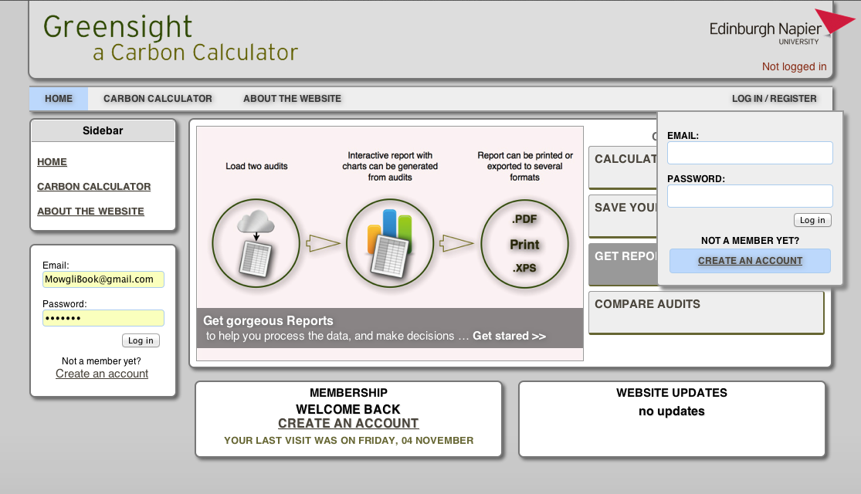

**b**

**c**

**a**

Several links are available to account creation form from the home page and the other pages.

1. & c. ) Will always be available for you as long as you are not logged in the system. From them you can sign in the system, or click “create an account” to be redirected to the account creation form.
2. ) Is only available on the web page. This will show the name of your organisation when you are logged instead of the link to the signup page.
3. ) See (a. )
4. ) Will show you when you are logged in.
5. ) Will show the name of your organisation, and buttons to edit your profile, and log out when you are logged in, as shown below.

**e**

**d**

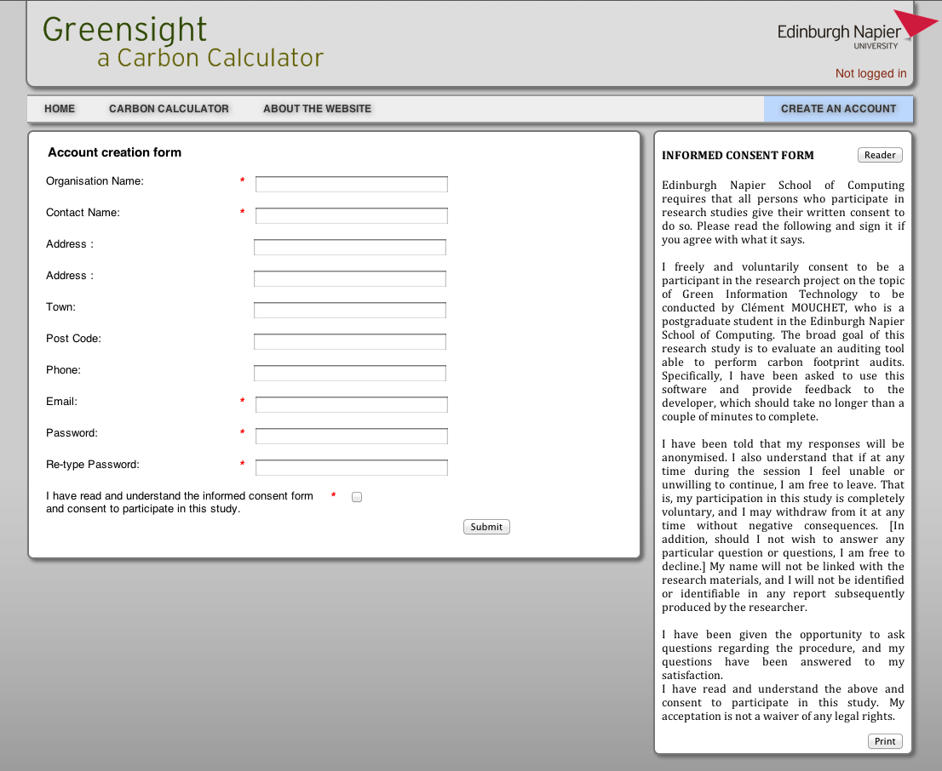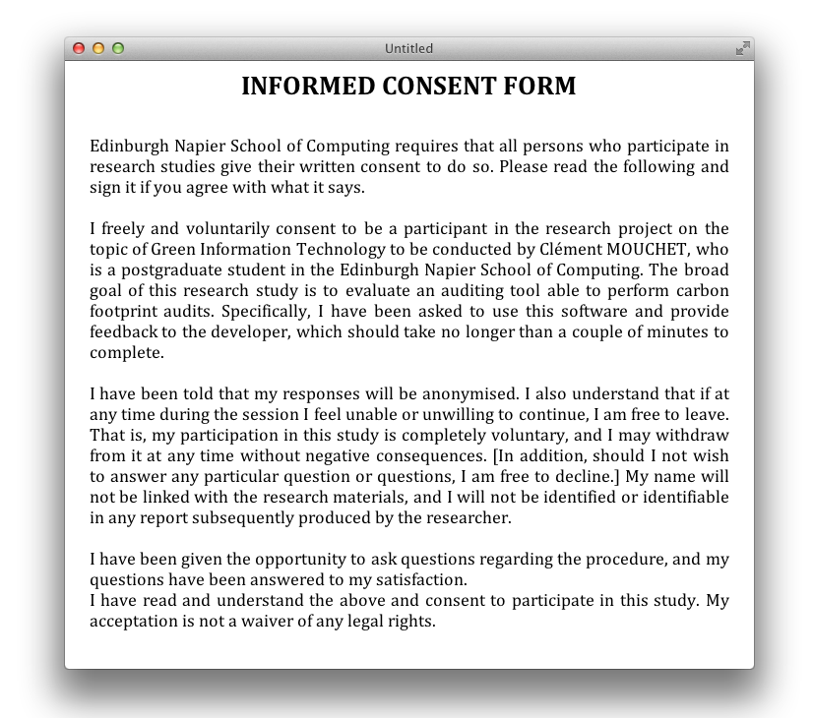

Signing up just takes a few seconds; simply enter:

- The name of your organisation and

- Your name,

- A valid email, and

- A password.

The other fields are not required.

Before you submit you’ll have to read the informed consent form on the right side of the page.

You can press the Reader or Print button to open it in a new window, with more readable 12pt text, and you can print it if you want.

When you’re done you will be confirmed that you have been registered and logged in automatically. From that point you can start using all the functionalities of the web-app.

1. **Creating Audits**
   1. Adding a device profile

Creating audits is really easy.

Simply drill down to the device profile you are looking for by following a couple of steps.

* Select a conversion factor
* Select a data source (Energy Star or The Market Transformation Programme, MTP)
* Select the type, brand, model of your computer if you have chosen Energy Star or
* Select a generic type of product and rating if you use the MTP dataset
* Select a role
* You can enter the location of the equipment if you want
* If you have chosen a product that can use custom time use values, enter them.
* Enter the quantity of identical products
* 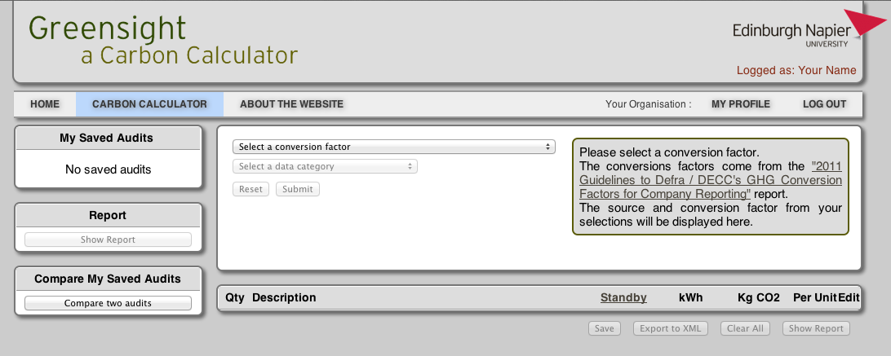Click submit

**b**

**a**

1. ) The select the option that correspond to your research.
2. ) Will always provide information to help you and give you precise information like the source of the data you are using.
3. ) Tooltips will assist you as well.

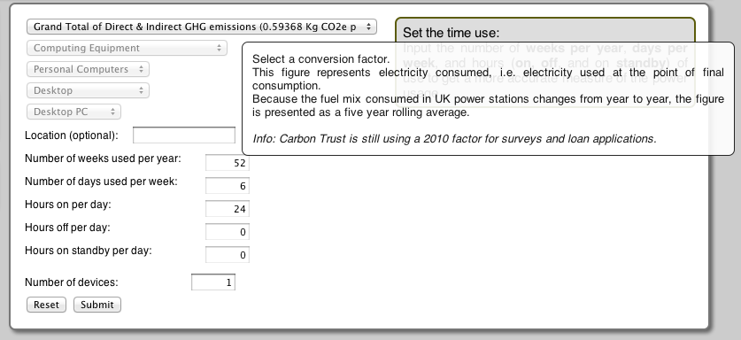

**c**

The device profile is immediately added to the table, as shown below.

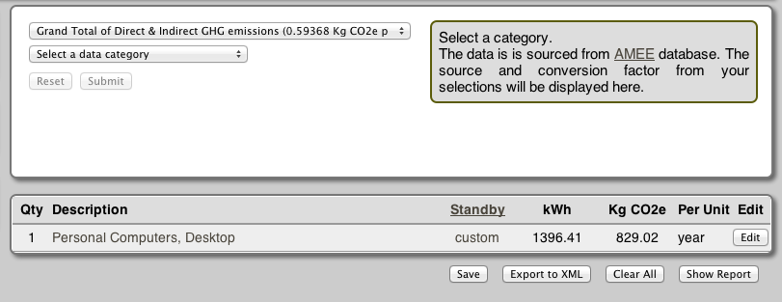

If you hover over the description or the standby information, details of the device profile will be displayed, as shown below.

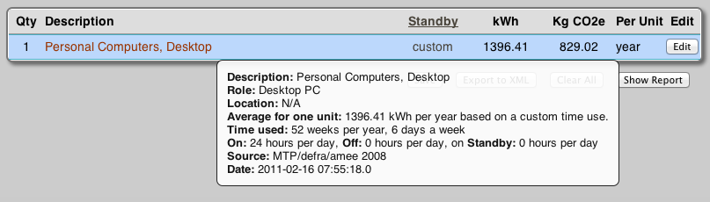

* 1. Editing or Removing a device profile

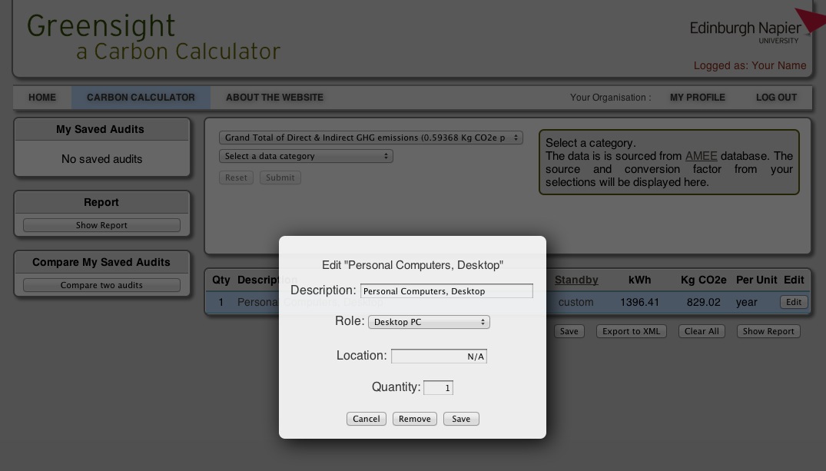Editing or removing a device profile is really easy, simply click the edit button at the right of the profile’s row, and edit, or remove your profile.

* 1. Saving an audit

*< You need to be logged in to access this feature >*

Saving an audit only takes 2 clicks.

* Click the save button below the table,
* Enter the description of your audit, then
* Click save again.

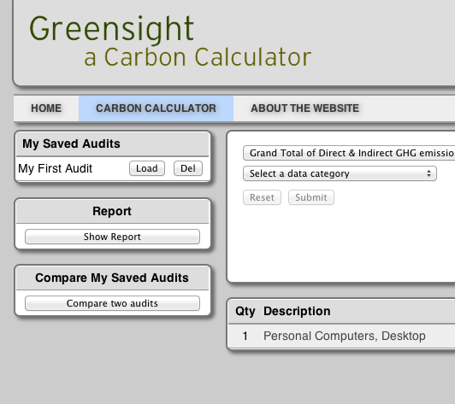**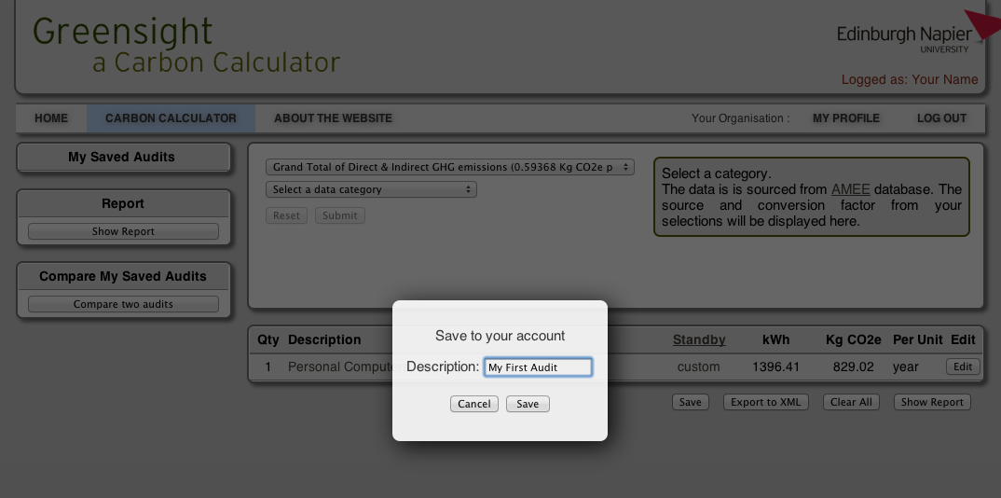**The saved audit will immediately appear in the sidebar “My Saved Audits”

Note that the audit is left unchanged in the table. You can continue working on it, add, edit and remove profiles it won’t affect the one saved in the database.

The sidebar will list all the audits you have saved, you can load them or delete them as you want.

* 1. Exporting an Audit

Audits can be exported to XML, if you want to import them into another program, or just keep a backup on your computer. Simply click the “Export to XML” button, below the table.

Other export functionalities, such as exporting to PDF are described in section 4.3 and 5.3.

1. **Creating reports**

Generating a report from an audit can be done in just one click.

Simply click the “Show Report” button below the table.

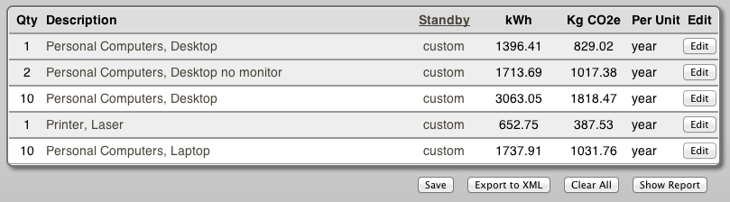

The snapshot bellow shows how a report can look like.

**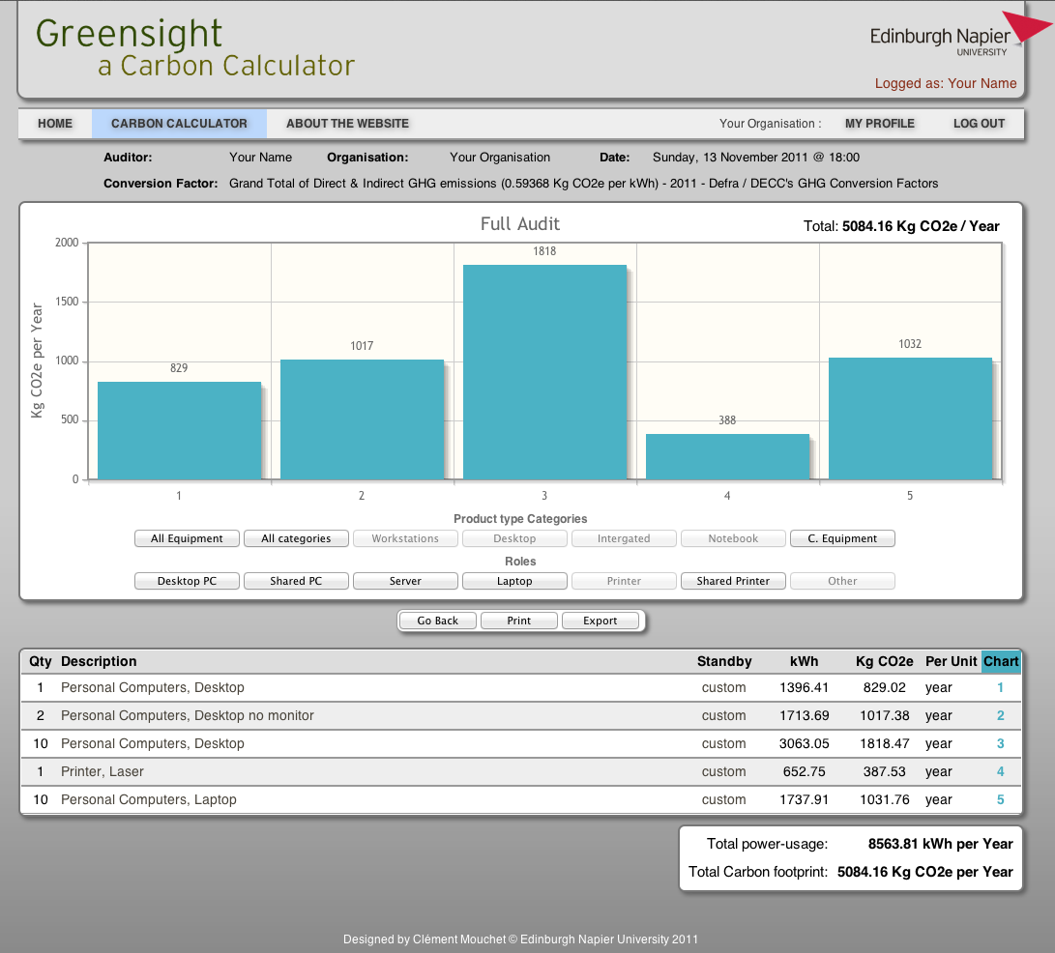**

* 1. Using charts

A series of buttons will allow you to change the content of the charts and tables to a selection of the audit, such as the category of equipment, or the role.

**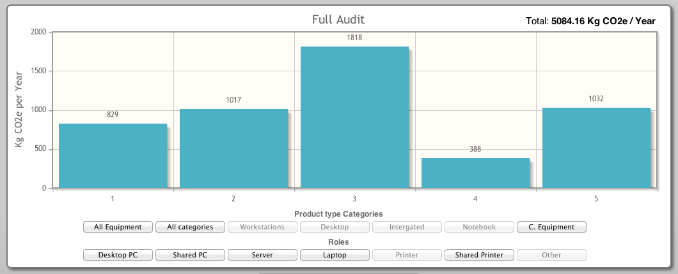**

Clicking on the bars will give you details on what it corresponds to, the example below, represents the charts and details frame after bar 3 was clicked.

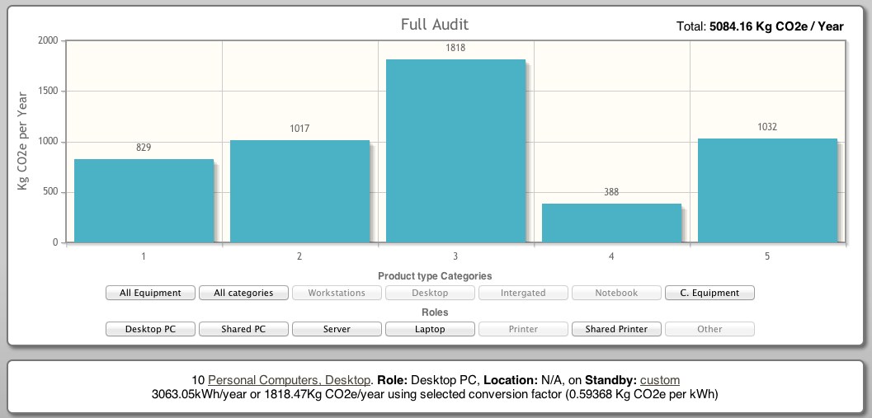

* 1. Printing reports

You can print a report or export it to PDF using a PDF creator, or Google Chrome built in feature to export to PDF.

Simply click the Print button in the middle of the page.

The example below represents the PDF or printed version of the report example.

You can see that details of the device profiles are added to the rows.

*Note: Reports are easier to read in landscape orientation than in portrait orientation. This example is in landscape orientation.*

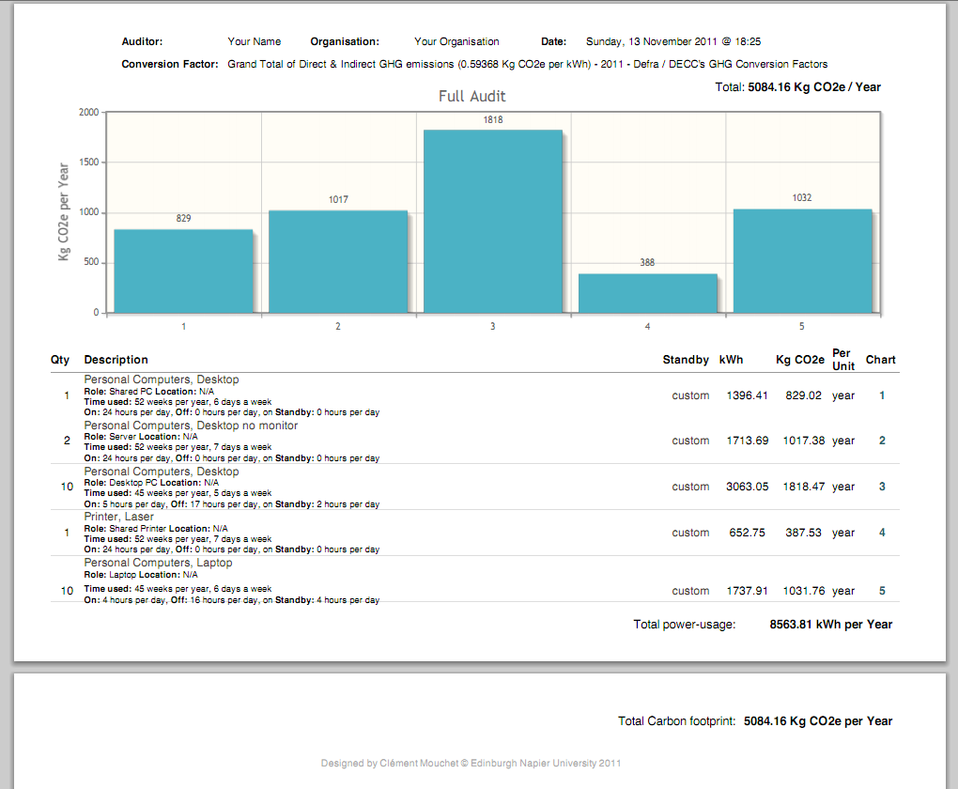

* 1. Exporting reports

See section 3.4

1. **Comparing reports**
   1. Creating comparison reports

This feature requires at least two audits to be saved before being available.

Load your audits as Series 1 and Series 2 by using the “Set as Series 1” and “Set as Series 2” your audits will appear in the table below and on right hand side in the table “My Loaded Audits”

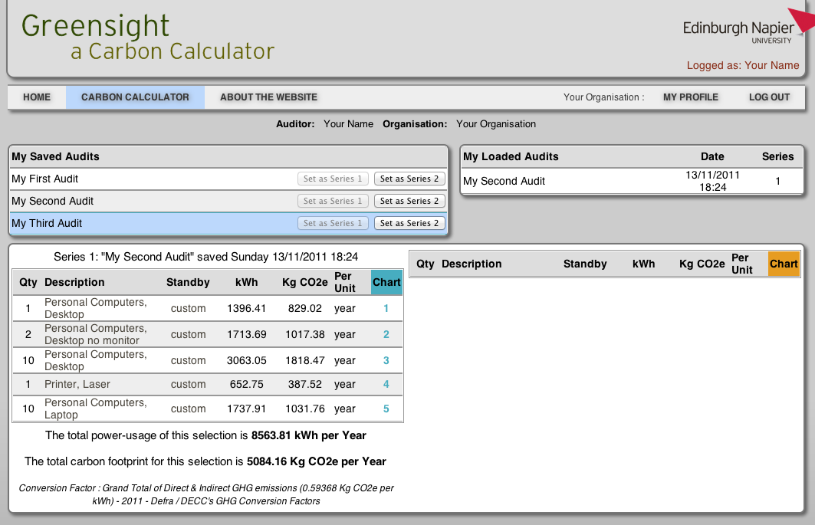

A dialog will give you details on the audit you are about to load.

*Note: It is best to compare two audits with the same structure (same number or profiles, in the same order and same unit or carbon emission)*

*If you get rid of a device profile (a computer for instance) it is probably best to set its quantity to 0 rather than removing it from the list.*

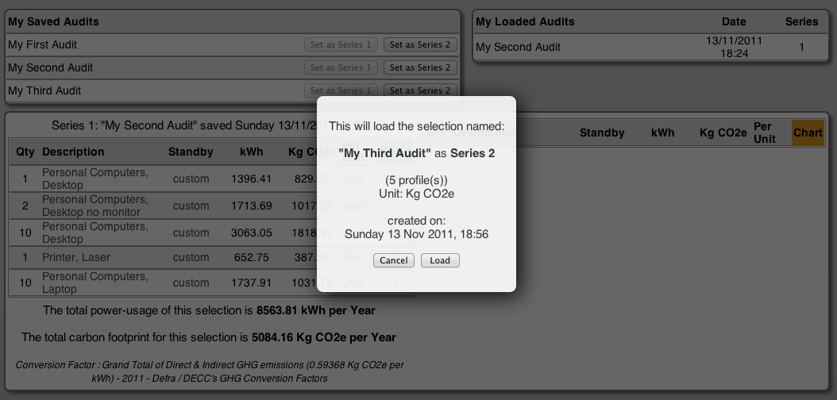

The following screen represents the comparison table once the two audits have been loaded. You can see that the new policy regarding the shutdown of computing equipment applied to the second audit has help reducing the carbon footprint. To get details, you would hover on the description and standby information.

In this example, the first profile was a computer that was never switched off. After the first audit a new policy was applied to computing equipment, and the result speaks for itself.

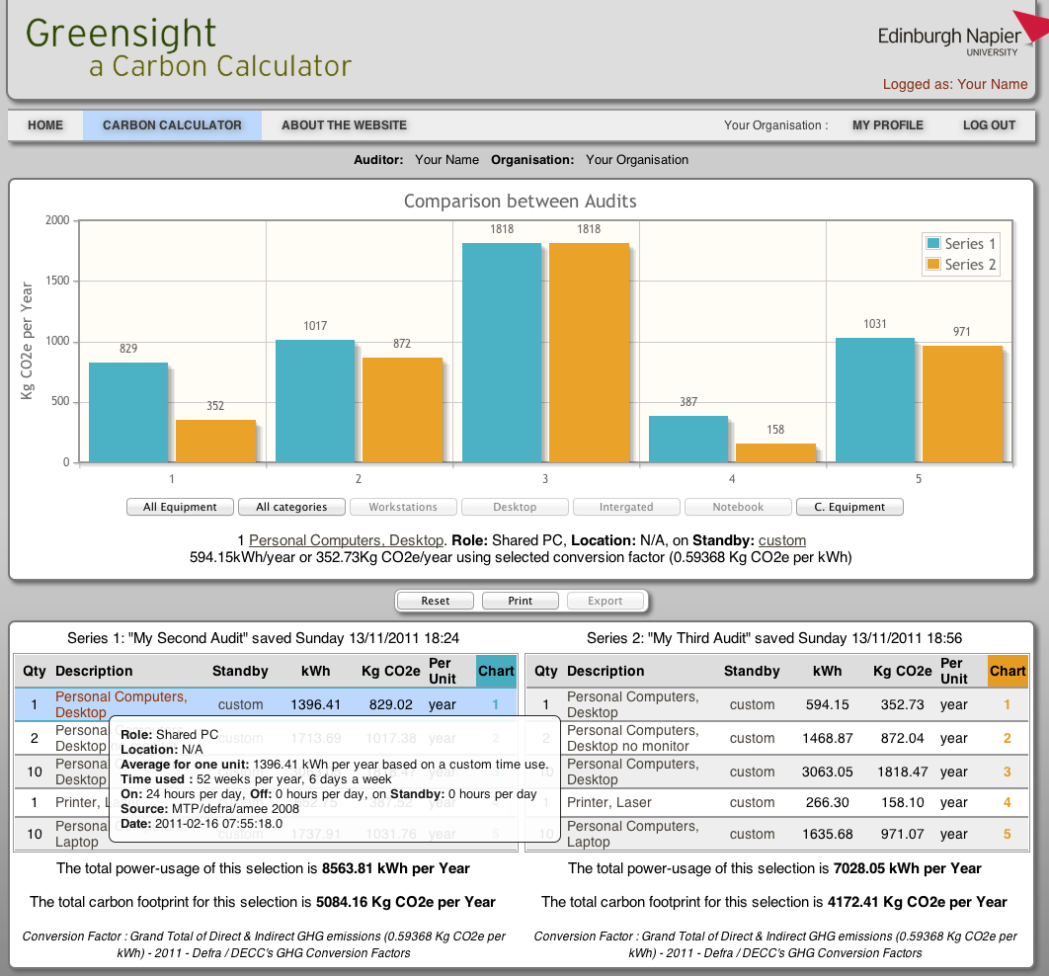

* 1. Printing reports

The static snapshot above cannot render the interactivity of the web-app, this is why you can print or exported to PDF as explained in section 4.2

The snapshot below represents the result that could be printed or exported to PDF.

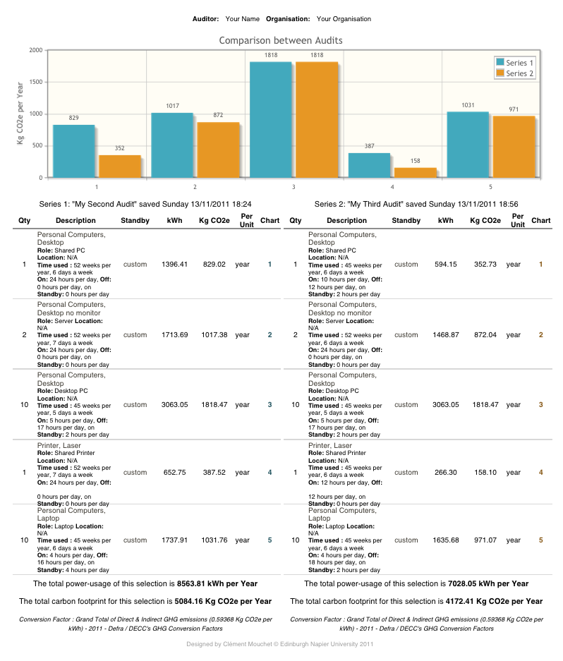Details are available in each row to enable you to compare and understand where changes were made to reduce the carbon footprint. In this case, the computers and printers are switched off when not used, at night and during the holidays for instance.

## Outputs of the web-application

This sub-chapter presents the reports generated by the platform. The report of the entire audit, as well the full listing and the reports for individual roles are available separately.

All the reports are presented “as is” directly printed from the web browser. In this case Mozilla Firefox 8 was used, and the print headers and footers option was unchecked.

Table of Reports

Listing of the entire audit of the S.o.C. & I.I.D.I. 120

Report of the entire audit of the S.o.C. & I.I.D.I. 130

Report of the Desktop PCs in the S.o.C. & I.I.D.I. 139

Report of the Shared PCs in the S.o.C. & I.I.D.I. 143

Report of the Laptops in the S.o.C. & I.I.D.I. 145

Report of the Servers in the S.o.C. & I.I.D.I. 147

Report of the Printers in the S.o.C. & I.I.D.I. 149

Report of the Shared printers in the S.o.C. & I.I.D.I. 152

Report of the Other equipment in the S.o.C. & I.I.D.I. 154

Report of the comparison function 158

### Listing of the entire audit of the S.o.C. & I.I.D.I.

The following list was created using the merging function of the system. It is a global view of the scope of the audit, organised by rooms.

It shows the footprint of each profile, each room and also the global footprint of the audit.

Macintosh HD:Users:Clement:Desktop:untitled folder:final_audit_list_byRoom-page1.pdfFigure 11: Listing of the entire audit of the S.o.C. & I.I.D.I.  
Macintosh HD:Users:Clement:Desktop:untitled folder:final_audit_list_byRoom-page2.pdf

Macintosh HD:Users:Clement:Desktop:untitled folder:final_audit_list_byRoom-page3.pdfMacintosh HD:Users:Clement:Desktop:untitled folder:final_audit_list_byRoom-page4.pdf

Macintosh HD:Users:Clement:Desktop:untitled folder:final_audit_list_byRoom-page5.pdf

Macintosh HD:Users:Clement:Desktop:untitled folder:final_audit_list_byRoom-page6.pdf

Macintosh HD:Users:Clement:Desktop:untitled folder:final_audit_list_byRoom-page7.pdf

Macintosh HD:Users:Clement:Desktop:untitled folder:final_audit_list_byRoom-page8.pdfMacintosh HD:Users:Clement:Desktop:untitled folder:final_audit_list_byRoom-page9.pdf

### Report of the entire audit of the S.o.C. & I.I.D.I.

The following chart and list was created using the reporting function of the prototype, based on the listing above. It shows the chart and list of all the equipment, organised by room. The readability of the chart is limited because of the large number of profiles listed. This should be fixed in future version, as explained in the results chapter.

Macintosh HD:Users:Clement:Desktop:untitled folder:final_audit_chart_all-page1.pdfFigure 12: Report of the entire audit of the S.o.C. & I.I.D.I.

Macintosh HD:Users:Clement:Desktop:untitled folder:final_audit_chart_all-page2.pdf

Macintosh HD:Users:Clement:Desktop:untitled folder:final_audit_chart_all-page3.pdf

Macintosh HD:Users:Clement:Desktop:untitled folder:final_audit_chart_all-page4.pdf

Macintosh HD:Users:Clement:Desktop:untitled folder:final_audit_chart_all-page5.pdf

Macintosh HD:Users:Clement:Desktop:untitled folder:final_audit_chart_all-page6.pdf

Macintosh HD:Users:Clement:Desktop:untitled folder:final_audit_chart_all-page7.pdf

Macintosh HD:Users:Clement:Desktop:untitled folder:final_audit_chart_all-page8.pdf

### Report of the Desktop PCs in the S.o.C. & I.I.D.I.

The following report only shows the equipment of the list presented in section 8.2.1, page 120 that have been set to the role “Desktop PC”.

Macintosh HD:Users:Clement:Desktop:untitled folder:final_audit_chart_DesktopPC-page1.pdfFigure 13: Report of the Desktop PCs in the S.o.C. & I.I.D.I.  
Macintosh HD:Users:Clement:Desktop:untitled folder:final_audit_chart_DesktopPC-page2.pdf

Macintosh HD:Users:Clement:Desktop:untitled folder:final_audit_chart_DesktopPC-page3.pdf

### Report of the Shared PCs in the S.o.C. & I.I.D.I.

The following report only shows the equipment of the list presented in section 8.2.1, page 120 that have been set to the role “Shared PC”.

Macintosh HD:Users:Clement:Dropbox:Napier Uni:SOC11101 Dissertation:final reports:final_audit_chart_SharedPC.pdfFigure 14: Report of the Shared PCs in the S.o.C. & I.I.D.I.

### Report of the Laptops in the S.o.C. & I.I.D.I.

The following report only shows the equipment of the list presented in section 8.2.1, page 120 that have been set to the role “Laptop”.

Macintosh HD:Users:Clement:Dropbox:Napier Uni:SOC11101 Dissertation:final reports:final_audit_chart_Laptop.pdfFigure 15: Report of the Laptops in the S.o.C. & I.I.D.I.

### Report of the Servers in the S.o.C. & I.I.D.I.

The following report only shows the equipment of the list presented in section 8.2.1, page 120 that have been set to the role “Server”.

Macintosh HD:Users:Clement:Dropbox:Napier Uni:SOC11101 Dissertation:final reports:final_audit_chart_Server.pdfFigure 16: Report of the Servers in the S.o.C. & I.I.D.I.

### Report of the Printers in the S.o.C. & I.I.D.I.

The following report only shows the equipment of the list presented in section 8.2.1, page 120 that have been set to the role “Printer”.

Macintosh HD:Users:Clement:Desktop:untitled folder:final_audit_chart_Printer-page1.pdfFigure 17: Report of the Printers in the S.o.C. & I.I.D.I.

Macintosh HD:Users:Clement:Desktop:untitled folder:final_audit_chart_Printer-page2.pdf

### Report of the Shared printers in the S.o.C. & I.I.D.I.

The following report only shows the equipment of the list presented in section 8.2.1, page 120 that have been set to the role “Shared Printer”.

Macintosh HD:Users:Clement:Dropbox:Napier Uni:SOC11101 Dissertation:final reports:final_audit_chart_SharedPrinter.pdfFigure 18: Report of the Shared printers in the S.o.C. & I.I.D.I.

### Report of the Other equipment in the S.o.C. & I.I.D.I.

The following report only shows the equipment of the list presented in section 8.2.1, page 120 that have been set to the role “Other”.

Macintosh HD:Users:Clement:Desktop:untitled folder:final_audit_chart_Other-page1.pdfFigure 19: Report of the Other equipment in the S.o.C. & I.I.D.I.  
Macintosh HD:Users:Clement:Desktop:untitled folder:final_audit_chart_Other-page2.pdf

Macintosh HD:Users:Clement:Desktop:untitled folder:final_audit_chart_Other-page3.pdf

### Report of the comparison function

This is an example of the report generated when comparing two audits. The example chose is the School Office, because computers and printers are never switched off. A new audit was made in the system to estimate what would be the carbon footprint if a new policy were enforced to turn off computers and printers at night and put them to standby when they are not used. The report shows that the emissions could be divided by more than two in this case.



Figure 20: Report of the comparison function on the school office

## Project Management documentation

The following documentation was produced during the first week to prepare and plan the project. The initial version was refined as the project evolved, as some tasks were allocated more time than initially planned and some other were achieved in less time than initially estimated. Not only this system proved useful for time tracking at a day level, and week level but it provided an overview of the time spent on each tasks, during and at the end of the project.

Macintosh HD:Users:Clement:Desktop:Project Plan-page6.pdf

Figure 21: Project plan overview

The project management documentation was included in the dissertation on the 5th of December, as a consequence it does not include the last hours spent between this day and the deadline (12th of December).

The overview confirms the evaluation did not take as long as initially allocated since no users were available for interview or testing.

*The quality of the diagram has been altered by the insertion in MS Word.*

Macintosh HD:Users:Clement:Desktop:Project Plan-page1.pdfMacintosh HD:Users:Clement:Desktop:Project Plan-page2.pdf

Figure 22: Detailed project plan page 1

Figure 23: Detailed project plan page 2

Macintosh HD:Users:Clement:Desktop:Project Plan-page3.pdfMacintosh HD:Users:Clement:Desktop:Project Plan-page4.pdf

Figure 24: Detailed project plan page 3

Figure 25: Detailed project plan page 4

## Audit Report

The following report was presented to the head of Edinburgh Napier University School of Computing, together with the reports in appendix 8.2 in order to evaluate the quality of the audit and potential impact on the Faculty.

She relied one week after by email, with a very positive feedback on the Audit Report but unfortunately no feedback on the reports generated by the prototype.

Audit Report

Edinburgh Napier School of Computing and the Institute for Informatics and Digital Innovation carbon footprint of their computing equipment.

Audit conducted between the 9th of November 2011 and the 21st of November 2011

By Clément MOUCHET,

MSc Information Systems (10011053)

Supervised by Neil Urquhart

**Executive summary**

This report was produced to present the results from the audit conducted between the 9th of November 2011 and the 21st of November 2011, in Edinburgh Napier the School of Computing and the Institute for Informatics and Digital Innovation. The purpose of the audit conducted by Clément MOUCHET was to evaluate a prototype auditing-tool developed during his dissertation.

Two server rooms, six labs and thirty-six staff offices were audited to measure the carbon footprint of the computing equipment used in those rooms.

The reports produced by the auditing tool enabled the auditor to draw conclusions and propose some recommendations regarding the energy policy of the computing equipment in order to reduce the power consumption and overall carbon footprint of the School or Computing and IIDI operations.

This audit report explains the methodology used, the results of the audit and presents the recommendation proposed by the author.

Overall the results of the audit showed that the Labs have a strong and efficient energy policy and that little could be done to reduce their footprint. Almost all the computers in the SoC and IIDI are recent computers that are energy efficient. However, their capacity to save power is under-exploited, and much could be done to reduce the carbon footprint of the staff offices computing equipment, since they are left on much more than necessary. Recommendations to setup new energy policies that would contribute to drastically reduce the carbon footprint of the School of Computing and IIDI operations are made in the last section of this report.

**Methodology**

As stated in the executive summary, Greensight, the platform, is a web-based application that has been used for the audit. Although it is still in a development stage; it was considered mature enough to be evaluated on a fairly large organization, in order to refine its requirements and continue its development.

The audit was performed in 3 stages. Labs were audited first, followed by Staff Offices and Server rooms.

The audit of the Labs was conducted over two days to allow a couple of hours of development, for fixes and improvements after the first two rooms where audited. The time use evaluation of the computing equipment was evaluated based on the timetable of the rooms.

Auditing the staff rooms took more time as access to their offices depended on the presence and availability of staff members. A large majority of them accepted to be shortly questioned about how they use of their computing equipment. In order to minimize the time needed for the audit and avoid disturbing them, questions were kept as simple and short as possible.

The following questions were asked to all the staff members interviewed:

* What and how many computing equipment are used?
* How many weeks per year is the computing equipment used?
* How many days per week?
* How many hours it is on?
* How many hours is it on standby?
* How many hours is it off?

Nearly sixty people accepted to answer these questions, covering almost every staff office of both the SoC and IIDI. Assumptions were made to estimate the few remaining computing equipment, when no one was available to provide information about them.

The server rooms proved to be the most difficult to audit, as their access is very restricted. Only a few minutes were spent in them, to list the hardware, and evaluate it. The second problem was that different parties are responsible for the management of the servers. Unfortunately, not all of them were able to provide detailed information regarding the hardware they are responsible for. Thirdly no data was available for servers in the datasets currently used by the platform. As a consequence, servers were counted in terms of number of CPU: a single CPU server = 1 Desktop without monitor, a dual CPU server = 2 Desktop without monitor and so on.

The limitation of the dataset did not only affect the audit of the server rooms but other audits as well. Networking equipment are absent from the audit as no data was available to evaluate it. Other specific systems such as labs microcomputers for instance were replaced by equivalent products such as ultra-low power netbooks in this case.

**Results**

The result of the audit revealed that most the computers currently used in the School of Computing and IIDI are recent and energy efficient. Most of them have the Energy Star label, and are from brands, such as HP, Dell and Apple that are known for making efforts to reduce their carbon footprint and design energy efficient equipment. (Greenpeace, 2011) There is no need to renew them to reduce the carbon footprint of the SoC and IIDI, but the power management and energy policies of the computers and printers should be improved.

Generally the accuracy of the estimation is questionable, since generic values have been used, and the estimation of time use can be quite rough in some cases. But it still provides interesting insights regarding the use of computing equipment and enables to draw conclusions and propose recommendations to reduce the carbon footprint of computing equipment, without replacing computers. The findings of the audit were that a large number of staff members are leaving their PC on all the time. Many of them justified that they need to access it from home using a VPN. The audit also revealed that the computers and monitors used are hardly exploiting they standby and low power mode. Computers in the labs do have suitable energy policies, and go to sleep, or even shutdown after a period of time idle, varying from 40mns to 2h. All computers in the labs are automatically shut down at 9PM is not used, and the monitors are also set to go to standby when not used.

However, in the staff offices computers are not set to standby if not used, and even monitors stay on unless they are switched off. This is not suitable to the reality of an organisation such as a University where staff members come and go from their offices for long period of time such as lectures, meetings etc. In such situation, computers are wasting power and life span for no reasons.

Most of the monitors are left on all day and are switched off at night. This revealed that staff members are aware of the importance of reducing the power usage during night-time, but improvements could be made during daytime.

Printers are also drawing much more power than they should, almost not printer whether shared or not are switched off at night or during holidays. Again this represents a power usage at least twice more important than necessary.

Based on those results, recommendations to improve the current policy regarding the use of computers and computing equipment are proposed in the next section.

**Recommendations**

As explained earlier, most of the computers are very recent and compliant with energy efficient standards and labels. However, the current policy does not really exploit the new capabilities of the computers to reduce their power usage.

Computers should be:

* Automatically set to standby using ACPI S3 sleeping state after a short period of time (20mn)
* Automatically shut down every night, unless remote access is needed. In this case the computer would be left on standby to use the “wake-on-lan” function.

Monitors should be:

* Automatically going to standby after a short time period idle (10mn)
* *Placed on timer plugs to be switched off automatically at night.*

Printers should be:

* Switched off during holidays
* *Placed on timer plugs to be switched off overnight*

These recommendations are very easy to setup and represent little spending compare to the savings they would provide. They would reduce the power usage and carbon footprint of much equipment such as printers by two, and would contribute to increase the lifespan of all the equipment used, by reducing their activity and operation to the time actually used.

Staff should be encouraged to take an active part in this effort as literature showed that a collective focus is crucial to the success of carbon footprint reduction. (O'Neil, 2010, p. 5) (Jenkin, Webster, & McShane, 2011, p. 26)

For instance, if reminders were displayed to encourage them to put their computer to standby when they leave the room, or to switch off their printer when they are finished using it, this would reduce the carbon footprint even more.

**References**

Greenpeace. (2011, 11 01). *Guide to Greener Electronics.* Retrieved 11 11, 2011, from www.greenpeace.org: http://www.greenpeace.org/international/Global/international/publications/climate/2011/Cool%20IT/greener-guide-nov-2011/guide-to-greener-electronics-nov-2011.pdf

Hewlett-Packard Corporation, Intel Corporation, Microsoft Corporation, Phoenix Technologies Ltd., Toshiba Corporation. (2010). *Advanced Configuration and Power Interface Specification, Revision 4.0a.* www.acpi.info.

Jenkin, T. A., Webster, J., & McShane, L. (2011). An agenda for ‘Green’ information technology and systems research. *Information and Organization*(21), 17-40.

O'Neil, M. (2010). *GREEN IT FOR SUSTAINABLE BUSINESS PRACTICE An ISEB Foundation Guide* (ISBN 978-1-906124-62-5 ed.). Chippenham, UK: British Informatics Society Limited.